REQUEST FOR MINOR CORRECTIONS IN FIGURES AND EQUATIONS

The editor may kindly note that a couple of typographic errors in Eq.2, Fig.7 and Fig.S2 were found during proof checking of the manuscript. We are providing herewith the details of the corrections to be made. Kindly do the needful.

- Modification in equation-2

A typographic error in equation-2 is to be corrected for maintaining uniformity in the variables.

Equation before correction:

$$C=\frac{t_{Band(i)}\left(τ;μ_{0}\right)∙t_{Band(i)}\left(τ;μ_{1}\right)}{R_{Band\left(i\right)}\left(μ_{1},μ_{0},ϕ\right)/T_{gas,Band(i)}^{2}-R_{Atmos(i)}\left(μ_{1},μ_{0},ϕ\right)}$$

Equation after correction:

$$C=\frac{t_{Band(i)}\left(τ;μ_{0}\right)∙t_{Band(i)}\left(τ;μ_{1}\right)}{R_{Band\left(i\right)}\left(μ_{1},μ_{0},ϕ\right)/T_{gas,Band(i)}^{2}-R_{Atmos,Band(i)}\left(μ_{1},μ_{0},ϕ\right)}$$

- Correction in Figure-7

Some texts (e.g., TVM, ATP, HYD) representing measurements locations are missing in the middle panel of Fig.7. Kindly consider replacing this figure with the corrected one.

Figure before correction:

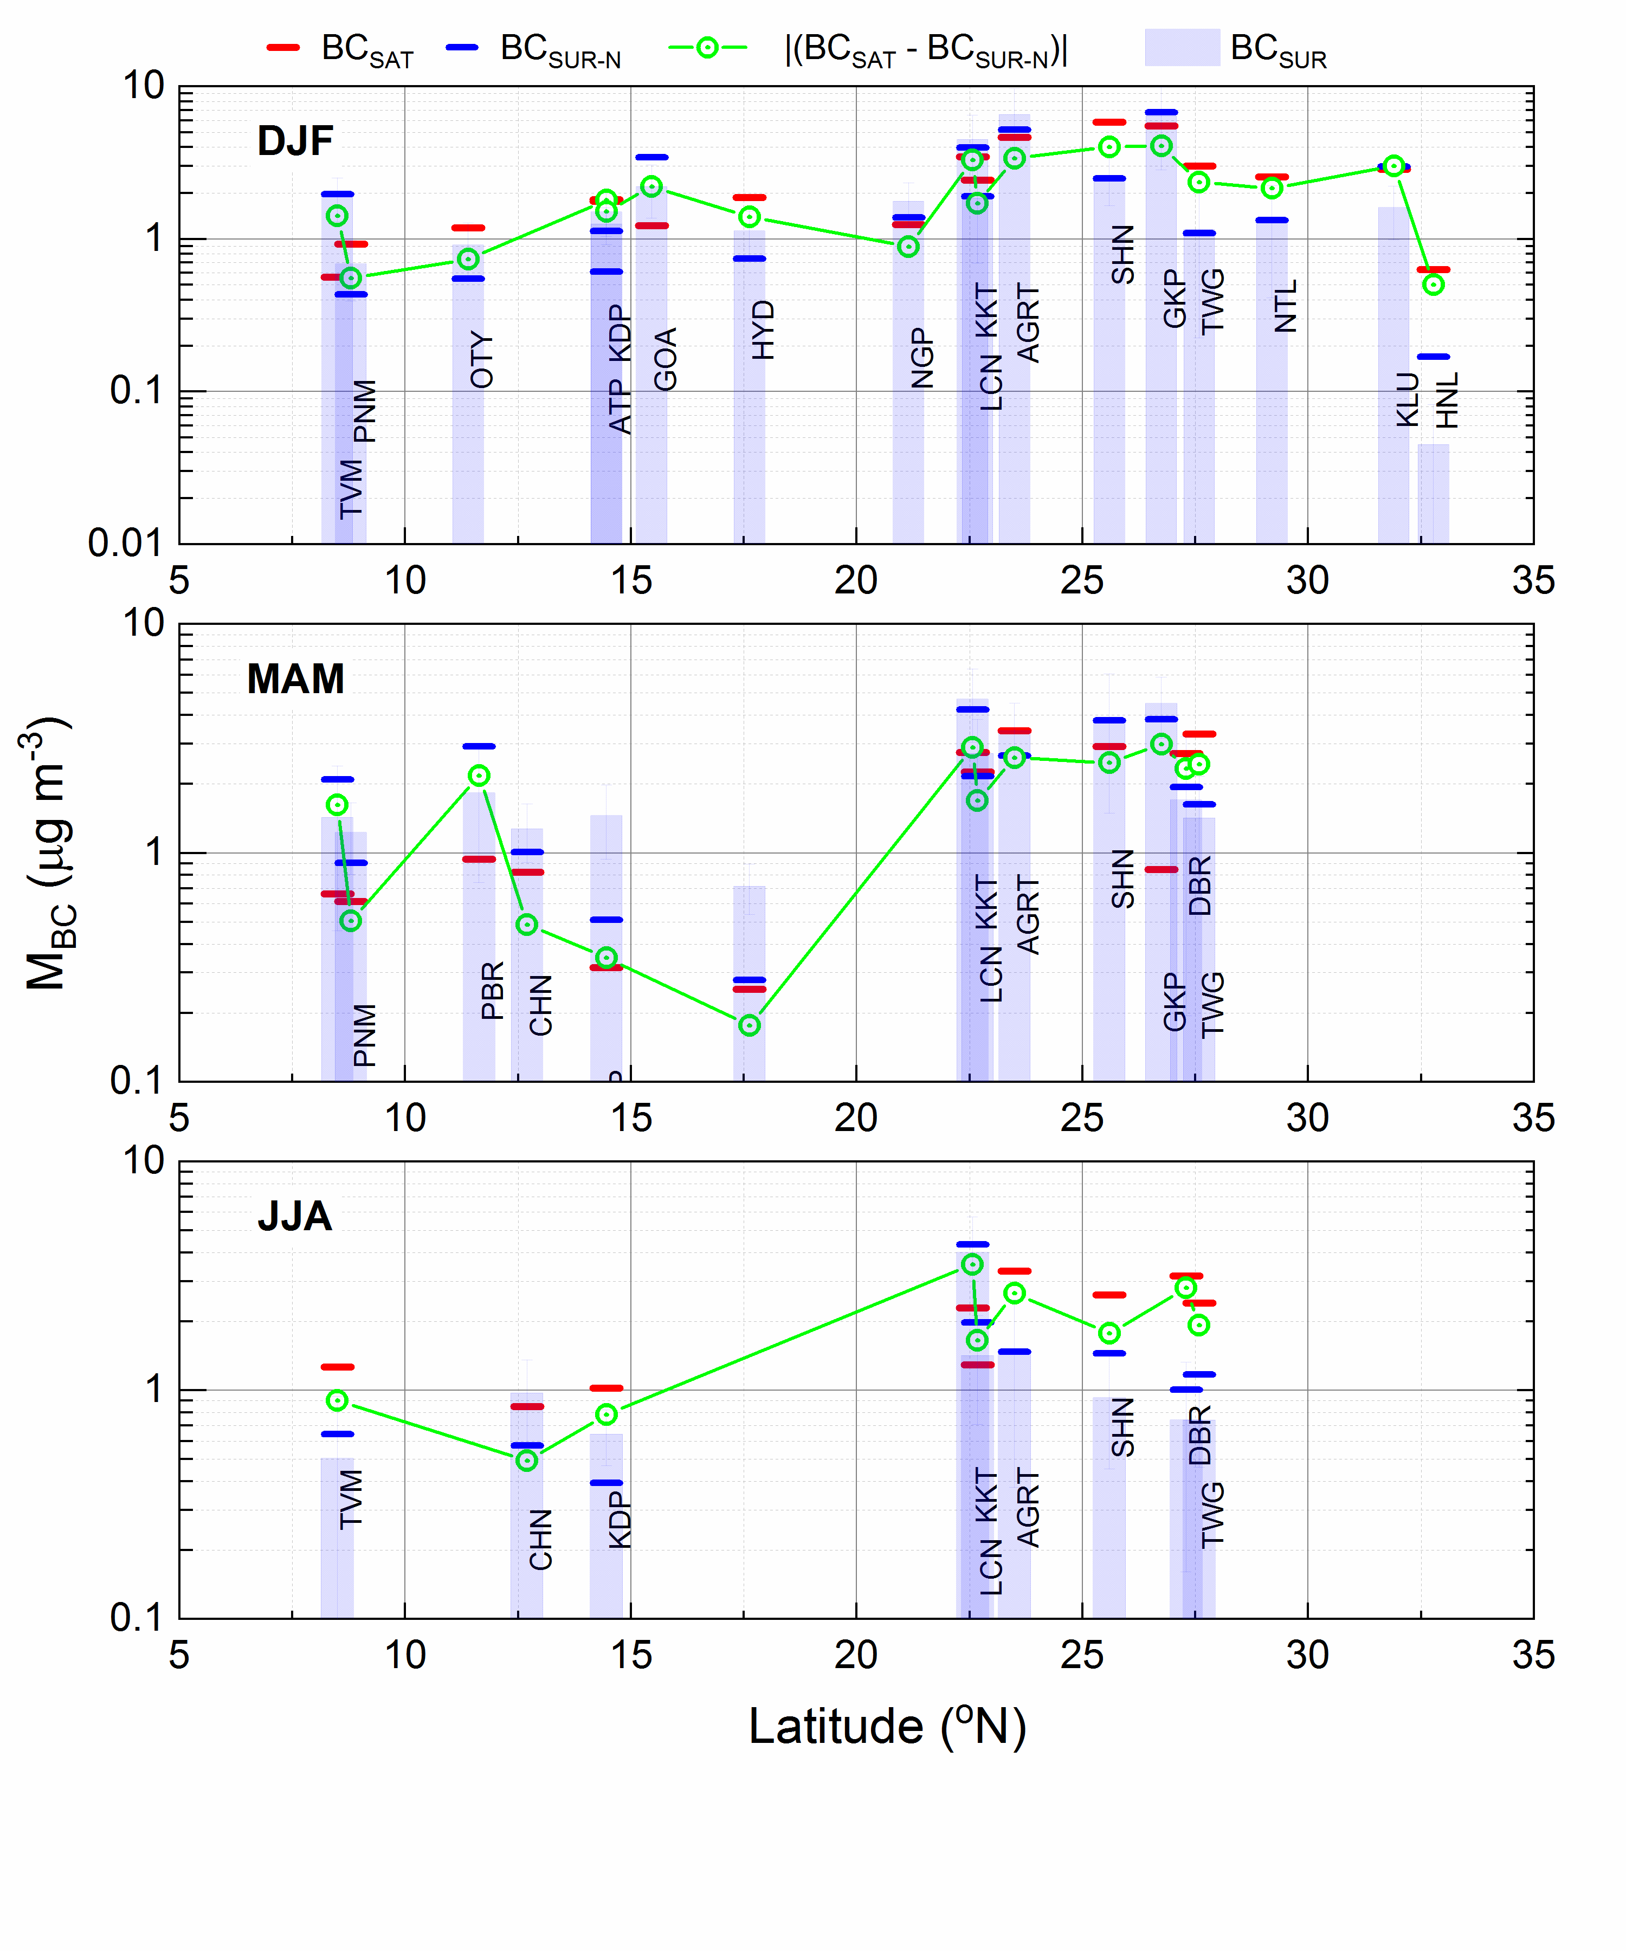
Figure after correction:

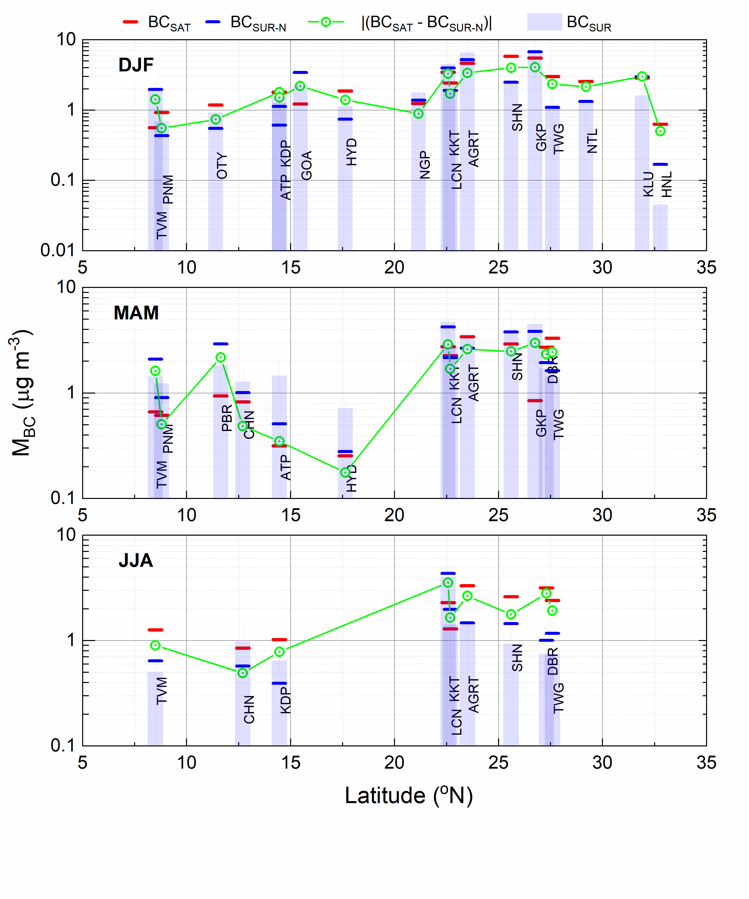

- Correction in Figure-S2 of the Supplement Document:

In this figure, the numerical value of wavelength "0.674 μm" is wrongly typed as "674 μm" (as is highlighted below). Kindly consider replacing this figure with the corrected one.

Figure before correction:

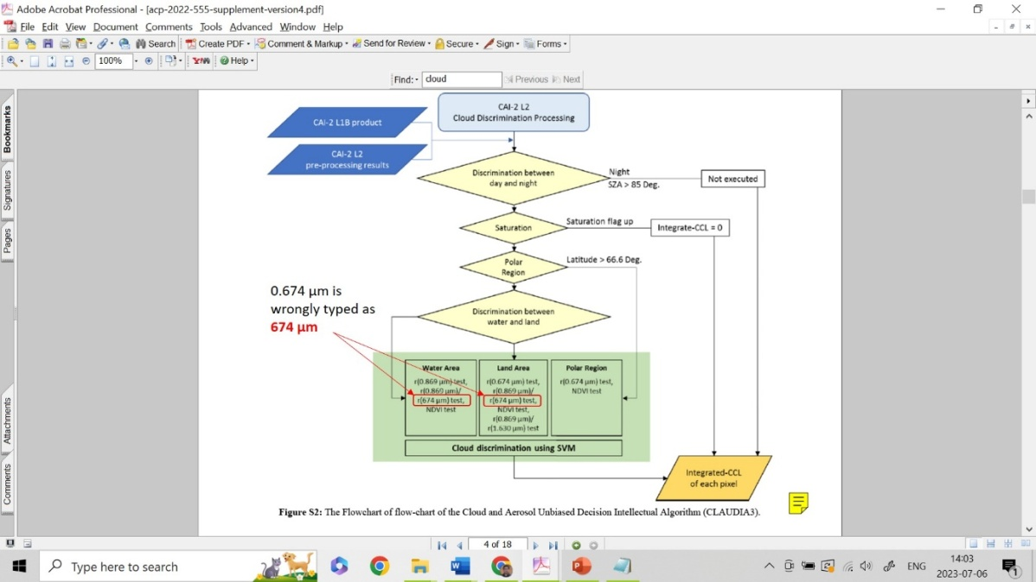

Figure after correction:

Figure S2: The Flowchart of flow-chart of the Cloud and Aerosol Unbiased Decision Intellectual Algorithm (CLAUDIA3).

