The requested changes are as follows:

Page 13, Figure 6 and lines 18 and 20:

- Change DBEs: “3.4±0.68” to “3.1±1.1”
- Change O:C ratios: “0.32±0.12” to “0.39±0.19”
- Exchange the above number shown in Fig. 6 (d) with following corrected version:
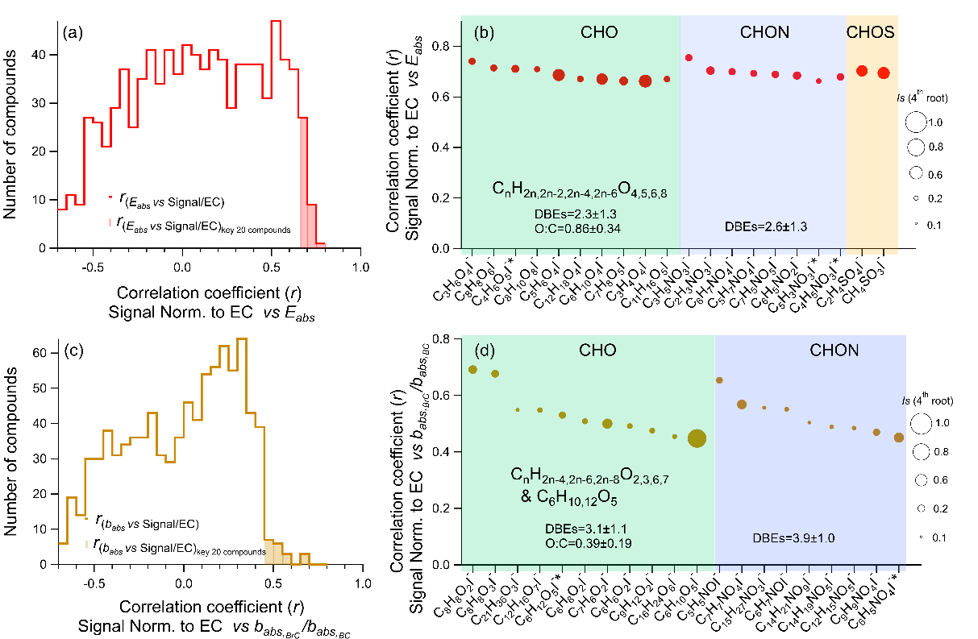

Explanation: We found a typo during the process of proofreading.
In Fig. 6 (d) (also page 13 Line 18,20), the original DBEs and O:C of "key compounds for babs" were calculated as the average value of CHO compounds without the two biomass burning tracers (C₆H_{10,12}O₅) that are separately listed in Fig. 6 (d). The overall average DBEs and O:C ratios of all CHO compounds included should be 3.1±1.1 and 0.39±0.19 instead of 3.4±0.68 and 0.32±0.12. Such slight changes do not bias our point that the "key compounds for babs" exhibit higher DBEs (3.1) and lower O:C ratios (0.39) than the "key compounds for Eabs” (DBEs 2.3, O:C 0.86).
We would like to correct the mistake in the text and figure before the manuscript is published.

