Equation 3 as formatted originally in the supplement.

$${∆{}_{}^{14}{CO}}_{2 }=\left(\frac{\frac{\sum{\left(\frac{\left(\frac{∆{{}_{}^{14}{CO}}_{2 i}}{1000}+1\right)×{{}_{}^{14}R}_{std}}{1-2×\frac{25+δ{{}_{}^{13}{CO}}_{ i}}{1000}}×{{}_{}^{12}{CO}}_{2 i}\right)}}{{{}_{}^{12}{CO}}_{2 }}×\left(1-2*\frac{25+δ{{}_{}^{13}{CO}}_{2}}{1000}\right)}{{{}_{}^{14}R}_{std}}-1\right)×1000$$

Equation 3 with a line break to fit in to the paper proofread
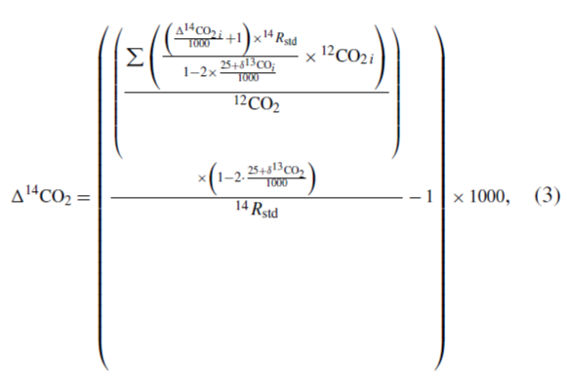
Splitting it in to two Equations
$X=\frac{\sum{\left(\frac{\left(\frac{∆{{}_{}^{14}{CO}}_{2 i}}{1000}+1\right)×{{}_{}^{14}R}_{std}}{1-2×\frac{25+δ{{}_{}^{13}{CO}}_{ i}}{1000}}×{{}_{}^{12}{CO}}_{2 i}\right)}}{{{}_{}^{12}{CO}}_{2 }}$ (3a)

${∆{}_{}^{14}{CO}}_{2 }=\left(\frac{X×\left(1-2*\frac{25+δ{{}_{}^{13}{CO}}_{2}}{1000}\right)}{{{}_{}^{14}R}_{std}}-1\right)×1000$ (3b)

