Interactive comment on “Sources of nitrogen deposition Federal Class I areas in the US” by H.- M. Lee

This is a well written and interesting manuscript on the use of GEOS-Chem to analyze the origin of reactive nitrogen that impacts Class I areas in the U.S. The authors first establish credible model performance by comparing deposition estimates from GEOS-Chem with those from measurements and other modeling approaches. Next, the authors examine the spatial and sectoral footprints of nitrogen deposition. Finally, the authors document the sensitivity of the source attribution to NH3 emissions inventories.

Comments:

Section 2.1 – It would be helpful to have a table that lists which NADP and CASTNET sites were used to represent each Class I area. At SM, the closest NADP site to the CASTNET site is 32 km away. It isn’t clear if this is the site that was used.

*> A table is added (Table 1) and an introduction sentence is added on lines 116:*

*“Table 1 lists sites used in this study.”*

Line 118 – the abbreviation JJA has not been defined. The abbreviation for all seasons (i.e. MAM, SON, DJF) while somewhat obvious, should be defined somewhere.

*> It is now defined in the Figure 3 caption.*

Line 118-119 – Did you test the validity of the approach for obtaining the values for 2010 at GT by taking the average for other years where there were data and comparing them to the value at GT?

Line 128-129 – The use of the Yellowstone and Pinedale CASTNET sites as surrogates for GT is questionable, particularly for Pinedale. Figure 1 shows that at GT, the land cover 100% cool coniferous. The CASTNET deposition value at Yellowstone is calculated assuming the land cover is 68% pine, 5% grass, and 27% rock. The CASTNET deposition value at Pinedale is calculated assuming the land cover is 70% grass and 30% sagebrush. The deposition velocity will depend on the land cover characteristics, so the values at Yellowstone and Pinedale will not likely be the same as what would be predicted for the land cover type at GT.

*> We couldn’t compare the total deposition from GT and the average of Yellowstone and Pinedale because there is no CASTNET (dry deposition) site in GT. However, the figure below shows comparison of NADP data (wet deposition) for 2012. In GT, modeled contribution from wet deposition is greater in MAM and DJF and comparable with dry deposition in JJA and SON (Fig. 4 in the manuscript). In 2012, the result below shows Grand Teton wet deposition is comparable with the average of Yellowstone and Pinedale data and tends to be higher than the average of the two sites. Thus, this comparison suggests that our modeling result would closer to the measurement if any were available in 2010.*

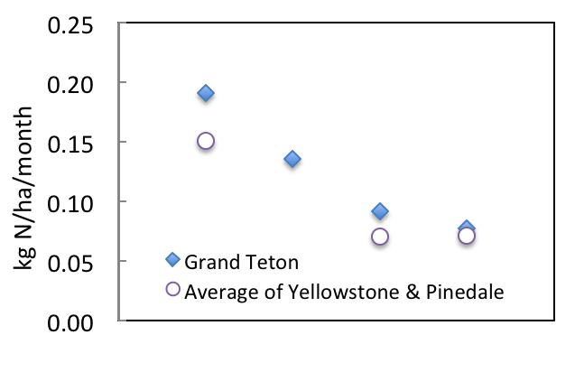

MAM JJA SON DJF

Line 414-418 – The discussion of the impact at VY of the different emissions inventories is not clear.

*> Now it is revised as:*

*“Differences in emissions between the two inventories in Minnesota and Iowa mainly contribute to changes in the sensitivities for Nr deposition in VY.”*

Line 418 – 420 – The sentence does not make sense as written. Consider breaking into smaller sentences.

*> Now it is revised as:*

*“SD is not affected much by different NH3 inventories in July and October as up to 50% of total Nr deposition is owing to sources within 250 km (Fig. 6). However, NEI2008 leads to broader estimates of the source footprints in April.”*

Figures – A large number of the maps (Figure 5, 7, 8, 10, 12) have the aspect ratio incorrect. They are too wide which causes states such as Colorado to become rectangles instead of the near square shapes they really are.

*> We apologize for the confusion it may cause. This occurred while we tried to set up the figure domain to show regions where sensitivities are visible, save space, and make them aligned with other figures. We hope that state outlines are recognizable enough that the aspect ratio of the projection will not lead to misinterpretation of our results.*

Figure 2 – I don’t see the benefit of having the maps for reduced and oxidized nitrogen smaller than the one for total nitrogen. It makes it harder to read.

*> The map of total nitrogen deposition is larger to show the park locations with text.*

Table 1 – The caption should indicate the year for the emissions.

*> Year is added.*

Figure 3 – As noted above, the abbreviations for the seasons should be explained.

*> Now it is defined in the caption of this figure.*

Figure 4 - It is difficult to see the color difference between HNO3-dry and NO3-wet, however their position in the column may be enough of a clue.

*> We agree.*

Figure 5 – It is difficult to distinguish between the colors for NH3 and NOx. The yellow for NH3 really gets lost. Maybe making it closer to orange would help. The circles for the site locations are hard to see, especially for VY. They might need to be darker.

*> The yellow (natural sources of NH3) is only a significant portion of the source footprint in BB. Making this sector orange leads to confusion with NH3 from livestock, which is a much more important sector. Site location markers have been made darker.*

Figure 7 – Same color concerns as for Figure 5.

*> We did not find a better color scheme, however the site markers have been made darker.*

Figure 12 – The maps are too small.

*> While we agree the maps would need to be zoomed in to examine values in each grid cell (which would be possible, given that they are vector graphics), the key features (such as differences between sensitivities across inventories in Iowa for the VY source footprint) are evident at the present scale.*