Data Assimilation in Atmospheric Chemistry Models: Current Status and Future Prospects for Coupled Chemistry Meteorology Models

M. Bocquet^{1,2}, H. Elbern³, H. Eskes⁴, M. Hirtl⁵, R. Žabkar⁶, G.R. Carmichael⁷, J. Flemming⁸, A. Inness⁸, M. Pagowski⁹, J.L. Pérez Camaño¹⁰, P.E. Saide⁷, R. San Jose¹⁰, M. Sofiev¹¹, J. Vira¹¹, A. Baklanov¹², C. Carnevale¹³, G. Grell⁹, C. Seigneur¹.

¹CEREA, Joint Laboratory école des Ponts ParisTech/EDF R&D, Université Paris-Est, Marne-la-Vallée, France
²INRIA, Paris Rocquencourt Research Center, France
³Institute for Physics and Meteorology, University of Cologne, Germany
⁴KNMI, De Bilt, The Netherlands
⁵Central Institute for Meteorology and Geodynamics, Vienna, Austria
⁶Faculty of Mathematics and Physics, University of Ljubljana, Slovenia
⁷Center for Global and Regional Environmental Research, University of Iowa, USA
⁸European Centre for Medium-range Weather Forecasts, Reading, UK
⁹NOAA/ESRL, Boulder, Colorado, USA
¹⁰Technical University of Madrid (UPM), Madrid, Spain
¹¹Finnish Meteorological Institute, Helsinki, Finland
¹²World Meteorological Organization (WMO), Geneva, Switzerland and Danish Meteorological Institute (DMI), Copenhagen, Denmark
¹³Department of Mechanical and Industrial Engineering, University of Brescia, Italy

Correspondence to: C. Seigneur (seigneur@cerea.enpc.fr)

Abstract

Data assimilation is used in atmospheric chemistry models to improve air quality forecasts, construct re-analyses of three-dimensional chemical (including aerosol) concentrations and perform inverse modeling of input variables or model parameters (e.g., emissions). Coupled chemistry meteorology models (CCMM) are atmospheric chemistry models that simulate meteorological processes and chemical transformations jointly. They offer the possibility to assimilate both meteorological and chemical data; however, because CCMM are fairly recent, data assimilation in CCMM has been limited to date. We review here the current status of data assimilation in atmospheric chemistry models with a particular focus on future prospects for data assimilation in CCMM. We first review the methods available for data assimilation in atmospheric models, including variational methods, ensemble Kalman filters, and hybrid methods. Next, we review past applications that have included chemical data assimilation in chemical transport models (CTM) and in CCMM. Observational data sets available for chemical data assimilation are described, including surface data, surface-based remote sensing, airborne data, and satellite data. Several case studies of chemical data assimilation in CCMM are presented to highlight the benefits obtained by assimilating chemical data in CCMM. A case study of data assimilation to constrain emissions is also presented. There are few examples to date of joint meteorological and chemical data assimilation in CCMM and potential difficulties associated with data assimilation in CCMM are discussed. As the number of variables being assimilated increases, it is essential to characterize correctly the errors; in particular, the specification of error cross-correlations may be problematic. In some cases, offline diagnostics are necessary to ensure that data assimilation can truly improve model performance. However, the main challenge is likely to be the paucity of chemical data available for assimilation in CCMM.
1. Introduction

Data assimilation pertains to the combination of modeling with observational data to produce a most probable representation of the state of the variables considered. For atmospheric applications, the objective of data assimilation is to obtain a better representation of the atmosphere in terms of meteorological and atmospheric chemistry variables (particulate matter (PM) is included here as part of atmospheric chemistry).

Data assimilation has been used for many decades in dynamic meteorology to improve weather forecasts and construct re-analyses of past weather. Several recent reviews of data assimilation methods used routinely in meteorology are available (e.g., Kalnay, 2003; Navon, 2009; Lahoz et al., 2010). The use of data assimilation in atmospheric chemistry is more recent, because numerical deterministic models of atmospheric chemistry have been used routinely for air quality forecasting only since the mid 1990’s; previously, most air quality forecasts were conducted with statistical approaches (Zhang et al., 2012a). Data assimilation is also used in air quality since the 1990’s for re-analysis to produce air pollutant concentration maps (e.g., Elbern and Schmidt, 2001), inverse modeling to improve (or identify errors in) emission rates (e.g., Elbern et al., 2007; Vira and Sofiev, 2012; Yumimoto et al., 2012), boundary conditions (e.g., Roustan and Bocquet, 2006) and model parameters (e.g., Barbu et al., 2009; Bocquet, 2012). Regarding air quality re-analyses, the 2008/50 European Union (EU) Air Quality Directive (AQD) suggests the use of modeling in combination with fixed measurements “to provide adequate information on the spatial distribution of the ambient air quality” (Borrego, in press; OJEU, 2008). An overview of data assimilation of atmospheric species concentrations for air quality forecasting was recently provided by Zhang et al. (2012b); however, only data assimilation in CTM was addressed. We address here data assimilation in atmospheric chemistry models, which we define to include both atmospheric chemical transport models (CTM), which use meteorological fields as inputs (e.g., Seinfeld and Pandis, 2006), and coupled chemistry meteorology models (CCMM), which simulate meteorology and atmospheric chemistry jointly (Zhang, 2008; Baklanov et al., 2014). In particular, we are interested in the future prospects and potential difficulties associated with data assimilation in CCMM.

In spite of available previous experience in data assimilation for meteorological modeling on one hand and chemical transport modeling on the other hand, conducting data assimilation in CCMM can be challenging because of interactions among meteorological and chemical variables. Assimilating large bodies of various meteorological and air quality data may lead to a point of diminishing return. The objective of this review is to present the current state of the science in data assimilation in atmospheric chemistry models. Because of the limited experience available with CCMM, our review covers primarily data assimilation in CTM and, to a lesser extent, in CCMM. The emphasis for future prospects is placed on the preferred approaches for CCMM and the challenges associated with the combined assimilation of data for meteorology and atmospheric chemistry. Potential difficulties are identified based on currently available experience and recommendations are provided on the most appropriate approaches (methods and data sets) for data assimilation in CCMM. Recommendations for method development are also provided since current efforts are ongoing in this area of geosciences.

We present in Section 2 an overview of the data assimilation techniques that are used in atmospheric modeling. Next, their applications to atmospheric chemistry are presented in Section 3; most applications to date pertain to meteorology and atmospheric chemistry separately, nevertheless a few recent applications pertaining to CCMM are described. Data assimilation in the context of optimal network design is also discussed because it may be used to improve the representativeness of observational monitoring networks. The observational data sets available for data assimilation are described in Section 4. Selected case studies of data assimilation in CCMM are presented in Section 5 to illustrate the current state of the science. A case study of data assimilation performed in the context of inverse modeling of the emissions is also presented. Potential difficulties associated with data assimilation in CCMM are discussed in Section 6. Finally, recommendations for future method development, method applications and pertinent data sets are provided in Section 7, along with a discussion of future prospects for data assimilation in CCMM.

2. Methods of data assimilation in meteorology and atmospheric chemistry

  - Overview of the methods

Data assimilation in geosciences has been initially applied to meteorology where methods have been very soon operationally implemented (Lorenc, 1986; Daley, 1991; Ghil and Malanotte-Rizzoli, 1991; Kalnay, 2003; Evensen, 2009; Lahoz et al., 2010). Building on established data assimilation methodology, assimilation of observations in offline CTM has emerged in the late 1990’s (Carmichael et al., 2008; Zhang et al., 2012a). Here, we briefly describe the most common techniques used in both fields and comment on their differences when appropriate.

As far as spatial analysis is concerned, most common data assimilation methods hardly differ. They are mainly based on statistical Gaussian assumptions on all errors and the analysis relies on the simple but efficient Best Linear Unbiased Estimator (BLUE). At a given time, BLUE strikes the optimal compromise between the observations and a background estimate of the system state, often given by a previous forecast. Such BLUE analysis can be performed solving for the gain matrix (that balances the observations and the background) using linear algebra, a procedure called Optimal/Statistical Interpolation (OI) (Fedorov, 1989; Daley, 1991), or it can be obtained through a three-dimensional (3D) variational spatial analysis, usually called 3D-Var. Within BLUE, it is mandatory to provide a priori statistics for both the observation errors and the errors of the background.

When time is accounted for, these methods need to be generalized. In particular, errors (or their statistics) attached to the best estimate must be propagated in time, which leads to substantial hardships in both statistical interpolation and variational approaches. The OI approach may be generalized to the (extended) Kalman filter (Ghil and Malanotte-Rizzoli, 1991), while 3D-Var is generalized to 4D-Var (Penenko and Obraztsov, 1976; Le Dimet and Talagrand, 1986; Talagrand and Courtier, 1987; Rabier et al., 2000). Kalman filters and 3D/4D-Var can be combined to address deficiencies of both methods: divergence of the filter and static covariance in variational methods (at least initially for 4D-Var) (Lorenc, 2003).

    - Filtering approaches

The extended Kalman filter requires the propagation of the error covariance matrix of rank the dimension of state-space, which can become unaffordable beyond a few hundred. Yet, when the analysis happens to be strongly localized, the method becomes affordable such as in land surface data assimilation. For higher dimensional applications, it has been replaced by the reduced-rank Kalman filter and the ensemble Kalman filter, and many variants thereof (Evensen, 1994; Verlaan and Heemink, 1997). In both cases, the uncertainty is propagated through a limited number of modes that are forecast by the model. This makes these methods affordable even with large dimensional models, especially because of the natural parallel architecture of such ensemble filtering. Unfortunately, the fact that the ensemble is of finite size entails a deficient estimation of the errors mostly due to undersampling, which may lead to divergence of the filter. This needs to be fixed and has been so through the use of inflation (Pham et al., 1998; Anderson and Anderson, 1999) and localization (Houtekamer and Mitchell, 2001; Hamill et al., 2001).

Inflation consists in additively or multiplicatively inflating the error covariance matrices so as to compensate for an underestimation of the error magnitude. The inflation can be fixed or adaptive, or it can be rendered by physically-driven stochastic perturbations of the ensemble members. Localization is made necessary when the finite size of the ensemble whose variability is too small in high-dimensional systems makes the analysis inoperative. Localization can be performed by either filtering the ensemble empirical error covariance matrix and making it full-rank using a Schur product with a short-range correlation function (Houtekamer and Mitchell, 2001) or performing parallel spatially local analyzes (Ott et al., 2004). Those methodological advances have been later tested and weighted with offline CTM (Hanea et al., 2004; Constantinescu et al., 2007a,b; Wu et al., 2008).

2.1.2 Variational approaches

Four-dimensional (4D) variational data assimilation (4D-Var) that minimizes a cost function defined in space and in time, requires the use of the adjoint of the forward and observation models, which may be costly to derive and maintain. It also requires the often complex modeling of the background error covariance matrix. Since linear algebra operations on this huge matrix are prohibitive, the background error covariance matrix is usually modeled as a series of operators, whose correlation part can for instance be approximated as a diffusion operator (Weaver and Courtier, 2001). This modeling is even more so pregnant in air quality data assimilation when the statistics of the errors on the parameters also need prior statistical assumptions (Elbern et al., 2007). However, as a smoother, 4D-Var could theoretically outperform ensemble Kalman filtering in nonlinear enough systems, if it was not for the absence of flow-dependence in the background statistics (Bocquet and Sakov, 2013). It also easily accounts for asynchronous observations that are surely met in an operational context.

Most operational 4D-Var are strong-constraint 4D-Var, which implies that the model is assumed to be perfect. Accounting for model error and/or extending the length of the data assimilation window would require generalizing it to weak-constraint 4D-Var (Penenko, 1996; Fisher et al., 2005, Penenko, 2009). However, several difficulties arise, such as the necessity to characterize model error and to significantly extend control space. On the contrary, filtering approaches quite easily incorporate model errors that nevertheless still need to be assessed. 4DVar has been rapidly evaluated and promoted in the context of air quality forecasting (Fisher and Lary, 1995; Elbern and Schmidt, 1999, 2001; Quélo et al., 2006; Chai et al., 2006; Elbern et al., 2007; Wu et al., 2008).

New data assimilation methods that have been recently developed are currently being tested in meteorological data assimilation such as hybrid schemes (Lorenc, 2003; Wang et al., 2007), particle filters (van Leeuwen, 2009; Bocquet et al., 2010) and ensemble variational schemes (Buehner et al., 2010a, 2010b). However, the flow dependence of the methods in air quality is not as strong as in meteorology, and it remains to be seen whether those methods have a potential in offline atmospheric chemistry modeling and, in the long term, in online CCMM (Bocquet and Sakov, 2013).

2.2 From state estimation to physical parameter estimation

As soon as time is introduced, differences appear between meteorological models and
offline CTM. For instance, the dynamics of a synoptic scale meteorological model is chaotic while the non-chaotic dynamics of offline CTM, even though possibly very non-linear, is mainly driven by forcings, such as emissions and insolation. As a consequence, a combined estimation of state and parameters might be an advantage in CTM data assimilation. A possible difference is also in the proven benefit of model error schemes where stochastic parameterizations offer variability that most CTM lack. More generally, one should determine which parameters have a strong influence on the forecasts and, at the same time, are not sufficiently known. Whereas pure initial value estimation might be a satisfying answer for synoptic meteorological models, emission, deposition, and transformation rates as well as boundary conditions are in competition with initial values for CTM for medium- to long-range forecasts.

With model parameter estimation, which is desirable in offline atmospheric data assimilation, the filtering and variational methods come with two types of solution. The (ensemble) filtering approach requires the augmentation of the state variables with the parameters (Ruiz et al., 2013). 4D-Var easily lends itself to data assimilation since the parameter variables can often be accounted for in the cost function (Penenko et al., 2002; Elbern et al., 2007; Bocquet, 2012; Penenko et al., 2012). However, it is often required to derive new adjoint operators corresponding to the gradient of the cost function with respect to these parameters if the driving mechanisms are not external forcings. Often, adjoint models and operators can nonetheless be obtained through a simplifying approximation (Issartel and Baverel, 2003; Krysta and Bocquet, 2007; Bocquet, 2012; Singh and Sandu, 2012).

2.3 Accounting for errors and diagnosing their statistics

All the above schemes rely on the knowledge of the error statistics for the observations and the background (state or parameters). Yet, in a realistic context, it is always imperfect. The performance of the data assimilation schemes is quite sensitive to the specification of these errors. Algorithms relying on consistency check, cross validation and statistical likelihood (Hollingsworth and Lönnberg, 1986; Desroziers and Ivanov, 2001; Chapnik et al., 2004; Desroziers et al., 2005) or the empirical but efficient National Meteorological Center (NMC) technique (Parrish and Derber, 1992) have been used in meteorology to better assess those pivotal statistics. Paradoxically, they have slowly percolated in air quality data assimilation where they should be crucial given the uncertainty on most forcings or the sparsity of observations for in situ concentration measurements.

The error covariance matrices can be parameterized with a restricted set of hyper-parameters, and those hyper-parameters can be estimated through maximum-likelihood or L-curve tests (Ménard et al., 2000; Davoine and Bocquet, 2007; Elbern et al., 2007). Alternatively, with sufficient data, the whole structure of the error covariance matrices in the observation space can be diagnosed using consistency matrix identities; see for example Schwinger and Elbern (2010) who applied the approach of Desroziers et al. (2005) to a stratospheric chemistry 4D-Var system.

As mentioned above, stochastic perturbations, as well as multi-physics parameterizations (within ensemble methods) can be implemented to offer more variability and counteract model error. More dedicated parameterizations of model error are possible and occasionally bring in substantial improvement. Kinetic energy backscatter (Shutts, 2005) or physical tendency perturbations at the ECMWF (Buizza et al., 1999) are used in numerical weather predictions. In air quality, a subgrid statistical method has been successful in quantitatively estimating and removing representativeness errors (Koohkan and Bocquet, 2012).

2.4 Nonlinearity and non-Gaussianity and the need for advanced methods

The aforementioned methods that are essentially derived from the BLUE paradigm may be far from optimal when dealing with significant nonlinearities or significantly non-Gaussian statistics. This surely happens when accounting for the convective scale or for the hydrometeors in meteorology. It also occurs when modeling aerosols and assimilating aerosols/optical observations. It is also bound to happen whenever positive variables are dealt with (which is the case for most of the variables in air quality). It could become important when error estimates of species concentrations are commensurate with those concentrations. It will happen with online coupling of meteorology and atmospheric chemistry. Possible solutions are a change of variables, the (related) Gaussian anamorphosis, maximum entropy on the mean inference, particles filters or the use of variational schemes that account for nonlinearity well within the data assimilation window (Bocquet et al., 2010).

2.5 Verification of the data assimilation process

Clearly, one would expect that model performance would improve with data assimilation. However, comparing model simulation results against the observations that have been assimilated is only a test of internal consistency of the data assimilation process and it cannot be construed as a verification of the improvement due to the data assimilation. Verification must involve testing the model against observations that have not been used in the data assimilation process. One may distinguish two broad categories of verification.

One approach is to test the result of a model simulation for a different time window than that used for the data assimilation. Since data assimilation is used routinely in meteorology to improve weather forecast, a large amount of work has been conducted to develop procedures to assess the improvement in the forecast resulting from the data assimilation. The model forecast with and without data assimilation may be tested in the forecast range (i.e., following the data assimilation window) either against observations or against reanalyses. Numerical weather forecast centers perform such verification procedures routinely and various perforamnce parameters have been developed to that end. See for example Table 6 in Yang et al. (2012a) for a non-exhaustive list of such parameters. Ongoing research continuously adds to such procedures (e.g., Rodwell et al., 2010; Ferro and Stevenson, 2011). Similar procedures may be used with CCMM to evaluate the improvement provided by data assimilation in a forecasting mode (e.g., see case studies in Sections 5.2 and 5.3).

Another approach to evaluate the improvement of model performance due to data assimilation consists in comparing model performance for the data assimilation time window, but using a set of data that was not used in the assimilation process. The Leave-one-out approach, where data from only n-1 stations are assimilated and the left-out station is used for evaluation is computationally expensive and, therefore, typically unfeasible. Consequently, the Group selection approach is more commonly used. A subset of the stations where observations are available (usually 15% to 25% of the total number of stations) is selected at the beginning of the verification process; those stations are not used in the data assimilation process and are used only for model performance evaluation with and without data assimilation. Clearly, the group selection approach is sensitive to the selection of that subset of stations.

The methods mentioned above can be applied in the case of different observational sources (e.g., ground based observations, satellite data, lidar data). They can also be applied in cases where data assimilation is used to conduct inverse modeling to estimate emissions or model parameters. For example, Koohkan et al. (2013) used both an evaluation in a forecast mode and a leave-one-out approach to evaluate the improvement in model performance resulting from a revised emission inventory obtained via inverse modeling.

One must note that the availability of chemical data is significantly less than that of meteorological data and, for all approaches, this paucity of chemical data will place some limits on the depth of the verification of the improvement due to data assimilation that can be conducted.

- Applications

3.1 Data assimilation in CTM

Many successful applications have demonstrated the benefits of data assimilation applied in CTM either with the purpose to produce re-analysis fields or with the focus on improvement of accuracy of model inputs (IC, BC, and emissions) and forecasts. To represent the current status and to illustrate the performance of data assimilation for these purposes, we provide examples from regional and global studies, using different types of observational data, including in-situ, airborne, and satellite data.

3.1.1 Initial conditions and re-analysis fields

A range of techniques have been used for estimating the best known estimate for the state space variables, such as ozone (O₃), nitrogen dioxide (NO₂), carbon monoxide (CO) or aerosols (particulate matter, PM), with the purpose either to conduct air quality assessments or to improve the initial conditions for forecast applications. Elbern and Schmidt (2001) in one of the pioneer studies providing a chemical state analysis for the real case O₃ episode with the use of a 4D-Var based optimal analysis, EURAD CTM model, with surface O₃ observations and radiosonde measurements. Analyses of the chemical state of the atmosphere obtained on the basis of a 6 hour data assimilation interval were validated with observational data withheld from the variational DA algorithm. The authors showed that the initial value optimization by 4D-Var provides a considerable improvement for the 6 to 12 hour O₃ forecast including the afternoon peak values, but vanishing improvements afterwards. A similar conclusion was later reached in other studies (e.g., Wu et al., 2008; Tombette et al. 2009; Wang et al. 2011; Curier et al. 2012). Chai et al (2006), with the STEM-2K1 model and 4D-Var technique applied to assimilate aircraft measurements during the TRACE-P experiment showed not only that adjusting initial fields after assimilating O₃ measurements improves O₃ predictions, but also that assimilation of NO_{y} measurements improves predictions of nitric oxide (NO), NO₂, and peroxy acetyl nitrate (PAN). In this study, the concentration upper bounds were enforced using a constrained limited memory Broyden-Fletcher-Goldfarb-Shanno minimizer to speed up the optimization process in the 4D-Var and the same approach was later used also by Chai et al. (2007) for assimilating O₃ measurements from various platforms (aircraft, surface, and ozone sondes) during the International Consortium for Atmospheric Research on Transport and Transformation (ICARTT) operations in the summer of 2004. Here, the ability to improve the predictions against the withheld data was shown for every single type of observations. A final analysis where all the observations were simultaneously assimilated resulted in a reduction in model bias for O₃ from 11.3 ppbv (the case without assimilation) to 1.5 ppbv, and in a reduction of 10.3 ppbv in RMSE. It was also demonstrated that the positive effect in air quality forecast for the near ground O₃ was seen even out to 48 hours after assimilation.

In addition to the variational data assimilation work, a number of atmospheric chemistry data assimilation applications used sequential approaches, including various Kalman filter methods. Coman et al. (2012) in their study used an Ensemble Square Root Kalman Filter (EnSRF) to assimilate partial lower tropospheric ozone columns (0 - 6 km) provided by the IASI (Infrared Atmospheric Sounding Interferometer) instrument into a continental-scale CTM, CHIMERE, for July 2007. In spite of the fact that IASI shows higher sensitivity for O₃ in the free troposphere and lower sensitivity at the ground, validations of analyses with assimilated O₃ observations from ozone sondes, MOZAIC aircraft and AIRBASE ground based measurements, showed 19% reduction of the RMSE and 33 % reduction of the bias at the surface. The more pronounced reduction of the errors in the afternoon than in the morning was attributed to the fact that the O₃ information introduced into the system needs some time to be transported downward.

The limitations and potentials of different data assimilation algorithms with the aim of designing suitable assimilation algorithms for short-range O₃ forecasts in realistic applications have been demonstrated by Wu et al. (2008). Four assimilation methods were considered and compared under the same experimental settings: optimal interpolation (OI), reduced-rank square root Kalman filter (RRSQRT), ensemble Kalman filter (EnKF), and strong-constraint 4D-Var. The comparison results revealed the limitations and the potentials of each assimilation algorithm. The 4D-Var approach due to low dependency of model simulations on initial conditions leads to moderate performances. The best performance during assimilation periods was obtained by the OI algorithm, while the EnKF had better forecasts than OI during the prediction periods. The authors concluded that serious investigations on error modeling are needed for the design of better DA algorithms.

Data assimilation approaches have been used also with the purpose of combining the measurements and model results in the context of air quality assessments. Candiani et al. (2013) formalized and applied two types of offline data assimilation approaches (OI and EnKF) to integrate the results of the TCAM CTM (Carnevale et al., 2008) and ground-level measurements and produce PM₁₀ re-analysis fields for a regional domain located in northern Italy. The EnKF delivered slightly better results and more model consistent fields, which was due to the fact that, for the EnKF, an ensemble of simulations randomly perturbing only PM₁₀ precursor emissions highlighted the importance of a consistent emission inventory in the modeling. EnKF approaches along with surface measurements have also been used for other models such as CUACE/dust (Lin et al., 2008). The use of such air quality re-analyses in the context of air quality regulations (e.g., assessment of air quality exceedances over specific areas, estimation of human exposure to air pollution) has been discussed by Borrego et al. (in press).

Kumar et al. (2012) used a bias-aware optimal interpolation method (OI) in combination with the Hollingsworth-Lönnberg method to estimate error covariance matrices to perform re-analyses of O₃ and NO₂ surface concentration fields over Belgium with the regional-scale CTM AURORA for summer (June) and winter (December) months. Re-analysis results were evaluated objectively by comparison with a set of surface observations that were not assimilated. Significant improvements were obtained in terms of correlation and error for both months and both pollutants.

Satellite data have also been assimilated into CTM to improve performance in terms of surface air pollutant concentrations. For example, Wang et al. (2011) assimilated NO₂ column data from OMI of the AURA satellite into the Polyphemus/Polair3D CTM to improve air quality forecasts. Better improvements were obtained in winter than in summer due to the longer lifetime of NO₂ in winter. Several studies have used aerosol optical depth (AOD, also referred to as aerosol optical thickness or AOT) observations along with CTM to obtain better air quality re-analyses. Some of these studies used the OI technique along with models such as STEM (Adhikary et al., 2008; Carmichael et al., 2009), CMAQ (Park et al., 2011; Park et al., 2014), MATCH (Collins et al., 2001), and GOCART (Yu et al., 2003). Other studies used variational approaches with models such as EURAD (Schroeder-Homscheidt et al., 2010; Nieradzik and Elbern, 2006) and LMDz-INCA (Generoso et al., 2007).

The question whether assimilation of lidar measurements instead of ground-level measurements has a longer lasting impact on PM₁₀ forecast, was investigated by Wang et al. (2013). They compared the efficiency of assimilating lidar network measurements or AirBase ground network over Europe using an Observing System Simulation Experiment (OSSE) framework and an OI assimilation algorithm with the POLAIR3D CTM (Sartelet et al., 2007) of the air quality platform POLYPHEMUS (Mallet et al., 2007). Compared to the RMSE for one-day forecasts without DA, the RMSE between one-day forecasts and the truth states was improved on average by 54% by the DA with data from 12 lidars and by 59% by the DA with AirBase measurements. Optimizing the locations of 12 lidars, the RMSE was improved by 57 %, while with 76 lidars the improvement of the RMSE became as high as 65%. For the second forecast days the RMSE was improved on average by 57% by the lidar data assimilation and by 56% by the AirBase data assimilation, compared to the RMSE for second forecast days without data assimilation. The authors concluded that assimilation of lidar data corrected PM₁₀ concentrations at higher levels more accurately than AirBase data, which caused the spatial and temporal influence of the assimilation of lidar observations to be larger and longer. is another example of assimilation of lidar data by using the MATCH model on a 3D-Var framework.

3.1.2 Initial conditions versus other model input fields

Pollutant transport and transformations in CTM are strongly driven by uncertain external parameters, such as emissions, deposition, boundary conditions, and meteorological fields, which explains why the impact of initial state adjustment is generally limited to the first day of the forecast. To address this issue, i.e., to improve the analysis capabilities and prolong the impact of DA on AQ forecasts, Elbern et al. (2007) extended the 4D-Var assimilation for adjusting emissions fluxes for 19 emitted species with the EURAD mesoscale model in addition to chemical state estimates as usual objective of DA. Surface in-situ observations of sulfur dioxide (SO₂), O₃, NO, NO₂, and CO from the EEA AirBase database were assimilated and forecast performances were compared for pure initial value optimization and joint emission rate/initial value optimization for an August 1997 O₃ episode. For SO₂, the emission rate optimization nearly perfectly reduced the emission induced bias of 10 ppb after two days of simulation with pure initial values optimization, and reduced RMS errors by about 60%, which demonstrated the importance of emission rate rather than initial value optimization. In the case of photolytically active species, the optimization of emission rates was shown to be considerably more challenging; for O₃, it was attributed mostly to the coarse model horizontal resolution of 54 km. The authors concluded that grid refinement with 4D-Var applied after introducing nesting techniques should enable more efficient use of NO_{x} observations and decrease bias and RMSE for a forecast longer than 48 h.

In limited area modeling, experiments concerning the relative importance of the initial model state and emissions of primary pollutants have been carried out with the SILAM chemistry transport model (http://silam.fmi.fi), which includes a subsystem for variational data assimilation. Both 4D- and 3D-Var methods are implemented and share the common observation operators, covariance models and minimization algorithms. The main features of the assimilation system are described by Vira and Sofiev (2012, 2015). In addition to model initialization, the 4D-Var mode can be set to optimize emission rates either via a location-dependent scaling factor or an arbitrary emission forcing restricted to a single point source. The former can be used for optimizing emission inventories of anthropogenic or natural pollutants (see case study 5.4), while the latter has been developed especially for source term inversion in volcanic eruptions. European-wide in-situ observations are assimilated routinely to produce daily analysis fields of gas-phase pollutants, while satellite observations have been used mainly for emission-related case studies. The assimilation of sulfur oxide observations from the Airbase database showed that for such compounds the effect of initial state determination, whether with 3D- or 4D-Var, tends to disappear within 10-12 hours, whereas the effect of emission correction rather starts after a few hours following the assimilation. The 3D-Var assimilation mode, while less versatile then 4D-Var, benefits from very low computational overhead. The adjoint code, required by 4D-Var, is available for all processes except aerosol chemistry.

3.1.3 Inverse modeling

The possibility to use data assimilation for establishing the initial state of the model as well as for improving the emission input data connects data assimilation to the source identification problem, either in the context of accidental releases or for evaluating and improving emission inventories. Numerous studies used data assimilation approaches for estimating or improving emission inventories. Mijling and van der A (2012) presented a new algorithm (DECSO) specifically designed to use daily satellite observations of column concentrations for fast updates of emission estimates of short-lived atmospheric constituents. The algorithm was applied for NO_{x} emission estimates of East China, using the CHIMERE model on a 0.25 degree resolution together with tropospheric NO₂ column retrievals of the OMI and GOME-2 satellite instruments (see Table 1). The important advantage of this algorithm over techniques using 4D-Var or the EnKF is the calculation speed of the algorithm, which facilitates for example its operational application for NO₂ concentration forecasting at mesoscale resolution. The DECSO algorithm needs only one forward model run from a CTM to calculate the sensitivity of concentration to emission, using trajectory analysis to account for transport away from the source. By using a Kalman filter in the inverse step, optimal use of the a priori (background) knowledge and the newly observed data is made. Tests showed that the algorithm is capable of reconstructing new NO_{x} emission scenarios from tropospheric NO₂ column concentrations and detecting new emission sources such as power plants and ship tracks. Using OMI and GOME-2 data, the algorithm was able to detect emission trends on a monthly resolution, such as during the 2008 Beijing Olympic Games. Furthermore, the tropospheric NO₂ concentrations calculated with the new emission estimates showed better agreement with the observed concentrations over the period of data assimilation, both in space and time, as expected, facilitating the use of the algorithm in operational air quality forecasting.

Koohkan et al. (2013) have focused on the estimation of emission inventories for different VOC species via inverse modeling. For the year 2005, they estimated 15 VOC species over western Europe: five aromatics, six alkanes, two alkenes, one alkyne and one biogenic diene. For that purpose, the Jacobian matrix was built using the POLAIR3D CTM. In-situ ground-based measurements of 14 VOC species at 11 EMEP stations were assimilated, and for most species the retrieved emissions led to a significant reduction of the bias. The corrected emissions were partly validated with a forecast conducted for the year 2006 using independent observations. The simulations using the corrected emissions often led to significant improvements in CTM forecasts according to several statistical indicators.

Barbu et al. (2009) applied a sequential data assimilation scheme to a sulfur cycle version of the LOTOS–EUROS model using ground-based observations derived from the EMEP database for 2003 for estimating the concentrations of two closely related chemical components, SO₂ and sulfate (SO₄⁼), and to gain insight into the behavior of the assimilation system for a multicomponent setup in contrast to a single component experiment. They performed extensive simulations with the EnKF in which solely emissions (single or multi component), or a combination of emissions and the conversion rates of SO₂ to SO₄⁼ were considered uncertain. They showed that two issues are crucial for the assimilation performance: the available observation data and the choice of stochastic parameters for this method. The modeling of the conversion rate as a noisy process helped the filter to reduce the bias because it provides a more accurate description of the model error and enlarges the ensemble spread, which allows the SO₄⁼ measurements to have more impact. They concluded that one should move from single component applications of data assimilation to multi-component applications, but the increased complexity associated with this move requires a very careful specification of the multi-component experiment, which will be a main challenge for the future.

Boundary conditions are also one of the crucial parameters. Roustan and Bocquet (2006) used inverse modeling for optimizing boundary conditions for gaseous elemental mercury (GEM) dispersion modeling. They applied the adjoint techniques using the POLAIR3D CTM with Petersen et al. (1995) mercury (Hg) chemistry model and available GEM observations at 4 EMEP stations. They showed that using assimilated boundary conditions improved GEM forecasts over Europe for all monitoring stations, whereas improvement for the two EMEP stations that provided the assimilated data was significant. The authors also extended the inverse modeling approach to cope with a more complex Hg chemistry. The generalization of the adjoint analysis performed with the Petersen model, showed no significant improvement for the simulation with the complex scheme model as compared to the complex scheme model without assimilated boundary conditions. The authors ascribed this result to the absence of well-known boundary conditions for the oxidized Hg species. They also concluded that due to the insufficient Hg observation network it was not possible to take the full benefit of the approach used in the study, for example, they were not able to use the inverse modeling of GEM to improve the sinks and emissions inventories.

Regarding other model input parameters, the work of Storch et al. (2007) is a rare example that used the inverse analysis techniques for the estimation of micro-meteorological parameters required for the characterization of atmospheric boundary layers. Bocquet (2012) focused on the retrieval of single parameters, such as horizontal diffusivity, uniform dry deposition velocity, and wet-scavenging scaling factor, as well as on joint optimization of removal-process parameters and source parameters, and on optimization of larger parameter fields such as horizontal and vertical diffusivities and the dry-deposition velocity field. In that study, the Polair3D CTM of the Polyphemus platform was used and a fast 4D-Var scheme was developed. The inverse modeling system was tested on the Chernobyl accident dispersion event with measurements of activity concentrations in the air performed in Western Europe with the REM database following Brandt et al. (2002). Results showed that the physical parameters used so far in the literature for the Chernobyl dispersion simulation are partly supported by that study. The question of deciding whether such an inversion modeling is merely a tuning of parameters or a retrieval of physically meaningful quantities was also discussed. From that study, it appears that the reconstruction of the physical parameters is a desirable objective, but it seems reasonable only for the most sensitive fields or a few scalars, while for large fields of parameters, regularization (background) is needed to avoid overfitting the observations.

3.1.4 Global studies

The benefit of data assimilation is also significant for global applications. Schutgens et al. (2010) presented the impact of the assimilation of Aerosol Robotic Network (AERONET) AOD and the Angström exponent (AE) using a global assimilation system for the aerosol model SPRINTARS (Takemura et al., 2000, 2002, 2005). The application was based on a Local EnKF approach. To obtain the ensemble of the model simulations different emission scenarios, which were computed randomly for sulfate, carbon, and desert dust (i.e., the aerosol species that are considered by SPRINTARS), were used. Simulated fields of AOD and AE from these experiments were compared to a standard simulation with SPRINTARS (no assimilation) and independent observations at various geographic locations. In addition to the AERONET sites, data from SKYNET observations (South-East Asia) and MODIS Aqua observations of Northern America, Europe and Northern Africa were used for the validation. The authors show the benefit of the assimilation of AOD compared to the simulation without considering the measurement data. It was also pointed out that the usefulness of the assimilation of AE is only limited to high AOD (>0.4) and low AE cases.

Yumimoto et al. (2013) also used SPRINTARS but presented a different data assimilation system based on 4D-Var. The aim of that study was to optimize emission estimates, improve 4D descriptions, and obtain the best estimate of the climate effect of airborne aerosols in conjunction with various observations. The simulations were conducted using an offline and adjoint model version that was developed in order to save computation time (about 30%). Comparing the results with the online approach for a 1 year simulation led to a correlation coefficient of r > 0.97 and an absolute value of normalized mean bias NMB < 7% for the natural aerosol emissions and AOD of individual aerosol species. The capability of the assimilation system for inverse modeling applications based on the OSSE framework was also investigated in that study. The authors showed that the addition of observations over land improves the impact of the inversion more than the addition of observations over the ocean (where there are fewer major aerosol sources), which indicates the importance of reliable observations over land for inverse modeling applications. Observation data over land provide information from around the source regions. The authors also showed that, for the inversion experiments, the aerosol classification is very important over regions where different aerosol species originate from different sources and that the fine- and coarse-mode AODs are inadequate for identifying sulfate and carbonaceous aerosols, which are among the major tropospheric aerosol species.

In general, the assimilation of different species has a strong influence on both assimilated and non-assimilated species through the use of interspecies error correlations and through the chemical model. Over the past few years, numerous measurements of different chemical species have been made available from satellite instruments. Miyazaki et al. (2012) combined observations of chemical compounds from multiple satellites through an advanced EnKF chemical data assimilation system. NO₂, O₃, CO, and HNO₃ measurements from the OMI, TES, MOPITT, and MLS satellite instruments (see Table 1) were assimilated into the global CTM CHASER (Sudo et al., 2002). The authors demonstrated a strong improvement by assimilating multiple species as the data assimilation provides valuable information on various chemical fields. The analysis (OmF; Observation minus Forecast) showed a significant reduction of both bias (by 85 %) and RMSE (by 50 %) against independent data sets when data assimilation was used. The authors showed that data assimilation of a combination of different observations (including multiple species) is a very effective way to remove systematic model errors. It was pointed out that the chemical data assimilation requires observations with sufficient spatial and temporal resolution to capture the heterogeneous distribution of tropospheric composition. This can be achieved through the combined use of satellite and surface in-situ data. Surface data may provide strong constraints on the near-surface analysis at high resolution in both space and time.

3.2 Data assimilation in coupled chemistry meteorology models

Since CCMM are more recent than CTM, there are fewer applications of data assimilation using the former. Nevertheless, there has been a growing number of applications with CCMM over the past few years and several of those are summarized below. In addition, three case studies are presented in greater detail in Section 5. Past applications of data assimilation in CCMM may be grouped into two major categories: applications that used the 4D-Var data assimilation system of the original meteorological model and applications that used a variety of techniques (3DVar, Kalman filters) with the CCMM. Examples of the former approach include applications using the Integrated Forecast System (IFS) of the European Centre for Medium-range Weather Forecasts (ECMWF), whereas examples of the latter approach include applications using WRF-Chem. One may also distinguish the assimilation of chemical data in CCMM with and without feedbacks between the chemical and meteorological variables. Clearly, data assimilation in a CCMM with chemistry/meteorology feedbacks is more interesting; it may, however, be more challenging, as discussed in Section 6.

One of the first applications of data assimilation with a CCMM is the assimilation of vertical profiles of ozone (O₃) concentrations obtained with the AURA/MLS into the ARPEGE/MOCAGE integrated system (Semane et al., 2009). ARPEGE is a mesoscale meteorological model and MOCAGE is the CTM that was coupled to ARPEGE for that application; both models are developed and used by Meteo France. ARPEGE simulated O₃ transport and the O₃ concentrations were subsequently modified at prescribed time steps with MOCAGE to account for O₃ chemistry. Data assimilation is performed routinely with ARPEGE using 4D-Var and that approach was used to assimilate the O₃ data into ARPEGE. The data assimilation resulted in better forecasting of wind fields in the lower stratosphere.

This general approach is also used in the chemical data assimilation conducted at ECMWF with IFS with coupled chemistry since a 4D-Var data assimilation system is operational in IFS. A presentation of this data assimilation system and its application for re-analyses at ECMWF is presented in Section 5.1.

Flemming and Innes (2013) have assimilated SO₂ data from GOME2 using 4D-Var into a version of IFS adapted for SO₂ fate and transport. SO₂ oxidation was treated with a first-order gas-phase reaction with hydroxyl (OH) radicals and its atmospheric removal was treated with a first-order scavenging rate. The approach was applied to the SO₂ plume of volcanic eruptions. The simulation results showed improvements following data assimilation for the plume maximum concentrations but there was a tendency to overestimate the plume spread, which may be due to predefined horizontal background error correlations.

Innes et al. (2013) used data assimilation into IFS coupled to the MOZART3 CTM to produce reanalysis of atmospheric concentrations of four chemical species, CO, NO_{x}, O₃, and formaldehyde (HCHO), over an 8-year period. The 4D-Var system of IFS was used for the assimilation of data obtained from 8 satellite-borne sensors for CO, NO₂ and O₃. HCHO satellite data were not assimilated because retrievals were considered insufficient. In this application, the influence of those chemical species on meteorological variables was not taken into account, which is a major difference with the previous application of Semane et al. (2009). The data assimilation results showed notable improvements for CO and O₃, but little effect for NO₂, because of its shorter lifetime compared to those of CO and O₃.

Flemming et al. (2011) used IFS coupled with three distinct O₃ chemistry mechanisms, including a linear chemistry, the MOZART3 chemistry (see above), and the TM5 chemistry. Using the IFS 4D-Var system, they assimilated O₃ data from four satellite-borne sensors (OMI, SCIAMACHY, MLS, and SBUV2) to improve the simulation of the 2008 stratospheric O₃ hole. Notable improvements were obtained with all three O₃ chemistry mechanisms.

An earlier application was conducted by Engelen and Bauer (2011) with the Radiative Transfer for the Television Infrared Observation Satellite Operational Vertical Sounder (RRTOV) model of IFS, where CO₂ was treated as a tracer. A variational bias correction was performed with radiance data from AIRS and IASI. The improvement in the radiative transfer led to improved temperature values.

Several applications using data assimilation have been conducted with WRF-Chem. Scientists at the National Center for Atmospheric Research (NCAR) have assimilated data into WRF-Chem. The Goddard Aerosol Radiation and Transport (GOCART) module was used; it includes several PM species, but does not treat gas-phase PM interactions. Liu et al. (2011) assimilated AOD from MODIS to simulate a 2010 dust episode in Asia using gridpoint statistical interpolation (GSI) (Wu et al., 2002; a 3D-Var method). The results of the re-analyses showed improvement in AOD, when compared to MODIS (as expected) and CALIOP (as a cross-validation), and in surface PM₁₀ concentrations when compared to AERONET measurements. Chen et al. (2014) used a similar approach to improve simulations of surface PM_{2.5} and organic carbon (OC) concentrations during a wild biomass fire event in the United States. Meteorological data (surface pressure, 3D wind, temperature and moisture) were assimilated in one simulation, whereas AOD MODIS data were in addition assimilated in another simulation, both using 6-hour intervals. The AOD assimilation significantly improved OC and PM_{2.5} surface concentrations when compared to measurements from the Interagency Monitoring of PROtected Visual Environments (IMPROVE) network. Jiang et al. (2013) also used GSI 3D-Var with WRF-Chem, but assimilated surface PM₁₀ concentrations instead of satellite data. Their application over China showed improvement in PM₁₀ concentrations; however, the benefit of the data assimilation diminished within 12 hours because of the effect of atmospheric transport (vertical mixing and horizontal advection), thereby suggesting the importance of assimilating PM data aloft (e.g., AOD) and/or correcting emissions, which are the forcing function for PM concentrations. Accordingly, Schwartz et al. (2012) used GSI 3D-Var to assimilate both AOD from MODIS and PM_{2.5} surface concentrations into WRF-Chem to improve simulated PM_{2.5} concentrations over North America. The use of 6-hour re-analyses for initialization led to notable improvements when both satellite and surface data were assimilated. More recently, Schwartz et al. (2014) assimilated the same AOD and PM_{2.5} surface concentration data using two additional methods: the EnSRF and a hybrid ensemble 3D-Var method. All three methods led to mostly improved forecasts, with the hybrid method showing the best performance and 3D-Var generally showing better performance than the EnSRF. However, the ensemble spread was considered insufficient and it was anticipated that a larger spread would lead to better results for the ensemble and hybrid methods.

Scientists at the National Oceanic and Atmospheric Administration (NOAA) also used the GSI 3D-Var method to assimilate data into WRF-Chem. Their version of WRF-Chem offered a full treatment of gas-phase chemistry and PM. Pagowski et al. (2010) assimilated both O₃ and PM_{2.5} surface concentrations over North America. Model performance improved, but the benefits of data assimilation lasted only for a few hours. Pagowski and Grell (2012) subsequently compared 3D-Var and the EnKF to assimilate PM_{2.5} surface concentrations into WRF-Chem. They concluded that better performance was obtained with the EnKF. A WRF-Chem case study with assimilation of surface data is presented in Section 5.2.

Saide et al. (2012a) developed the adjoint of the mixing/activation parameterization for the activation of aerosols into cloud droplets of WRF-Chem and, using 3D-Var data assimilation of MODIS data, they improved aerosol simulated concentrations. The important result in that work was the ability to improve aerosol simulations using the assimilation of cloud droplet number concentration data, which is only possible due to the coupled nature of WRF-Chem that integrates aerosol indirect effects into the forecasts. Saide et al. (2013) also used a modified GSI 3DVar to assimilate MODIS AOD data into WRF-Chem for a sectional aerosol treatment and using the adjoint of the Mie computation for the AOD from aerosol concentrations. Improvements in aerosol concentrations were obtained at most locations when compared to measurements at surface monitoring sites in California and Nevada. The study found that observationally constrained AOD retrievals resulted in improved performance compared to the raw retrievals and that the use of multiwavelength AOD satellite data led to improvements in the simulated aerosol size distribution. This assimilation tool was further used in two studies. First, AOD from the GOCI sensor on board of COMS (a geostationary satellite observing northeastern Asia) was combined with MODIS AOD assimilation to show that future geostationary missions are expected to improve air quality forecasts considerably when included into current systems that assimilate MODIS retrievals (Saide et al., 2014). Second, AOD assimilation improved forecasts of Central America biomass burning smoke and was further used to assess smoke impacts on a historical severe weather outbreak in the southeastern U.S. (Saide et al., 2015). The smoke impacts were related to aerosol-cloud-radiation interactions, thus this study was only possible via data assimilation in a CCMM, highlighting the importance of further research and applications in this area. Satellite data assimilation into WRF-Chem is presented as a case study in Section 5.3.

Data assimilation has been conducted with other CCMM. For example, Messina et al. (2011) used OI to assimilate O₃ and NO₂ data into BOLCHEM, a one-way CCMM, applied over the Po Valley. They used an OSSE approach and showed that NO₂ data assimilation was successful in correcting errors due to NO_{x} emission biases. Furthermore, the benefit of the data assimilation could exceed one day. However, the assimilation of NO₂ data increased the O₃ bias at night because of the nocturnal O₃/NO₂ chemistry. The combination of O₃ and NO₂ assimilation helped resolve that night-time issue; however, the benefit disappeared after a few hours due to the short lifetime of those air pollutants as discussed in Section 3.1.

The treatment of interactions between aerosols and meteorology in the NASA Goddard Earth Observing System (GEOS-5) model was shown to improve the simulations of the atmospheric thermal structure and general circulation during Saharan dust events (Reale et al., 2011) and the assimilation of MODIS-derived AOD was conducted in GEOS-5 with this interactive aerosol/meteorology treatment (Reale et al., 2014).

3.3 Optimal monitoring network design

Atmospheric chemistry (including PM) monitoring networks should ideally be designed according to a rational criterion. Such a criterion (called the science criterion) would assess the ability of the network to provide information in order to optimally estimate physical quantities. The overall design criterion could also account for the investment and maintenance costs of the network or for the technical sustainability and reliability of stations (Munn, 1981). This overall design criterion that mixes all of these aspects can be devised in the form of an objective scalar function evaluating network configuration.

The science criterion often judges the ability of the network to estimate instantaneous or average concentrations, or the threshold exceedance of any relevant regulated species. The estimation could rely on basic interpolation, more advanced kriging, or data assimilation techniques (Müller, 2007). The latter would come with a very high numerical cost, since one would have to perform a double (nested) optimization on the data assimilation control variables, as well as on the potential station locations.

These ideas have been used in air quality to reduce an already existing ozone monitoring network (Nychka and Saltzman, 1998; Wu et al., 2010) or to extend this network (Wu and Bocquet, 2011). Ab nihilo station deployment, extension and reduction of networks lead to problems of different nature. For instance, when extending a network one is forced to guess physical quantities and their statistics on the new stations to be gauged, requiring a costly observation campaign or a clever extrapolation from existing sites to tentative sites. The mathematical criterion to evaluate the skills of the modeling system for a given network, beyond the choice of the observed physical quantities, also calls for a choice of performance metrics. Many attractive criteria have been proposed: root mean square errors of network-based estimation of the field, information-theoretical based criteria, etc. Such criteria have been investigated in atmospheric chemistry in many studies conducted by environmental statisticians, more recently for instance by Fuentes et al. (2007) and Osses et al. (2013). Nowadays, the network design issue also concerns the sparse ground networks of greenhouse gases monitoring at meso and global scales (Rayner, 2004; Lauvaux et al., 2012), which in our context can be seen mostly as tracers of atmospheric transport.

In meteorology, optimal network design is often studied in an Observing System Simulation Experiment context, where the impacts of new predefined observations (e.g., data retrieval from a future satellite) are evaluated rather than the optimal locations of future stations. Nevertheless, the dynamic placement of new and informative observations (targeting) has been investigated theoretically (Berliner et al. 1999; and many since then) and experimentally in field campaigns such as the Fronts and Atlantic Storm-Track Experiment (FASTEX) of Meteo France (http://www.cnrm.meteo.fr/dbfastex/ftxinfo/) and the Observing System Research and Predictability Experiment of the World Meteorological Organization (THORPEX; http://www.wmo.int/pages/prog/arep/wwrp/new/THORPEXProjectsActivities.html). Although these adaptive observations were shown to be very informative in the case of severe events, they are based on monitoring flights and hence are very costly, whereas other observations are much more abundant and cheaper.

Targeting has been little investigated in atmospheric chemistry, but recent studies have demonstrated its potential, especially in an accidental context (Abida and Bocquet, 2009). It would certainly be interesting to use a coupled chemical/meteorological targeting system since targeting of concentration observations could also require meteorological observations at the same location for a proper assimilation of chemical concentrations into a CCMM.

Observational data sets

Observational data sets available for data assimilation and model performance evaluation include mainly in situ observations, satellite data, and ground-based remote sensing data (e.g., lidar data). Air quality observation systems include routine surface-based ambient air and deposition networks, satellites, field campaigns, and programs for monitoring background concentrations and long-range transport of pollutants.

Non-satellite observations

Routine air quality monitoring in North America, Europe, and worldwide
Dense networks of air quality monitors are available in North America and Europe. They provide measurements with near real-time availability and a short one-hourly averaging period. These aspects, together with the link to health policy, make these network observations especially suitable for chemical data assimilation applications.
In Europe, air quality observations are made available through the Air Quality Database (AirBase) of the European Environmental Agency (EEA). Access is provided to validated surface data, with a delay of one to two years. These validated datasets are used primarily for assessments (e.g., EEA, 2013). The delivery of (unvalidated) data in near-real time through EEA for data assimilation purposes is receiving much attention recently and is under development, stimulated by the development of the EU Copernicus Atmosphere Service. Key species provided by AirBase (http://www.eea.europa.eu/themes/air/air-quality/map/airbase) are PM₁₀, O₃, NO₂, NO, CO, and SO₂. Apart from these, measurements are available for ammonium, heavy metals (lead), benzene, and others. Related to more recent EC directives (e.g. Directive 2008/50/EC), member states are developing networks to measure PM_{2.5}, but the number of sites with PM_{2.5} capability is presently significantly smaller (slightly more than half) than those for PM₁₀.
It should be noted that PM measurements are often provided on a daily-mean basis, in contrast to O₃ and NO₂, for which hourly values are reported. This is not ideal for data assimilation purposes, where instantaneous observations are preferred. The classification of the surface observations and representativeness of measurements for larger areas is important, in order to allow meaningful comparisons of the observations with air quality models (e.g., Joly and Peuch, 2012). For the measurements of NO₂ it should be realized that in particular sensors with molybdenum converters make the measurement also sensitive to other oxidized nitrogen compounds such as PAN and nitric acid (HNO₃) (e.g., Steinbacher et al., 2007).
In the context of the Convention of Long-Range Transboundary Air Pollution, the European Monitoring and Evaluation Programme (EMEP) provides data (http://www.nilu.no/projects/ccc/emepdata.html) on a selection of sites in Europe, for O₃, NO_{x}, VOC, SO₂, Hg, and aerosol (PM₁₀), including additional information on carbonaceous PM and secondary inorganic aerosol, which is of use for model evaluation in Europe (e.g. EMEP, 2012 ; Tørseth et al., 2012). Atmospheric deposition is measured for several chemical species in the EMEP network.
In North America, surface measurements of O₃ and PM_{2.5} are accessible through the U.S. EPA’s AIRNow gateway (http://www.airnowgateway.org). For a comprehensive description of air quality observation systems over North America, we refer the reader to a report (NSTC, 2013), which is available at http://www.esrl.noaa.gov/csd/AQRS/reports/aqmonitoring.pdf. This report focuses on observations in the United States, but also provides succinct information on observations in Canada and Mexico.
Over 1300 surface stations measure hourly concentrations of O₃ using a UV absorption instrument (Williams et al., 2006). The instrument error is bounded by ±2% of the concentration. The majority of the measurement sites are located in urban and suburban settings. The highest density of monitors is found in the eastern U.S., followed by California and eastern Texas, while observations are relatively sparse in the center of the continent.
Hourly PM_{2.5} concentrations are measured at over 600 locations using Tapered Element Oscillating Microbalance instruments (TEOM, Thermo Fisher, Continuous particulate TEOM monitor, Series 1400ab, product detail, 2007, available at http://www.thermo.com/com/cda/product/detail/1,10122682,00.html). The uncertainty of PM_{2.5} measurements is calculated as 1.5 μg m⁻³ plus an inaccuracy of 0.75% times the species concentration. We caution that much larger measurement errors can occur, depending on meteorological conditions, because of the volatility of some aerosol species (Hitzenberger et al., 2004). Geographic distribution of PM_{2.5} measuring sites is similar to that of the O₃ sites.
Concentrations of the remaining criteria pollutants (NO₂, CO, SO₂, Pb, and PM₁₀) are measured at several hundred locations across the continent at varying frequencies and averaging periods.
The IMPROVE network measures major components of PM_{2.5} (sulfate, nitrate, organic and elemental carbon fractions, and trace metals) at over 100 locations in national parks and in rural settings. Complementary aerosol measurements in urban and suburban locations are available at more than 300 EPA’s STN speciation sites. IMPROVE and STN sites typically collect 24-hour samples every three days. Since those PM_{2.5} samples are collected on filters and need to be sent to analytical laboratories for analysis, data are not available in near real-time. Continuous aerosol species concentrations are only occasionally measured by the industry-funded SEARCH network, which operates eight sites in the southeastern U.S.
In addition, toxics are monitored by the NATTS network sampling at 27 locations for 24 hours every six days. The NADP, IADN, and CASTNET networks track atmospheric wet and dry deposition.

At the global scale, monitoring of atmospheric chemical composition was organized by the World Meteorological Organization (WMO) Global Atmospheric Watch (GAW) program about 25 years ago. The GAW program currently addresses six classes of variables (O₃, UV radiation, greenhouse gases, aerosols, selected reactive gases, and precipitation chemistry). The surface-based GAW observational network comprises global and regional stations, which are operated by WMO members. These stations are complemented by various contributing networks. Currently, the GAW program coordinates activities and data from 29 global stations, more than 400 regional stations, and about 100 stations operated by contributing networks. All observations are linked to common references and the observational data are available in the designated World Data Centers. Information about the GAW stations and contributing networks is summarized in the GAW Station Information System (GAWSIS; http://gaw.empa.ch/gawsis/).

Other surface-based, balloon, and aircraft observations
Other types of observations that can be assimilated into atmospheric models include surface-based remote sensing data, such as lidar data, balloon-borne souding systems (sondes), and aircraft observations.
Lidar data
The GAW Aerosol Lidar Observation Network (GALION) provides information on the vertical distribution of aerosols through advanced laser remote sensing in a network of ground-based stations. Several regional lidar networks, such as the Asian Dust and Aerosol Lidar Observation Network (AD-Net), the Latin America Lidar Network (ALINE), the Commonwealth of Independent States (Belarus, Russia and Kyrgyz Republic) LIdar NETwork (CIS-LINET, the Canadian Operational Research Aerosol Lidar Network (CORALNet), CREST funded by NOAA and run by the City University of New York covering eastern North America, the MicroPulse Lidar NETwork (MPLNET) operated by NASA, the European Aerosol Research Lidar Network (EARLINET), and the Network for the Detection of Atmospheric Composition Change (NDACC), Global Stratosphere are participants in GALION. Some of these regional lidar networks are described in greater detail below.

MPLNET is a global lidar network of 22 stations operated by NASA with lidars collocated with the photometers of the NASA AERONET. The Network for the Detection of Atmospheric Composition Change (NDACC) is operated by NOAA. It includes a network of about 30 lidars located world-wide. AD-Net gathers 13 research lidars that cover East Asia and operate continuously. The National Institute for Environmental Studies (NIES) operates a lidar network in Japan (http://www-lidar.nies.go.jp). Initiated in 2000, EARLINET now operates a set of 27 research lidar stations over Europe and is part of the Europe-funded ACTRIS network (http://actris.nilu.no). Following the eruption of the Eyjafjallajökull volcano in 2010 (Chazette et al., 2012), weather operational centers such as Meteo France and the UK MetOffice are planning to deploy automatic operational lidar networks over France and the United Kingdom, with the objective to deliver continuous measurements and to use them in aerosol forecasting systems.

In order to be assimilated into an aerosol model, the raw aerosol signal can either be converted into aerosol concentrations using assumptions on their distribution (Raut et al., 2009a, 2009b, Wang et al., 2013), or it can be assimilated directly into the model solving the lidar equation within the observation operator (Wang et al., 2014). Note that even in the latter case, the redistribution over the aerosol size bins is carried out following the size distributions of the first guess used in the analysis. It is expected that the benefit of assimilating lidar signals is to last longer (up to a few days) and should propagate farther than ground-based in situ measurements, owing to this height-resolved information but also owing to the smaller representativeness error in elevated layers. This has recently been demonstrated using lidar data from three days of intensive observations over the western Mediterranean Basin in July 2012 (Wang et al., 2014b).

Aerosol optical properties
A world-wide routine monitoring of aerosol optical depth and other properties like the Ångstrom component is provided by the photometers of the Aerosol Robotic Network (AERONET, http://aeronet.gsfc.nasa.gov) coordinated by NASA (e.g., Holben et al. 1998).
The GAW aerosol network also provides measurements of aerosol properties over the globe. The GAW in-situ aerosol network contains now more than 34 regional stations and 54 contributing stations, in addition to 21 global stations, reporting data – some of them in near-real-time – to the World Data Center for Aerosols (WDCA) hosted by the Norwegian Center for Air Research (NILU) and available freely to all. The GAW-PFR network for aerosol optical depth (AOD), coordinated by the World Optical Depth Research and Calibration Center (WORCC), includes 21 stations currently providing daily data to WORCC (GAW, 2014).
SKYNET is a network of radiometers mainly based in Eastern Asia and the database is hosted by Chiba University in Japan (http://atmos.cr.chiba-u.ac.jp).
Aircraft measurements
In Europe, routine monitoring of the atmosphere is provided by the IAGOS (In-service Aircraft for a Global Observing System) program (http://www.iagos.org). An increasing number of aircraft is equipped to measure O₃, water vapor, and CO and instruments are developed to measure NO_{x}, NO_{y} and CO₂. This initiative evolved from the successful MOZAIC (Measurements of OZone, water vapor, CO, NO_{x} by in-service AIrbus airCraft, http://www.iagos.fr/web/rubrique2.html) project with links to the CARIBIC (http://www.caribic-atmospheric.com) project. In North America, NOAA-ESRL has a Tropospheric Aircraft Ozone Measurement Program consisting of O₃ measurements (http://www.esrl.noaa.gov/gmd/ozwv/) and a flask sampling program, measuring greenhouse gases including CO (http://www.esrl.noaa.gov/gmd/ccgg/aircraft/).
Despite the limited coverage, aircraft chemical observations have the potential to provide important improvements to models when assimilated (Cathala et al., 2003).
Ozone sondes
Balloon-borne measurements of O₃ are performed on a global scale and the data are collected by the World Ozone and Ultraviolet Radiation Data Centre (WOUDC, http://www.woudc.org/index_e.html). The sondes provide very detailed vertical profiles from the surface to about 30-35 km altitude, with an accuracy of 5-10% (Smit et al., 2007). Apart from monitoring the stratospheric O₃ layer, the data are extensively used to validate global tropospheric models as well as regional air quality models.
Other sources of tropospheric composition information
Surface-based Multi-AXis Differential Optical Absorption Spectroscopy (MaxDOAS) measurements are very interesting for atmospheric chemistry applications, because of their ability to deliver approximately boundary-layer mean concentrations of O₃, NO₂, HCHO, glyoxal (CHOCHO), SO₂, halogens and aerosols. Measurements are provided at several sites, but a large-scale network is still missing.
Some regional networks of ceilometer observations exist (e.g., UK Met Office, Deutscher Wetterdienst, Météo France). They provide mostly cloud base and cloud layer data. They may in some cases (e.g., volcanic plumes) provide useful information on atmospheric aerosols.
The Network for the Detection of Atmospheric Composition Change (NDACC, http://www.ndacc.org) provides measurements relevant to evaluate tropospheric composition models, such as lidar data, O₃ sondes and MaxDOAS.
Apart from ozone sondes, WMO Global Atmospheric Watch (GAW, http://www.wmo.int/pages/prog/arep/gaw/gaw_home_en.html) coordinates a variety of atmospheric observations and the data are provided through the World Data Centres. The Earth System Research Laboratory (ESRL) of NOAA provides access to a host of routine observations and links to field campaigns.
For greenhouse gases, the WMO-GAW World Data Centre for Greenhouse Gases (WDCGG, http://ds.data.jma.go.jp/gmd/wdcgg/) provides access to data with a global coverage. The Global Greenhouse Gas Reference Network (http://www.esrl.noaa.gov/gmd/ccgg/ggrn.php) of NOAA provides a backbone of world-wide observations. Data from the Total Carbon Column Observing Network (TCCON, http://www.tccon.caltech.edu) is used extensively to validate greenhouse gas assimilation and inversion systems as well as satellite data.
Dedicated measurement campaigns are essential additions to the more routine capabilities discussed above. Such campaigns provide dense observations of a larger number of species and/or aerosol components with profiling capabilities and often in combination with surface in-situ and remote sensing. This provides excellent tests for multiple aspects of the models. Examples are the TRACE-P (Talbot et al., 2003; Eisele et al., 2003) and ICARTT (Fehsenfeld et al., 2006), the data of which have been used in assimilation studies.

Satellite observations
For atmospheric chemistry modeling and assimilation, the relevant species measured from space are NO₂, CO, SO₂, HCHO, CHOCHO, O₃, and aerosol optical properties (optical depth and other properties, aerosol backscatter profiles). The main tropospheric satellite products are listed in Table 1 and the acronyms are expanded in Table 2.

The satellite instruments listed in Table 1 are all on polar-orbiting satellites with a fixed overpass time. The huge benefit of satellite instruments is the large volume of data. For instance, an instrument like OMI provides a full global coverage each day with a mean resolution of about 20 km, see Figure 1. The fact that area-averages are observed, as opposed to the point measurements of the surface networks, has the advantage that the retrieved quantities can be more easily compared to model grid cell value, and the representation error is often smaller than for point observations. Another advantage of the satellite data is the sensitivity to concentrations in the free troposphere, although retrieving the vertical distribution of the concentrations may in some cases be challenging. Air quality models are typically evaluated against surface measurements and their performance inside and above the planetary boundary layer is generally not well known.

On the other hand, satellite data have limitations. Currently, only one observation per day or less is available, as compared to the hourly data from the routine surface networks and there is only limited information on the diurnal cycle. Most instruments provide about one piece of vertical information in the troposphere and this information is averaged over an extended vertical range: typically a total column or average free tropospheric value is retrieved. Furthermore, there are error correlations among nearby pixels, which typically requires the application of thinning methods.

The retrieval of trace gases in the troposphere is far from trivial, because of the dependence on clouds, aerosols, surface albedo, thermal contrast, and other trace gases. Errors in the characterization of these interfering aspects will result in sometimes substantial systematic or quasi random errors. Furthermore, the detection limit of minor trace gases may exceed typical atmospheric concentrations (e.g., SO₂ and HCHO over Europe). More work is needed to continuously improve existing retrieval algorithms concerning the systematic errors and detection limits.

Many of the satellites listed in Table 1 are already past their nominal lifetime. Future follow-up missions are discussed and coordinated internationally (IGACO 2004; CEOS-ACC, 2011; GEOSS, 2014; GCOS, 2010 & 2011). In Europe, the EU Copernicus program will facilitate the launch of a series of satellite missions, the Sentinels. Sentinels number 4 and 5 will provide observations of atmospheric composition. The sentinel 5 precursor mission with the TROPOMI instrument (Veefkind et al., 2012), a successor of OMI with 7 km resolution, will fill a possible gap between the present generation of instruments (see Table 1) and the next generation of satellite instruments.

An international geostationary constellation of satellites to observe air quality is in preparation. This will consist of the European Space Agency (ESA) Sentinel 4 over Europe (Ingmann et al., 2012), the Korean Aerospace Research Institute (KARI) GEMS satellite over Asia (http://eng.kari.re.kr/sub01_01_02_09), and the National Aeronautics and Space Administration (NASA) TEMPO mission over America (Chance et al., 2013). These missions will provide unprecedented high-resolution measurement of air pollution with hourly observations from space (e.g. Fishman, 2008).

Most retrieval products for the satellite sensors listed in Table 1 are based on the general retrieval theory detailed by Rodgers (2000). Retrievals of atmospheric trace gas profiles are fully specified by providing the retrieved profile, the averaging kernel, the covariance matrix and the a priori profile. The assimilation observation operator, which relates the model profile x_{model} to the retrieved profile, is then:

x_{r,model} ≈ x_{a-priori} + A(x_{model}- x_{a-priori})

The retrieval covariance describes the observation errors. The kernel and covariance together describe the altitude dependence of the sensitivity of the measurement to the concentrations, the degree of freedom of the signal and the intrinsic vertical resolution of the observation. Kernels and covariances are not always provided by the retrieval teams, which will result in a loss of information. Even the popular Differential Optical Absorption Spectroscopy (DOAS) retrieval approach for total columns may be reformulated in Rodgers’ terminology and averaging kernels can be defined (Eskes and Boersma, 2003).

Use of observations in chemical data assimilation

Combining satellite datasets through data assimilation is a powerful approach to put multiple constraints on the chemistry/aerosol model. An example is MACC-II, where most of the satellite datasets on O₃, CO, NO₂, AOD/backscatter, CO₂ and CH₄, as listed in Table 1, are used (e.g. Inness et al., 2013). Another example is a recent study (Miyazaki et al., 2014), where satellite observations of NO₂, O₃, HNO₃, and CO from OMI, MLS, TES and MOPITT are combined to constrain the production of NO_{x} by lightning. The use of satellite retrievals in assimilation applications focused on top-down emission estimates was recently reviewed (Streets et al., 2013).

For the use of satellite and surface/in-situ/remote sensing data in operational applications such as MACC-II, the availability of data in near-real time is an important requirement.

For regional air quality, the major source of information is provided by the routine surface observations, which have been put in place to monitor air quality regulations. In the USA, Europe and in parts of Asia (Japan), dense observations networks are in place. For concentrations above the surface, the monitoring network is very sparse, with a limited amount of aircraft, sonde and surface remote sensing data points. Several groups have started to incorporate satellite data to constrain tropospheric concentrations. One major aspect here is the lack of diurnal sampling, which is addressed by future geostationary missions, as discussed above. Furthermore, the number of species observed routinely from space, or from the ground, is limited, and dedicated campaigns (e.g. with aircraft) are crucial to test more model aspects. A more systematic approach to this sparseness of above-surface information would be important to improve the regional air quality models and to bridge the gap between global and regional scale modeling.

Recommendations for global observing systems are discussed internationally. The WMO-GAW IGACO report provides a useful overview of existing and planned satellite missions and the complementary surface, balloon and aircraft observations (IGACO, 2004). GCOS discusses the observations needed to monitor the essential climate variables (GCOS, 2010+2011). The Group on Earth Observations (GEO) is coordinating efforts to build a Global Earth Observation System of Systems, or GEOSS (http://www.earthobservations.org/geoss.shtml), on the basis of a 10-year implementation plan. The Committee on Earth Observation Satellites (CEOS) supports GEO and has an acivity on Atmospheric Composition Constellation (ACC). The CEOS ACC White Paper (CEOS-ACC, 2011) discusses the Geostationary Satellite Constellation for Observing Global Air Quality. Gaps in observing atmospheric composition are discussed in these international activities.

In many parts of the world, pollutant emissions are dominated by the smoke from fires. The occurrence and strength of the fires is intrinsically unpredictable, which makes these a major source of errors in the models. Recently, satellite observations of fire radiative power and burned area have been used to estimate emissions of aerosols, organic and inorganic trace gases (Giglio et al., 2013). For instance, within the MACC-II project a near-real time global fire product was developed with a resolution of 0.1 degree, which is used for reanalyses, nowcasting and even forecasting (Kaiser et al., 2012). Given the importance of fires, the use of such fire emission estimates based on observations is recommended.

Sand and dust storms may contribute significantly to PM (mostly PM₁₀) ambient concentrations at long distances from their source region. Because the emission source terms of sand and dust storm events are difficult to quantify, aerosol data assimilation is a promising area for sand and dust storm modeling and forecasting (SDS-WAS, 2014). The main efforts have focused on the assimilation of retrieval products (i.e. atmospheric parameters inferred from raw measurements), such as AOD retrieved from satellite reflectance or from ground-based sun photometer measurements. However, the difficulties associated with the operational use of lidar (and potentially ceilometer) observations as well as satellite aerosol vertical profiles, is the most limiting aspect in data assimilation to improve sand/dust forecasts. Although there are some initial promising non-operational experiments to assimilate aerosol vertical profiles (e.g., at the Japan Meteorological Agency), more efforts are needed to better represent the initial vertical dust structure in the models.

In numerical weather prediction, a significant step in forecast skill was achieved when the assimilation of retrieval products was replaced by the assimilation of satellite radiances. In this way a loss of information or introduction of biases through the extra retrieval process is avoided. It should be noted, however, that early retrievals often did not follow the full retrieval theory (Rodgers, 2000) and it is important to use the kernels, covariances and a-priori profiles in the observation operator and error matrices. Because of this success it has been debated whether to apply similar radiance assimilation approaches to the atmospheric chemistry satellite observations. We do not in general recommend such radiance assimilation approach for atmospheric composition applications for the following reasons. First, a successful radiance assimilation depends crucially on knowledge of the possible systematic biases of the instruments, a clever choice of microwindows, and state-of-the-art radiative transfer modelling. Secondly, a careful implementation of Rodgers formalism preserves the information of the satellite data, and there is a theoretical equivalence between the assimilation of retrievals and the assimilation of radiances (Migliorini, 2012). Third, retrievals can be stored in an efficient way, which avoids dealing with the large volumes of radiance data provided by the satellite instruments (Migliorini, 2012).

- Case Studies

In this section, four case studies are presented. The first three pertain to the assimilation of chemical concentrations for forecasting or re-analysis. The fourth one highlights inverse modeling to improve emission inventories; although it is performed with a CTM, it is relevant to CCMM as well.

  - Case Study from ECMWF: MACC re-analysis of atmospheric composition

An important application of data assimilation techniques is to produce consistent 3D gridded data sets of the atmospheric state over long periods. These meteorological re-analyses are widely used for climatological studies and more specifically to drive offline CTM. Meteorological re-analyses have been produced by several centres such as the National Centers for Environmental Prediction (NCEP; Kalnay et al. 1996), ECMWF (Gibson et al., 1997; Uppala et al., 2005, Dee et al., 2011), the Japan Meteorological Agency (JMA; Onogi et al., 2007) and the Global Modeling and Assimilation Office (Schubert et al., 1993).

Atmospheric composition, apart from water vapor, is typically not covered in these re-analysis data sets. Only stratospheric O₃ has been included in ECMWFs ERA-40 (Dethof and Hólm, 2004) and ERA-Interim (Dragani, 2011).

The availability of global satellite retrievals of reactive traces gases and aerosols from satellites such as ENVISAT, Aura, MLS, Metop, Terra and Aqua over the last two decades made it possible to produce a re-analysis data set with emphasis on atmospheric composition. Within the Monitoring Atmospheric Composition and Climate (MACC) and the Global and regional Earth-system Monitoring using Satellite and in-situ data (GEMS) project (Hollingsworth et al., 2008), the Integrated Forecasting System (IFS) of ECWMF, which had been used to produce the ERA40 and ERA-Intrim meteorological re-analysis, was extended to simulate chemically reactive gases (Flemming et al. 2009), aerosols (Morcrette et al. 2009; Benedetti et al. 2008) and greenhouse gases (Engelen et al. 2009), so that ECMWF's 4D-Var system (Courtier et al. 1994; Rabier et al., 2000) could be used to assimilate satellite observations of atmospheric composition together with meteorological observations at the global scale.

The description of the MACC model and data assimilation system and an evaluation of the MACC re-analysis for reactive gases are given by Inness et al. (2013) in full detail. The MACC system follows closely the configuration of the ERA-Interim re-analysis (Dee et al., 2011). Meteorological observations from the surface and sonde networks as well as meteorological satellite observations were assimilated together with satellite retrievals of total column and O₃ profiles, CO total columns, AOD and tropospheric columns of NO₂. The MACC re-analysis has a horizontal resolution of about 80 km (T255) for the troposphere and the stratosphere and covers the period 2003-2012.

The MACC system assimilated more than one observation data set per species if multiple data were available. For example, O₃ profile retrievals from MLS were assimilated together with O₃ total column retrievals from OMI, SBUV-2 and SCIAMACHY to exploit synergies of different instruments (Flemming et al. 2011). To reduce detrimental effects of inter-instrument biases, the variational bias correction scheme (Dee and Uppala, 2009) developed for the meteorological assimilation was adapted to correct multiple atmospheric composition retrievals.

In the context of the 4D-Var approach, it would have been possible to use the information content of the atmospheric composition retrievals to correct the dynamic fields as demonstrated by Semane et al. (2009). However, earlier experiments (Morcrette, 2003) with IFS did not show a robust benefit for the quality of the meteorological fields. Therefore, this feedback was disabled in the MACC re-analysis. A major issue in this respect would be the correct specification of the complex error covariance between meteorological fields and atmospheric composition. Also, no error correlation between different chemical species and between chemical and meteorological variables was considered.

While the assimilation of radiance observations was the preferred choice for the meteorological satellite observations, only retrievals of atmospheric composition total columns or profile or AOD were assimilated. Ground-based and profile in-situ observations of atmospheric composition were not assimilated but used to evaluate the MACC re-analysis. The National Meteorological Center (NMC) method (Parrish and Derber 1992) was used to estimate initial background error statistics for the atmospheric constituents apart from O₃ for which an ensemble method was applied (Fisher and Anderson, 2001).

A key issue for chemical data assimilation with the MACC system is the limited vertical signal of the retrievals from the troposphere, in particular from near the surface where the highest concentrations of air pollutants occur. Further, the assimilation of AOD does only constrain the optical properties of total aerosols but not of individual aerosol components. It is therefore important that the assimilating model, i.e., IFS, can simulate the source and sink terms in a realistic way. As shown by Huijnen et al. (2012), the chemical data assimilation of total column CO and AOD greatly improved the realism of the vertically integrated fields during a period of intensive biomass burning in Western Russia in 2010. However, the biggest improvement with respect to surface measurements was achieved by using a more realistic biomass burning emissions data set (GFAS, Kaiser et al. 2012).

The MACC re-analysis is a widely used data set which is freely available at http://www.copernicus-atmosphere.eu. It has been used to provide realistic boundary conditions for regional air quality models (e.g. Schere et al., 2012; Zyryanov et al., 2012). To demonstrate the long-range transport, Figure 2 shows a cross section of the zonal CO flux at 180 E averaged over the 2003-2012 period in the top panel. The bottom panel shows the time series of the monthly averaged meridonal CO transported over the Northern Pacific (20N-70N, 180 E, up to 300 hPa) for the whole period. The MACC re-analysis was used to diagnose the anomalies of the inter-annual variability of global aerosols (e.g. Benedetti et al. 2013) and CO (Flemming and Inness, 2014). Finally, the MACC AOD re-analysis was instrumental to estimate aerosol radiative forcing (Bellouin et al. 2013) and was presented in the Fifth Assessment Report of the Intergovernmental Panel on Climate Change (IPCC, 2013). As pointed out by Inness et al. (2013), the changes in the assimilated retrieval products from different instruments, namely CO and O₃, during the 2003-2012 period as well as the rather short period of 10 years requires caution if the MACC-re-analysis is used to estimate long-term trends.

  - Ground-level PM_{2.5} data assimilation into WRF-Chem

In the following, we demonstrate an application of the EnKF (Whitaker and Hamill, 2002) to assimilate surface fine particulate matter (PM_{2.5}) observations with the WRF-Chem model (Grell et al., 2005) over the eastern part of North America. The modeling period began on 23 June 2012, ended on 06 July 2012, and included a five-day spin-up period. During this modeling period, weather over the area of interest was influenced by a Bermuda high pressure system that contributed to the elevated concentrations of PM_{2.5}. For an illustration of such conditions, Figure 3 shows 24-hour average PM_{2.5} concentrations at AIRNow sites for June 29 and July 05 obtained by hourly assimilation of AIRNow observations.

PM_{2.5} observations used in the assimilation come from the U.S. EPA AIRNow data exchange program (see Section 4). Standard meteorological upper air and surface observations were also assimilated.
The grid resolution of the simulations is equal to 20 km. Initial and lateral boundary conditions for meteorology were obtained from the global GFS ensemble that has been operational at NCEP since May 2012. The length of ensemble forecasts limited the extent of our forecasts to nine hours. Lateral boundary conditions for chemical species were obtained from a global CTM (MOZART) simulation (Emmons et al., 2010). Pollution by forest fires was derived from the Fire emission INventory from NCAR (FINN, Wiedinmyer et al., 2011). Parameterization choices for physical and chemical processes and specification of anthropogenic emissions follow those described by Pagowski and Grell (2012) (except for emissions of SO₂ for 2012 reduced by 40% as recommended by Fioletov et al., 2011). The reader is referred to previous work for details given therein (Pagowski and Grell, 2012).
The six-hour assimilation cycle at 00z, 06z, 12z, and 18z used a one-hour assimilation window for PM_{2.5} and a three-hour assimilation window for meteorological observations.
Two numerical experiments were performed:
- NoDA – that included assimilation of meteorological observations only; and
- EnKF – that included assimilation of both AIRNow PM_{2.5} and meteorological observations. The increments to individual PM_{2.5} species were distributed according to their a priori contributions to the total PM_{2.5} mass. For the GOCART aerosol module (Chin et al., 2000, 2002; Ginoux et al., 2001) employed in the simulations, this approach yields better results compared to using individual aerosol species as state variables in the EnKF procedure.
Verification statistics presented below were calculated over the period starting at 00Z June 28 and ending at 00Z July 07, 2012.
In Figure 4, bias and temporal correlation of forecasts interpolated to measurement locations are shown for the two experiments. In calculating these verification statistics, all available forecasts were matched with corresponding observations. We note that the data assimilation significantly reduces negative model bias observed over most of the area of interest. A marked improvement in temporal correlation due to the assimilation, in places negative for NoDA, is also apparent.
In Figure 5, time series of bias and spatial correlation of forecasts are shown. It is noteworthy that the effect of meteorological observation assimilation on PM_{2.5} statistics is rather minor. That is both a result of the scarcity of PBL profiles available for the assimilation and difficulties in assimilating surface observations. A large positive impact of PM_{2.5} data assimilation on PM_{2.5} concentrations is confirmed in Figure 4, but forecast quality deteriorates quickly. Causes for such deterioration include deficiencies of the initial state resulting from the lack of observations of the individual PM_{2.5} species and their vertical distribution, and errors due to inaccuracies in chemical and physical parameterizations and inaccuracies of emission sources. The application of the GOCART aerosol parameterization was only dictated by computational requirements of ensemble simulations. Investigation on whether more sophisticated parameterizations of aerosol chemistry maintain the quality of forecasts for a longer period is on-going. Fast deterioration of forecasts suggests that, short of improving the model formulation and/or the emissions inventory, parameterization of model errors within the ensemble and post-processing of forecasts might provide an avenue for better PM_{2.5} prediction.

5.3 Satellite data assimilation into WRF-Chem

The Gridpoint Statistical Interpolation (GSI) system , which uses a 3D-Var approach, is applied here to perform data assimilation experiments using satellite data to improve the initial aerosol state for the WRF-Chem model when utilizing the MOSAIC aerosol model . We present two case studies, which correspond to the use of AOD and cloud number droplet satellite retrievals (N_{d}) . The WRF-Chem configuration is based on .

Assimilating AOD retrievals. In this case study, simulations were performed over California, USA, and its surroundings assimilating AOD retrievals. Figure 6 shows results when assimilating two 550 nm AOD retrievals, the MODIS dark target , and the NASA neural network retrieval (http://gmao.gsfc.nasa.gov/forecasts/), which corrects biases with respect to AERONET and filters odd retrievals. The experiment shows that the AOD assimilation is able to correct the biases in the forward model providing a better agreement to AQS PM_{2.5} observations and AERONET AOD measurements. PM_{2.5} concentrations show low bias one hour after assimilation and then the assimilation gradually returns towards concentrations and errors found when no assimilation is performed getting close to it after 48 hours. Figure 6 also shows that the observationally constrained retrieval generally provides better results than the non-corrected AOD. An extreme case is where the dark target retrieval has problems due to the bright surfaces (Figure 6, bottom-right panel) deteriorating model performance and the corrected retrieval is able to partially fix the problem.

Figure 7 illustrates the effects of assimilating multiple-wavelength AOD retrievals comparing its performance against just assimilating AOD at 550 nm, which is what is commonly done. Error reductions with respect to non-assimilated AOD observations are similar for both cases, but notable differences are found when comparing error reductions for the Ångström exponent (AE), a proxy for the aerosol size distribution. The simulation assimilating only 550 nm AOD does not significantly change the AE, while assimilating multiple-wavelength AOD improves performance of the AE.

These results demonstrate that satellite AOD assimilation can be used for improving analysis and forecast, with additional improvements when using observationally constrained retrievals and multiple wavelength data. Thus, future work needs to point towards incorporating additional retrievals, which need to be observationally constrained to improve assimilation performance.

Assimilating cloud retrievals. Vast regions of the world are constantly covered by clouds, which limit our ability to constrain aerosol model estimates with AOD retrievals. In order to overcome this limitation, a novel data assimilation approach was developed to use cloud satellite retrievals to provide constraints on below-cloud aerosols . The method consists in using the online coupling and aerosol-cloud interactions within WRF-Chem to provide cloud droplet number (N_{d}) estimates, which are compared to satellite retrievals through the data assimilation framework. Figure 8 presents results for the southeastern Pacific stratocumulus deck, where the MODIS retrieval is assimilated and compared against independent GOES retrievals . The assimilation is able to correct the low and high biases in N_{d} found in the guess with these corrections persisting even throughout the second day after assimilation. Furthermore, show that the corrections made to the below-cloud aerosols are in better agreement with in-situ measurements of aerosol mass and number. Future steps should try to show the value of this assimilation method on other regions and find potential synergies between AOD and N_{d} assimilation in order to provide better aerosol forecasts and analyses.

5.4 Satellite data assimilation for constraining anthropogenic emissions

The case studies performed with the SILAM dispersion model (http://silam.fmi.fi) have demonstrated the possibility and efficiency of extension of the data assimilation towards source apportionment. The goal of the numerical experiment was to improve the emission estimates of PM_{2.5} via assimilating the MODIS-retrieved column-integrated AOD fields. The 4D-Var assimilation method generally followed the approach of Vira & Sofiev (2012) with several updates:
- three domains were considered: Europe, Southern Africa, and Southeast Asia
- the aerosol species included:
  - primary OC, BC (MACCITY emission inventory, non-European domains) or primary PM_{2.5}/PM₁₀ (TNO-MACC emission, European domain)
  - sulfate from SO₂ oxidation
  - nitrate from NO_{x} oxidation (not adjusted during the assimilation)
  - sea salt (embedded module in SILAM, adjusted by the assimilation)
  - desert dust (embedded module in SILAM, adjusted by the assimilation)
  - PM_{2.5} from wildfires (IS4FIRES emission inventory, adjusted by the assimilation)
- the assimilation window was 1 month to reduce the noise and random fluctuations of the emission corrections
- the boundary conditions were taken from a global SILAM simulation
- a complete year, 2008, was analyzed with 0.5° spatial resolution and vertical coverage up to the tropopause; the model was driven by ERA-Interim meteorological information

An example of SILAM a-priori AOD pattern for Asia, fully collocated with MODIS observations (Figure 9) shows the significant initial disagreement between the SILAM and MODIS AOD. In particular, the model shows almost no aerosol in northwestern India and much too low values over eastern China. Assimilation improves the distribution and reduces the negative bias (Figure 9, bottom panel). Since the amount of dust emitted by the experimental version of SILAM was quite low, the northern part of China and Mongolia are practically not corrected. But the Indian and Chinese industrial and agriculture regions were improved very efficiently. A comparison with independent data (AATSR AOD retrievals) confirmed the trends: both substantial bias reduction and increase of the correlation coefficient (Table 3).
The resulting emission estimates had substantial seasonal variation, different from the a-priori estimates (Figure 10). Apart from almost doubling the annual OC emissions (from 7.8 Mt to 15 Mt of PM), the inversion also altered the seasonality, clearly suggesting spring and autumn as the two periods with strong emission.

The efficiency of the emission inversion varied between the regions and strongly depended on quality of the a-priori information. Thus, in Africa strong contribution from wild land fires might have affected the final results for other PM species.

The other potential issue in assimilation of total PM is the need to distribute the information among individual components that are either emitted or created by chemical transformations. In particular, there is a risk of artificial changes in SO₂ sources because in many cases the total AOD is more sensitive to changing sulfate production than to variations of the primary PM emission. A possible way out is to perform simultaneous inversion for several species, e.g., for SO₂ and PM emissions.

- Potential difficulties for data assimilation in CCMM

Data assimilation in CCMM is recent and has typically been limited to chemical (including PM) data assimilation to improve chemical and, in a few cases, meteorological predictions. The effect of assimilating jointly meteorological and chemical variables on meteorological and chemical predictions has been limited to date and it is worthwhile to discuss the potential difficulties that may be associated with such future applications, particularly in the case of CCMM with feedbacks between chemistry and meteorology.

The effect of chemical data assimilation on meteorological variables has been investigated in a few specific cases, for example the effect of stratospheric O₃ assimilation on winds (Semane et al., 2009) and that of AOD assimilation on the radiative budget and winds (Jacobson and Kaufman, 2006; Reale et al., 2014). It has also been shown to be potentially important using a low-order model (Bocquet and Sakov, 2013)However, joint data assimilation of both meteorological (e.g. winds or temperature) and chemical data has not been conducted to a large extent and it is not clear how much interactions could occur among meteorological and chemical state variables when assimilating both chemical and meteorological data. Assimilating distinct data sets that influence the same model variable could lead to some contradictory information concerning that model variable when the error statistics are misspecified (e.g., unknown bias in semi-volatile PM components); therefore, it will be essential to properly specify those measurement error statistics. Most likely, one of the influential data sources may dominate as being less uncertain and/or more influential. Then, either an offline sensitivity analysis could be used to diagnose which input variable to retain for data assimilation or the data assimilation process would automatically give more weight to the less uncertain/more influential variable.

Another potential difficulty concerns the assimilation of aggregated variables such as PM mass concentration or AOD. The effect on the model individual variables (i.e., PM individual components) is currently typically performed by modifying all PM components proportionally to the model component fractions. This approach may lead to erroneous results if the prior chemical composition differs significantly from the one in the model, for example, if one component of the aggregated variable (total PM mass) is dominating in the model, but is not the one that needs to be corrected. One example is the assimilation of AOD in the presence of a volcanic ash plume over the ocean, which may lead to a corrective increase in sea salt instead of the addition of volcanic ash in the model.

An approach to circumvent that problem is to assimilate individual PM component mass concentrations. However, the lack of routinely available continuous measurements of PM component concentrations has so far prevented the operational use of such information. Furthermore, this process could potentially lead to difficulties, when both total mass concentration and the mass concentrations of individual PM components are assimilated. The sum of individual PM component mass concentrations may not necessarily be consistent with the total PM mass concentration because of measurement artifacts (which may affect both the individual component mass measurements and the total PM mass measurement). If so, the data source with the least observation error should dominate or the forecast may remain little affected by the assimilation. This implies that the observation errors need to be correctly characterized. In that regard, assimilation of multi-wavelength AOD, single-scattering albedo, Ångstrom exponent, and/or absorption optical depth can place additional constraints on the aerosol composition by providing information on particle size and absorption.

Similar difficulties could arise when assimilating multiple gaseous species with chemical interactions (e.g., O₃, NO₂, HCHO). However, such multi-species data assimilation applications have been conducted successfully so far, which suggests that this process is not a major source of difficulties. Typically, the assimilation of additional chemical species (e.g., NO₂ in addition to O₃) shows little improvement over the assimilation of the first species.

The assimilation of both satellite and surface data for chemical species has been conducted and previous applications have shown that it works well. It is likely that the satellite data correct concentrations in the free troposphere whereas surface data correct concentrations in the planetary boundary layer and that the two regions are not strongly coupled. Cases with conditions of deep convection when the coupling between those atmospheric regions becomes important should be investigated to stress the data assimilation process of distinct sources of data having greater interactions on the model variables.

Concerning data assimilation methods, the error cross-correlations, such as wind-chemical species or species-species, would be dynamically estimated with the EnKF or another ensemble-based method; however, their specification would be complex if not problematic in an optimal interpolation, 3D-Var or 4D-Var data assimilation.

Finally, a major difficulty for data assimilation in CCMM is likely to be the paucity of data for chemical (including PM) data assimilation. For example, in the case of satellite data, insufficient vertical resolution and temporal resolution are a potential difficulty for chemical data assimilation.

- Conclusion and Recommendations

Data assimilation has been performed so far mostly as assimilation of meteorological observations in numerical weather prediction (NWP) models or as assimilation of chemical concentrations in CTM and, to a lesser extent, in CCMM. Improvements in meteorological fields typically benefits CTM and CCMM performance and there are some examples of the effect of chemical data assimilation on meteorological results; however, little work has been conducted so far to assimilate both meteorological and chemical data jointly into CCMM. As a result, the potential feedbacks of chemical data assimilation on meteorological forecasts have not been fully investigated yet.

Although most applications of chemical data assimilation have addressed the improvement of chemical concentration fields, the correction of emission biases may also be an important area of development and applications, in particular for emission terms that carry large uncertainties, such as sand/dust storms, biomass fires, allergenic pollen episodes, volcanic eruptions, and accidental releases.

A major limitation of data assimilation in CCMM is likely to be the limited availability of data, particularly in near-real-time. For example, there has been no assimilation of PM component concentration data conducted so far and the assimilation of total PM concentrations necessarily involves assumptions that may not reflect reality and, therefore, significantly limit the benefits of assimilating those data. Joint assimilation of surface and satellite data has proven useful, but rather disconnected, the former affecting mostly the boundary layer concentrations while the latter affects the free troposphere concentrations. A more thorough investigation of the potential couplings between those tropospheric compartments appears warranted. Satellite data are very valuable because of the coverage that they can provide; the combination of using data from polar orbiting satellites that provide good spatial coverage but with limited temporal resolution and geostationary satellites that provide limited spatial coverage and resolution but continuous temporal coverage should be investigated (e.g., the future ESA sentinel-4 and sentinel-5 missions would provide such complementary information for atmospheric chemical species such as O₃, NO₂, SO₂, HCHO, and AOD).

As more chemical data become available in near-real-time, the assimilation of large data sets from widely different sources (e.g., surface, ground-based remote and satellite data) into CCMM may lead to new challenges to develop optimal and efficient data assimilation procedures. However, assimilating a wide variety of data should benefit not only the model variable corresponding directly to the data being assimilated, but also other model variables influenced via meteorology/chemistry interactions, as exemplified for example by the improvement in aerosol concentrations via CCN data assimilation (Saide et al., 2012a) and the potential improvement in meteorological variables via AOD data assimilation during dust storms (Reale et al., 2011, 2014).

Although data assimilation for CCMM is still in its infancy, results obtained so far suggest that it is likely that more work in this area will lead to improvements not only for atmospheric chemistry forecasts, but also for numerical weather forecasts. If such results are indeed confirmed in future applications, one could hope then that chemical data assimilation will become more valuable in terms of operational applications and that more resources, particularly in terms of data bases, will be allocated to it. Furthermore, as computer resources become increasingly more powerful, global CCMM are likely to become also more common and data assimilation in global CCMM could grow accordingly.

In terms of data assimilation methods, two major competing branches for data assimilation are likely to emerge for future operational applications: weak constraint 4D-Var with longer assimilation windows and ensemble 4D-Var in which covariances are evolved using ensembles but minimization of the cost function is obtained with a variational approach.

Finally, this review has focused on data assimilation. Image assimilation is also an important field in the geosciences. The assimilation of images such as clouds and large plumes (due to volcanic eruptions or large biomass fires) can also provide notable improvements for short-term forecasting (nowcasting). Furthermore, the source terms of volcanic eruptions, biomass fires, and sand/dust storms could be better determined via image assimilation. This area of research would complement nicely current ongoing work on data assimilation and lead to better capabilities for CCMM.

Acknowledgments

This work was realized within and supported by the COST Action ES1004 EuMetChem.

References

Abida, R. and Bocquet, M.: Targeting of observations for accidental atmospheric release monitoring, Atmos. Env., 43, 6312-6327, 2009..
Adhikary, B., Kulkarni, S., Dallura, A., Tang, Y., Chai, T., Leung, L. R., Qian, Y., Chung, C. E., Ramanathan, V., and Carmichael, G. R.: A regional scale chemical transport modeling of Asian aerosols with data assimilation of AOD observations using optimal interpolation technique, Atmos. Environ., 42, 8600-8615, doi.org/10.1016/j.atmosenv.2008.08.031, 2008.
Anderson, J. L. and Anderson, S. L.: A Monte Carlo implementation of the nonlinear filtering problem to produce ensemble assimilations and forecasts, Mon. Wea. Rev. 127, 2741–2758, 1999.
Aumann, H. H., Chahine, M. T., Gautier, C., Goldberg, M. D., Kalnay, E., McMillin, L. M., Revercomb, H., Rosenkranz, P.W., Smith, W.L., Staelin, D.H., Strow, L.L. and Susskind, J.: AIRS/AMSU/HSB on the Aqua mission: Design, science objectives, data products, and processing systems, IEEE Transactions on Geoscience and Remote Sensing, 41(2), 253-264, 2003.
Baklanov, A., Schlünzen, K. H., Suppan, P. , Baldasano, J., Brunner, D., Aksoyoglu, S., Carmichael, G., Douros, J., Flemming, J., Forkel, R., Galmarini, S., Gauss, M., Grell, G., Hirtl, M., Joffre, S., Jorba, O., Kaas, E., Kaasik, M., Kallos, G., Kong, X., Korsholm, U., Kurganskiy, A., Kushta, J., Lohmann, U., Mahura, A., Manders-Groot, A., Maurizi, A., Moussiopoulos, N., Rao, S. T., Savage, N., Seigneur, C., Sokhi, R.S., Solazzo, E., Solomos, S., Sørensen, B., Tsegas, G., Vignati, E., Vogel, B., and Zhang, Y.: Online coupled regional meteorology chemistry models in Europe: current status and prospects, Atmos. Chem. Phys., 14, 317-398, 2014.
Barbu, A.L., Segers, A.J., Schaap, M., Heemink, A.W., and Builtjes, P.J.H.: A multi-component data assimilation experiment directed to sulphur dioxide and sulphate over Europe, Atmos. Environ., 43, 1622-1631, 2009.
Barnes, W. L., Pagano, T. S., and Salomonson, V. V.: Prelaunch characteristics of the moderate resolution imaging spectroradiometer (MODIS) on EOS-AM1, IEEE Transactions on Geoscience and Remote Sensing, 36, 1088-1100, 1998.
Beer, R., Glavich, T. A., and Rider, D. M.: Tropospheric emission spectrometer for the Earth Observing System’s Aura satellite, Applied Optics, 40, 2356-2367, 2001.
Bellouin N., Quaas, J., Morcrette, J-J., and Boucher, O.: Estimates of aerosol radiative forcing from the MACC re-analysis, Atmos. Chem. Phys., 13, 2045–2062. doi:10.5194/acp-13-2045-2013, 2013.
Benedetti, A., Morcrette, J.-J., Boucher, O., Dethof, A., Engelen, R. J., Fisher, M., Flentje, H., Huneeus, N., Jones, L., Kaiser, J. W., Kinne, S., Mangold, A., Razinger, M., Simmons, A. J., Suttie, M., and the GEMS-AER team: Aerosol analysis and forecast in the European Centre for Medium-Range Weather Forecasts Integrated Forecast System: Data Assimilation, J. Geophys. Res., D13205, 114, doi:10.1020/2008JD011115, 2008.
Benedetti, A., Jones, L. T., Inness, A., Kaiser, J. W., and Morcrette, J.-J.: [Global climate] Aerosols [in “State of the Climate in 2012”]. Bull. Amer. Meteor. Soc., 94, S34–S36, 2013.
Berliner, L. M., Lu, Z. Q., and Snyder, C.: Statistical design for Adaptive Weather Observations, J. Atmos Sci., 56, 2536-2552, 1999.
Bocquet, M., Pires, C. A., and Wu, L. : Beyond Gaussian statistical modeling in geophysical data assimilation, Mon. Wea. Rev. 138, 2997–3023, 2010.
Bocquet, M.: Parameter field estimation for atmospheric dispersion: Applications to the Chernobyl accident using 4D-Var, Q.J. R. Meteorol. Soc., 138, 664-681, 2012.
Bocquet, M. and Sakov, P.: Joint state and parameter estimation with an iterative ensemble Kalman smoother, Nonlin. Processes Geophys., 20, 803-818, 2013.
Boersma, K. F., Eskes, H. J., Dirksen, R. J., van der A, R. J., Veefkind, J. P., Stammes, P., Huijnen, V., Kleipool, Q. L., Sneep, M., Claas, J., Leitão, J., Richter, A., Zhou, Y., and Brunner, D.: An improved tropospheric NO₂ column retrieval algorithm for the Ozone Monitoring Instrument, Atmos. Meas. Tech., 4, 1905-1928, doi:10.5194/amt-4-1905-2011, 2011.
Borrego, C., Coutinho, M., Costa, A.M., Ginja, J., Ribeiro, C., Monteiro, A., Ribeiro, I., Valente, J., Amorim, J.H., Martins, H., Lopes, D., Miranda, A.I.: Challenges for a new air quality directive: the role of monitoring and modelling techniques, Urban Climate, http://dx.doi.org/10.1016/j.uclim.2014.06.007, in press.
Bovensmann, H., Burrows, J. P., Buchwitz, M., Frerick, J., Noël, S., Rozanov, V. V., Chance, K. V., and Goede, A. P. H.: SCIAMACHY: Mission Objectives and Measurement Modes. J. Atmos. Sci., 56, 127–150, doi.org/10.1175/1520-0469, 1999.
Brandt J, Christensen J.H, and Frohn M.: Modelling transport and deposition of caesium and iodine from Chernobyl accident using the DREAM model, Atmos. Chem. Phys., 2, 397–417, 2002.
Buehner, M.P., Houtekamer, I., Charette, C., Mitchell, H.L., and He, B.: Intercomparison of variational data assimilation and the ensemble Kalman filter for global determinst-ic N.W.P., Part I. Description and single-observation experiments, Mon. Wea. Rev., 138, 1550-1566, 2010a.
Buehner, M.P., Houtekamer, I., Charette, C., Mitchell, H.L., and He, B.: Intercomparison of variational data assimilation and the ensemble Kalman filter for global determinstic N.W.P., Part II. One-month experiments with real observations, Mon. Wea. Rev., 138, 1567-1586, 2010b.
Buizza, R., Miller, M., and Palmer, T. N.: Stochastic representation of model uncertainties in the ecmwf ensemble prediction system, Q. J. R. Meteor. Soc., 125, 28872908, 1999.
Callies, J., Corpaccioli, E., Eisinger, M., Hahne, A., and Lefebvre, A.: GOME-2-Metop's second-generation sensor for operational ozone monitoring, ESA bulletin, 102, 28-36, 2000.
Candiani, G., Carnevale, C., Finzi, G., Pisoni, E., Volta, M.: A comparison of reanalysis techniques: Applying optimal interpolation and Ensemble Kalman Filtering to improve air quality monitoring at mesoscale, Sci. Total Environ., 458–460, 7–14, 2013.
Carmichael, G. R., Sandu, A., Chai, T., Daescu, D., Constantinescu, E., and Tang, Y. : Predicting air quality: Improvements through advanced methods to integrate models and measurements, J. Comp. Phys., 227, 3540–3571, 2008.
Carmichael, G. R., Adhikary, B., Kulkarni, S., D’Allura, A., Tang, Y., Streets, D., Zhang, Q., Bond, T. C., Ramanathan, V., and Jamroensan, A.: Asian aerosols: current and year 2030 distributions and implications to human health and regional climate change, Environ. Sci. Technol., 43, 5811-5817, 2009.
Carnevale, C., Decanini, E., and Volta, M.: Design and validation of a multiphase 3D model to simulate tropospheric pollution, Sci. Total Environ., 390:166–76, 2008.
Cathala, M.-L., Pailleux, J., and Peuch, V.-H., Improving global chemical simulations of the upper troposphere–lower stratosphere with sequential assimilation of MOZAIC data, Tellus B, 55, 1–10, doi: 10.1034/j.1600-0889.2003.00002.x, 2003.
CEOS-ACC: A Geostationary Satellite Constellation for Observing Global Air Quality: An International Path Forward, Prepared by the CEOS Atmospheric Composition Constellation, Draft Version 4.0, April 12, 2011.
Chai, T. F., Carmichael, G. R., Sandu, A., Tang, Y. H., and Daescu, D. N. : Chemical data assimilation of transport and chemical evolution over the Pacific (TRACE-P) aircraft measurements, J. Geophys. Res., 111, D02301, 2006..
Chai, T., Carmichael, G. R., Tang, Y., Sandu, A., Hardesty, M., Pilewskie, P., Whitlow, S., Browell, E. V., Avery, M. A., N´ed´elec, P., Merrill, J. T., Thompson, A. M., and Williams, E.: Four dimensional data assimilation experiments with International Consortium for Atmospheric Research on Transport and Transformation ozone measurements, J. Geophys. Res., 112, 20 D12S15, doi:10.1029/2006JD007763, 2007.
Chance, K., Liu, X., Suleiman, R. M., Flittner, D. E., Al-Saadi, J., and Janz, S. J.: Tropospheric emissions: monitoring of pollution (TEMPO). In SPIE Optical Engineering+ Applications (pp. 88660D-88660D). International Society for Optics and Photonics, September 2013.
Chapnik, B., Desroziers, G., Rabier, F., and Talagrand, O.: Properties and first application of an error-statistics tuning method in variational assimilation, Q. J. Roy. Meteor. Soc., 130, 2253–2275, 2004.
Chazette, P., Bocquet, M., Royer, P., Winiarek, V., Raut, J.-C., Labazuy, P., Gouhier, M., Lardier, M., and Cariou, J.-P. Eyjafjallajökull ash concentrations derived from both lidar and modeling, J. Geophys. Res. 117, D00U14, 2012.
Chen, D., Liu, Z., Schwartz, C.S., Lin, H.-C., Cetola, J.D., Gu, Y., and Xue, L.: The impact of aerosol optical depth assimilation on aerosol forecasts and radiative effects during a wild fire event over the United States. Geosci. Model Dev., 7, 2709-2715, 2014.
Chin, M., Rood, R. B., Lin, S.-J., Muller, J.-F., and Thompson, A. M.: Atmospheric sulfur cycle simulated in the global model GOCART: Model description and global properties, J. Geophys. Res., 105, 24,671–24,687, doi:10.1029/2000JD900384, 2000.
Chin, M., Ginoux, P., Kinne, S., Torres, O., Holben, B. N., Duncan, B. N., Martin, R. V., Logan, J. A., and Higurashi, A.: Tropospheric aerosol optical thickness from the GOCART model and comparisons with satellite and Sun photometer measurements, J. Atmos. Sci., 59, 461–483, 2002.
Clerbaux, C., Boynard, A., Clarisse, L., George, M., Hadji-Lazaro, J., Herbin, H., Hurtmans, D., Pommier, M., Razavi, A., Turquety, S., Wespes, C., and Coheur, P. F. : Monitoring of atmospheric composition using the thermal infrared IASI/MetOp sounder, Atmos. Chem. Phys., 9, 6041-6054, 2009.
Collins, W. D., Rasch, P. J., Eaton, B. E., Khattatov, B. V., Lamarque, J.-F., and Zender, C. S.: Simulating aerosols using a chemical transport model with assimilation of satellite aerosol retrievals: Methodology for INDOEX, J. Geophys. Res., 106, 7313-7336, 10.1029/2000jd900507, 2001.
Coman, A., Foret, G., Beekmann, M., Eremenko, M., Dufour, G., Gaubert, B., Ung, A., Schmechtig, C., Flaud, J.-M., and Bergametti, G.: Assimilation of IASI partial tropospheric columns with an Ensemble Kalman Filter over Europe, Atmos. Chem. Phys., 12, 2513–2532, 2012..
Constantinescu, E. M., Sandu, A., Chai, T., and Carmichael, G. R. Ensemble-based chemical data assimilation. i: General approach. Q. J. R. Meteor. Soc., 133, 1229–1243, 2007a.
Constantinescu, E. M., Sandu, A., Chai, T., and Carmichael, G. R. : Ensemble-based chemical data assimilation. ii: Covariance localization, Q. J. R. Meteor. Soc., 133, 1245–1256, 2007b.
Courtier, P., Thépaut, J.-N., and Hollingsworth, A.: A strategy for operational implementation of 4D-Var, using an incremental approach, Q. J. R. Meteorol. Soc., 120, 1367-1388, 1994.
Curier, R.L., Timmermans, R., Calabretta-Jongen, S., Eskes, H., Segers, A., Swart, D., and Schaap, M. Improving ozone forecasts over Europe by synergistic use of the LOTOS-EUROS chemical transport model and in-situ measurements. Atmos. Environ., 60, 217-226, 2012..
Daley, R.: Atmospheric Data Analysis. Cambridge University Press, 1991..
Davoine, X. and Bocquet, M.: Inverse modelling-based reconstruction of the Chernobyl source term available for long-range transport, Atmos. Chem. Phys. 7, 1549–1564, 2007..
Dee, D. P. and Uppala, S.: Variational bias correction of satellite radiance data in the ERA-Interim reanalysis, Q. J. R. Meteorol. Soc, 135, 1830–1841, 2009.
Dee, D P., Uppala, S. M., Simmons, A. J., Berrisford, P., Poli, P., Kobayashi, S., Andrae, U., Balmaseda, M. A., Balsamo, G., Bauer, P., Bechtold, P., Beljaars, A. C. M. , van de Berg, L., Bidlot, J., Bormann, N., Delsol, C., Dragani, R., Fuentes, M., Geer, A. J., Haimberger, L., Healy, S. B., Hersbach, H., Hólm, E. V., Isaksen, L., Kållberg, P., Köhler, M., Matricardi, M., McNally, A. P., Monge-Sanz, B. M., Morcrette, J.-J., Park, B.-K., Peubey, C., de Rosnay, P., Tavolato, C., Thépaut, J.-N., and Vitarta, F.: The ERA-Interim reanalysis: Configuration and performance of the data assimilation system, Quart. J. R. Meteor. Soc., 137, 553-597, 2011.
Desroziers, G., Berre, L., Chapnik, B., and Poli, P.: Diagnosis of observation, background and analysis error statistics in observation space, Q. J. R. Meteor. Soc., 131, 3385–3396, 2005.
Desroziers, G. and Ivanov, S.: Diagnosis and adaptive tuning of observationerror parameters in a variational assimilation. Q. J. R. Meteor. Soc. 127, 1433–1452, 2001.
Dethof, A. and Hólm, E.V.: Ozone assimilation in the ERA-40 reanalysis project, Quart . J. Roy. Met. Soc., 130, 2851-2872, 2004.
Diner, D. J., Abdou, W. A., Bruegge, C. J., Conel, J. E., Crean, K. A., Gaitley, B. J., Helmlinger, M.C., Kahn, R.A., Martonchik, J.V., Pilorz, S.H., and Holben, B. N.: MISR aerosol optical depth retrievals over southern Africa during the SAFARI‐2000 dry season campaign, Geophys. Res. Lett., 28, 3127-3130, 2001.
Dragani, R.: On the quality of the ERA-Interim ozone reanalyses: comparisons with satellite data, Quart. J. Roy. Meteor. Soc., 137: 1312–1326, doi: 10.1002/qj.821, 2011.
Drummond, J. R. and Mand, G. S.: The Measurements of Pollution in the Troposphere (MOPITT) instrument: Overall performance and calibration requirements. J. Atmos. Oceanic Technol., 13, 314-320, 1996.
EEA; Air quality in Europe, 2013 report, EEA Report No 9/2013, 2013.
Eisele, F., Mauldin, L., Cartrell, C., Zondio, M., Apel, E., Fried, A., Walega, J., Sheffer, R., Lefer, B., Flocke, F., Weinheimer, A., Avery, M., Vay, S., Sachse, G., Podolske, J., Diskin, G., Barrick, J.D., Singh, H.B., Brune, W., Harder, H., Martinez, M., Bandy, A., Thornton, D., Heikes, B., Kondo, Y., Riemer, D., Sandholm, S., Tan, D., Talbot, R., and Dibb, J.:Summary of measurement intercomparisons during TRACE-P, J. Geophys. Res., 108(D20), 8791, doi:10.1029/2002JD003167, 2003.
Elbern, H., and Schmidt, H.: A four-dimensional variational chemistry data assimilation scheme for Eulerian chemistry transport modeling, J. Geophys. Res., 104, 18583–18598, 1999..
Elbern, H. and Schmidt, H.: Ozone episode analysis by four-dimensional variational chemistry data assimilation, J. Geophys. Res., 106, 3569–3590, 2001..
Elbern, H., Strunk, A., Schmidt, H., and Talagrand, O.: Emission rate and chemical state estimation by 4-dimensional variational inversion, Atmos. Chem. Phys., 7, 3749–3769, 2007.
EMEP:Transboundary Particulate Matter in Europe: EMEP Status Report 2012, edited by: Yttri, K. E. et al., European Monitoring and Evaluation Programme Status Report 4/2012, 2012.
Emmons, L. K., Walters, S., Hess, P. G., Lamarque, J.-F., Pfister, G. G., Fillmore, D., Granier, C., Guenther, A., Kinnison, D., Laepple, T., Orlando, J., Tie, X., Tyndall, G., Wiedinmyer, C., Baughcum, S. L., and Kloster, S.: Description and evaluation of the Model for Ozone and Related chemical Tracers, version 4 (MOZART-4), Geosci. Model Dev., 3, 43-67, doi:10.5194/gmd-3-43-2010, 2010.
Engelen, R.J. and Bauer, P.: The use of variable CO2 in the data assimilation of AIRS and IASI radiances, Q.J.R. Meteorol. Soc., doi: 10.1002/qj.919, 2011.
Engelen R. J., Serrar, S., and Chevallier, F.: Four-dimensional data assimilation of atmospheric CO₂ using AIRS observations, J. Geophys. Res., 114, D03303, doi:10.1029/2008JD010739, 2009.
Eskes, H., and Boersma, K. : Averaging kernels for DOAS total-column satellite retrievals, Atmos. Chem. Phys., 3, 1285–1291, 2003.
Evensen, G.: Sequential data assimilation with a nonlinear quasigeostrophic model using Monte Carlo methods to forecast error statistics, J. Geophys. Res. 99 (C5), 10,143–10,162, 1994.
Evensen, G.: Data Assimilation: The Ensemble Kalman Filter, 2nd Edition. Springer-Verlag, 2009.
Fedorov, V. V.:. Kriging and other estimators of spatial field characteristics (with special reference to environmental studies), Atmos. Env. 23, 175–184, 1989.
Fehsenfeld, F.C., Ancellet, G., Bates, T.S., Goldstein, A.H., Hardesty, R.M., Honrath, R., Law, K.S., Lewis, A.C., Leaitch, R., McKeen, S., Meagher, J., Parrish, D.D., Pszenny, A.A.P., Russell, P.B., Schlager, H., Seinfeld, J., Talbot, R., and Zbinden, R.: International Consortium for Atmospheric Research on Transport and Transformation (ICARTT): North America to Europe—Overview of the 2004 summer field study, J. Geophys. Res., 111, D23S01, doi:10.1029/2006JD007829, 2006.
Ferro, C. A. T., and Stephenson, D. B.: Extremal dependence indices: improved verification measures for deterministic forecasts of rare binary events, Wea. Forecasting, 26, 699–713, 2011.
Fioletov, V. E., McLinden, C. A., Krotkov, N., Moran, M. D., and Yang, K.: Estimation of SO₂ emissions using OMI retrievals, Geophys. Res. Lett., 38, 2011.
Fisher, M. and Lary, D. J.: Lagrangian four-dimensional variational data assimilation of chemical species, Q. J. Roy. Meteor. Soc., 121, 1681–1704, 1995..
Fisher, M., Leutbecher, M., and Kelly, G. A.: On the equivalence between Kalman smoothing and weak-constraint four-dimensional variational data assimilation, Q. J. R. Meteor. Soc., 131, 3235–3246, 2005..
Fisher, M. and Andersson, E.: Developments in 4D-Var and Kalman Filtering. ECMWF Technical Memorandum 347. Available from ECMWF, Shinfield Park, Reading, Berkshire, RG2 9AX, UK, 2001.
Fishman, J., Bowman, K. W., Burrows, J. P., Richter, A., Chance, K. V., Edwards, D. P., Martin, R. V., Morris, G. A., Pierce, R. B. and Ziemke, J. R. : Remote sensing of tropospheric pollution from space, Bullet. Amer. Meteor. Soc., 89(, 805–822, 2008.
Flemming, J., Inness, A., Flentje, H., Huijen, V., Moinat, P., Schultz, M.G., and Stein O.: Coupling global chemistry transport models to ECMWF's integrated forecast system, Geosci. Model Dev., 2, 253-265, 2009.
Flemming, J., Inness, A., Jones, L., Eskes, H. J., Huijnen, V., Schultz, M. G., Stein, O., Cariolle, D., Kinnison, D., and Brasseur, G.: Forecasts and assimilation experiments of the Antarctic ozone hole 2008, Atmos. Chem. Phys., 11, 1961-1977, doi:10.5194/acp-11-1961-2011, 2011,
Flemming , J. and Inness, A: [Global climate] Carbon monoxyde [in “State of the Climate in 2013”], Bull. Amer. Meteor. Soc., 95, S43-S44, 2014.
Fuentes, M., Chaudhuri, A., and Holland, D. M. Bayesian entropy for spatial sampling design of environmental data, Environ. Ecol. Stat., 14, 323-340, 2007.
GAW: Global Atmosphere Watch (GAW) Programme: 25 years of global coordinated atmospheric composition observations and analysis, WMO, Geneva, Switzerland, 70 pp., 2014.
GCOS, Global Climate Observing System, implementation plan 2010, and satellite supplement, 2011, http://www.wmo.int/pages/prog/gcos/documents/SatelliteSupplement2011Update.pdf
Generoso, S., Bréon, F. M., Chevallier, F., Balkanski, Y., Schulz, M., and Bey, I.: Assimilation of POLDER aerosol optical thickness into the LMDz-INCA model: Implications for the Arctic aerosol burden, J. Geophys. Res., 112, D02311, 10.1029/2005jd006954, 2007.
GEOSS, Global Earth Observation System of Systems, 2014, http://www.earthobservations.org/geoss.shtml.
Ghil, M. And Malanotte-Rizzoli, P.: Data assimilation in meteorological and oceanography. Adv. Geophys. 33, 141–266, 1991.
Gibson J.K., Kallberg P., Uppala S.M., Nomura A., Hernandez A., and Serrano E.: ‘ERA description’, ERA-15 Report Series, No.1, ECMWF: Reading, UK, 1997.
Giglio, L., Randerson, J.T., and van der Werf, G.R.: Analysis of daily, monthly, and annual burned area using the fourth-geneartion global fire emissions database (GFED4), J. Geophys. Res. Biogeosciences, 118, doi:10.1002/jgrg.20042, 2013.
Ginoux, P., Chin, M., Tegen, I., Prospero, J., Holben, B., Dubovik, O., and Lin, S.-J.: Sources and distributions of dust aerosols simulated with the GOCART model, J. Geophys. Res., 106, 20,225–20,273, doi:10.1029/2000JD000053, 2001.
Grell, G., Peckham, S. E., Schmitz, R., McKeen, S. A., Frost, G., Skamarock, W. C., and Eder, B.: Fully coupled “online” chemistry within the WRF model, Atmos. Environ., 39, 6957-6975, 10.1016/j.atmosenv.2005.04.027, 2005.
GSFC: Joint Polar Satellite System (JPSS) VIIRS Aerosol Optical Thickness (AOT) and Particle Size Parameter Algorithm Theoretical Basis Document (ATBD), 2011.
Hamill, T. M., Whitaker, J. S., and Snyder, C.: Distance-dependent filtering of background error covariance estimates in an ensemble Kalman filter, Mon. Wea. Rev., 129, 2776–2790, 2001.
Hanea, R. G., Velders, G. J. M., and Heemink, A. W.: Data assimilation of ground-level ozone in Europe with a Kalman filter and chemistry transport model, J. Geophys. Res. 109, D10302, 2004..
Hitzenberger, R., Berner, A, Galambos, Z., Maenhaut, W., Cafmeyer, J., Schwarz, J., Müller, K., Spindler, G., Wieprecht, W., Acker, K., Hillamo, R., and Mäkelä, T.: Intercomparison of methods to measure the mass concentration of the atmospheric aerosol during INTERCOMP2000 —Influence of instrumentation and size cuts, Atmos. Environ., 38, 6467–6476, doi:10.1016/j.atmosenv.2004.08.025, 2004,.
Holben, B. N., Eck, T. F., Slutsker, I., Tanré, D., Buis, J. P., Setzer, A., Vermote, E., Reagan, J. A., Kaufman, Y. J., Nakajima, T., Lavenu, F., Jankowiak, I., and Smirnov A.: AERONET – a federated instrument network and data archive for aerosol characterization, Remote Sens. Environ., 66, 1–16, 5529, 5533, 5537, 5544, 1998.
Holben, B., Tanré, D., Smirnov, A., Eck, T., Slutsker, I., Abuhassan, N., Newcomb, W., Schafer, J., Chatenet, B., and Lavenu, F.: An emerging ground-based aerosol climatology: Aerosol optical depth from AERONET, J. Geophys. Res., 106, 12067-12012,12097, 2001.
Hollingsworth, A. and Lönnberg, P.: The statistical structure of shortrange forecast errors as determined from radiosonde data: Part 1. The wind field, Tellus A, 38, 111–136, 1986.
Hollingsworth, A., Engelen, R. J., Textor, C., Benedetti, A., Boucher, O., Chevallier, F., Dethof, A., Elbern, H., Eskes, H., Flemming, J., Granier, C., Kaiser, J. W., Morcrette, J.-J., Rayner, R., Peuch, V.-H., Rouil, L., Schultz, M. G., Simmons, A. J. and The GEMS Consortium: Toward a Monitoring and Forecasting System For Atmospheric Composition: The GEMS Project, Bull. Amer. Meteor. Soc., 89, 1147–1164, doi:10.1175/2008BAMS2355.1, 2008.
Houtekamer, P. L. and Mitchell, H. L. A sequential ensemble Kalman filter for atmospheric data assimilation, Mon. Wea. Rev., 129, 123–137, 2001..
Huijnen, V., Flemming, J., Kaiser, J. W., Inness, A., Leitão, J., Heil, A., Eskes, H. J., Schultz, M. G., Benedetti, A., Hadji-Lazaro, J., Dufour, G., and Eremenko, M.: Hindcast experiments of tropospheric composition during the summer 2010 fires over western Russia, Atmos. Chem. Phys., 12, 4341-4364, doi:10.5194/acp-12-4341-2012, 2012.
IGACO 2004: An Integrated Global Atmospheric Chemistry Observation Theme for the IGOS Partnership. GAW report No. 159. September 2004. [http://www.wmo.ch/web/arep/reports/gaw159.pdf].
Ingmann, P., Veihelmann, B., Langen, J., Lamarre, D., Stark, H., and Courrèges-Lacoste, G. B.: Requirements for the GMES Atmosphere Service and ESA's implementation concept: Sentinels-4/-5 and-5p. Remote Sensing of Environment, 120, 58-69, 2012.
Inness, A., Baier, F., Benedetti, A., Bouarar, I., Chabrillat, S., Clark, H., Clerbaux, C., Coheur, P., Engelen, R. J., Errera, Q., Flemming, J., George, M., Granier, C., Hadji-Lazaro, J., Huijnen, V., Hurtmans, D., Jones, L., Kaiser, J. W., Kapsomenakis, J., Lefever, K., Leitão, J., Razinger, M., Richter, A., Schultz, M. G., Simmons, A. J., Suttie, M., Stein, O., Thépaut, J.-N., Thouret, V., Vrekoussis, M., Zerefos, C., and the MACC team: The MACC reanalysis: an 8 yr data set of atmospheric composition, Atmos. Chem. Phys., 13, 4073-4109, doi:10.5194/acp-13-4073-2013, 2013.
IPCC: Climate Change 2013: The Physical Science Basis. Contribution of Working Group I to the Fifth Assessment Report of the Intergovernmental Panel on Climate Change, Stocker, T.F., Qin, D., Plattner, G.-K., Tignor, M., Allen, S.K., Boschung, J., Nauels, A., Xia, Y., Bex V., and Midgley, P.M. (eds.), Cambridge University Press, Cambridge, United Kingdom and New York, NY, USA, 1535 pp, 2013.
Issartel, J.-P. and Baverel, J.: Inverse transport for the verification of the Comprehensive Nuclear Test Ban Treaty, Atmos. Chem. Phys., 3, 475–486, 2003.
Jacobson, M.Z. and. Kaufman, Y.J :Wind reduction by aerosol particles, Geophys. Res. Lett., 33, L24814, doi:10.1029/2006GL027838, 2006.
Jiang, Z., Liu, Z., Wang, T., Schartz, C.S., Lin, H.-C., and Jiang, F.: Probing into the impact of 3DVAR assimilation of surface PM₁₀ observations over China using process analysis. J. Geophys. Res. Atmos., 118, 6738-6749, doi:10.1002/jgrd.50495, 2013.
Joly, M. and Peuch, V.-H.: Objective classification of air quality monitoring sites over Europe, Atmos. Environ., 47, 111-123, doi:10.1016/j.atmosenv.2011.11.025, 2012.
Kahnert, M.: Variational data analysis of aerosol species in a regional CTM: background error covariance constraint and aerosol optical observation operators, Tellus B, 60, 753-770, 10.1111/j.1600-0889.2008.00377.x, 2008.
Kaiser, J. W., Heil, A., Andreae, M. O., Benedetti, A., Chubarova, N., Jones, L., Morcrette, J.-J., Razinger, M., Schultz, M. G., Suttie, M., and van der Werf, G. R.: Biomass burning emissions estimated with a global fire assimilation system based on observed fire radiative power, Biogeosciences, 9, 527–554, 2012.
Kalnay, E., Kanamitsu, M., Kistler, R., Collins, W., Deaven, D., Gandin, L., Iredell, M., Saha, S., White, G., Woollen, J., Zhu, Y., Chelliah, M., Ebisuzaki, W., Higgins, W., Janowiak, J., Mo, K.C., Ropelewski, C., Wang, J., Leetmaa, A., Reynolds, R., Jenne, R., Joseph, D.: The NCEP/NCAR 40-year reanalysis project, Bull. Amer. Meteor. Soc., 77, 437-470, 1996.
Kalnay, E.: Atmospheric modeling, data assimilation and predictability, Cambridge University Press, Cambridge, UK, 2003.
Kleist, D. T., Parrish, D. F., Derber, J. C., Treadon, R., Wu, W.-S., and Lord, S.: Introduction of the GSI into the NCEP global data assimilation system, Weather and Forecasting, 24, 1691-1705, 2009.
Koohkan, M. R. and Bocquet, M.: Accounting for representativeness errors in the inversion of atmospheric constituent emissions: Application to the retrieval of regional carbon monoxide fluxes, Tellus B, 64, 19047, 2012..
Koohkan, M.R., Bocquet, M., Roustan, Y., Kim, Y., and Seigneur, C.: Estimation of volatile organic compound emissions for Europe using data assimilation, Atmos. Chem. Phys., 13, 5887–5905, 2013..
Krysta, M. and Bocquet, M.: Source reconstruction of an accidental radionuclide release at European scale, Q. J. R. Meteor. Soc., 133, 529–544, 2007.
Kumar, U., De Ridder, K., Lefebvre, W., and Janssen, S.: Data assimilation of surface air pollutants (O₃ and NO₂) in the regional-scale air quality model AURORA, Atmos. Environ., 60, 99-108, 2012.
Kuze, A., Suto, H., Nakajima, M., and Hamazaki, T.: Thermal and near infrared sensor for carbon observation Fourier-transform spectrometer on the Greenhouse Gases Observing Satellite for greenhouse gases monitoring, Appl. Optics, 48, 6716-6733, 2009.
Lahoz, W., Khattatov, B., and Ménard, R. eds.: Data assimilation - Making sense of observations, Spinger, 718 pp, 2010.
Lauvaux, T., Schuh, A. E., Bocquet, M., Wu, L., Richardson, S., Miles, N., and Davies, K. J.: Network design for mesoscale inversions of CO₂ sources and sinks, Tellus B, 64, 17980, 2012. .
Le Dimet, F.-X. and Talagrand, O.: Variational algorithms for analysis and assimilation of meteorological observations: Theoretical aspects, Tellus A, 38, 97–110, 1986.
Lee, J., Kim, J., Song, C. H., Ryu, J.-H., Ahn, Y.-H., and Song, C. K.: Algorithm for retrieval of aerosol optical properties over the ocean from the Geostationary Ocean Color Imager, Remote Sensing of Environment, 114, 1077-1088, dx.doi.org/10.1016/j.rse.2009.12.021, 2010.
Levelt, P. F., van den Oord, G. H., Dobber, M. R., Malkki, A., Visser, H., de Vries, J., Stamees, P., Lundell, J.O.V., and Saari, H.: The ozone monitoring instrument. IEEE Transactions on Geoscience and Remote Sensing, 44(5), 1093-1101, 2006.
Lier, P. and Bach, M.: PARASOL a microsatellite in the A-Train for Earth atmospheric observations, Acta Astronautica, 62, 257-263, 2008.
Lin, C., Z. Wang, J. Zhu. An Ensemble Kalman Filter for severe dust storm data assimilation over China, Atmos. Chem. Phys., 8, 2975-2983, 2008.
Liu, Z., Liu, Q., Lin, H.-C., Schwartz, C.S., Lee, Y.-H., and Wang, T.: Three-dimensional variational assimilation of MODIS aerosol optical depth: Implementation and application to a dust storm over East Asia. J. Geophys. Res., 116, D22306, doi:10.1029/2011JD016159, 2011.
Lorenc, A. C.: Analysis methods for numerical weather prediction, Q. J. R. Meteor. Soc., 112, 1177–1194, 1986.
Lorenc, A.C. The potential of the ensemble Kalman filter for NWP – a comparison with 4D-Var, Q.J.R. Meteorol. Soc., 129, 3183-3203, 2003:.
Mallet, V., Quélo, D., Sportisse, B., Ahmed de Biasi, M., Debry, E., Korsakissok, I., Wu, L., Roustan, Y., Sartelet, K., Tombette, M., and Foudhil, H.: Technical Note: The air quality modeling system Polyphemus, Atmos. Chem. Phys., 7, 5479-5487, 2007.
Ménard, R., Cohn, S. E., Chang, L.-P., Lyster, P. M.: Assimilation of stratospheric chemical tracer observations using a Kalman filter. Part I: Formulation, Mon. Wea. Rev., 128, 2654–2671, 2000.
Messina, P., D’Isodoro, M., Murizi, A., Fierli, F.: Impact of assimilated observations on improving tropospheric ozone simulations, Atmos. Environ., 45, 6674-6681, 2011.
Migliorini, S.,: On the Equivalence between Radiance and Retrieval Assimilation, Monthly Weather Review,140, doi:10.1175/MWR-D-10-05047.1, 2012.
Mijling, B. and van der A, R.J.: Using daily satellite observations to estimate emissions of short-lived air pollutants on a mesoscopic scale, J. Geophys. Res., 117, D17302, doi:10.1029/2012JD017817, 2012.
Miyazaki, K., Eskes, H.J., Sudo, K.,Takigawa, M., van Weele, M., and Boersma, K.F.: Simultaneous assimilation of satellite NO₂, O₃, CO, and HNO₃ data for the analysis of tropospheric chemical composition and emissions. Atmos. Chem. Phys., 12: 9545–9579, 2012..
Miyazaki, K., Eskes, H. J., Sudo, K., and Zhang, C.: Global lightning NO_{x} production estimated by an assimilation of multiple satellite data sets, Atmos. Chem. Phys., 14, 3277-3305, doi:10.5194/acp-14-3277-2014, 2014.
Morcrette, J.J., Boucher, O., Jones, L., Salmond, D., Bechtold, P., Beijaars, A., Benedetti, A., Bonet, A., Kaiser, J.W., Razinger, M., Schulz, M., Seerrar, S., Simmons, A.J., Sofiev, M., Sutte, M., Tompkins, A.M., and Untch, A.: Aerosol analysis and forecast in the European Centre for Medium ‐Range Weather Forecasts Integrated Forecast System: Forward modeling, J. Geophys. Res., 114, D06206, doi:10.1029/2008JD011235, 2009.
Morcrette, J-J.: Ozone-radiation interactions in the ECMWF forecast system, December, ECMWF Technical Memorandum 375, available from http://www.ecmwf.int/publications/library/do/references/list/14 , 2003.
Müller, W. G.: Collecting Spatial Data : Optimum Design of Experiments for Random Fields, Third edition, Springer-Verlag, 2007.
Munn, R. E.: The Design of Air Quality Monitoring Networks. MacMillan Publishers Ltd, 1981.
Navon, I.M.: Data assimilation for numerical weather prediction: A review, in Data Assimilation for Atmospheric, Oceanic and Hydrologic Applications, S.K. Park, L. Xu, eds., Springer-Verlag, Berlin Heidelberg, Germany, 2009.
Nieradzik, L. and Elbern, H.: Variational assimilation of combined satellite retrieved and in situ aerosol data in an advanced chemistry transport model, Proceedings of the ESA Atmospheric Science Conference, 12, 2006,
NSTC: Air Quality Observations Systems in the United States, National Science and Technology Council, Committee on Environment, Natural Resources, and Sustainability, Washington, DC, USA, 2013.
Nychka, D. and Saltzman, N.: Design of air quality networks, in Case Studies in Environmental Statistics, eds. D. Nychka, W. Piegorsch and L.H. Cox, Lecture Notes in Statistics number 132, Springer Verlag, New York, pp.51-76, 1998.
OJEU: Directive 2008/50/EC of the European Parliament and of the Council of 21 May 2008, Official Journal of the European Union, L 152/1, 11 June 2008.
Onogi, K., Tsutsui, J., Koide, H., Sakamoto, M., Kobayashi, S., Hatsushika, H., Matsumoto, T., Yamazaki, N., Kamahori, H., Takahashi, K., Kadokura, S.,Wada, K., Kato, K., Oyama, R., Ose, T., Mannoji, N., and Taira, R.: The JRA-25 Reanalysis. J. Meteor. Soc. Japan, 85, 369\u2013432, 2007.
Osses, A., Gallardo, L. and Faundez, T.: Analysis and evolution of air quality monitoring networks using combined statistical information indexes, Tellus B, 65, 19822, 2013.
Ott, E., Hunt, B. R., Szunyogh, I., Zimin, A. V., Kostelich, E. J., Corazza, M., Kalnay, E., Patil, D. J., Yorke, A.: A local ensemble Kalman filter for atmospheric data assimilation, Tellus A 56, 415–428, 2004.
Pagowski, M., G.A. Grell, S.A. McKeen, S.E. Peckham, D. Devenyi: Three-dimensional variational data assimilation of ozone and fine particulate matter observations: some results using the Weather Research and Forecasting – Chemistry model and Grid-point Statistical Interpolation, Q. J. R. Meteorol. Soc., 136, 2013-2024, 2010.
Pagowski, M., and Grell, G. A.: Experiments with the assimilation of fine aerosols using an Ensemble Kalman Filter, J. Geophys. Res., 117, D21302, doi:10.1029/2012JD018333, 2012.
Painemal, D., and Zuidema, P.: Assessment of MODIS cloud effective radius and optical thickness retrievals over the Southeast Pacific with VOCALS-REx in situ measurements, J. Geophys. Res., 116, D24206, 10.1029/2011jd016155, 2011.
Painemal, D., Minnis, P., Ayers, J. K., and O'Neill, L.: GOES-10 microphysical retrievals in marine warm clouds: Multi-instrument validation and daytime cycle over the southeast Pacific, J. Geophys. Res., 117, D19212, 10.1029/2012jd017822, 2012.
Park, R. S., Song, C. H., Han, K. M., Park, M. E., Lee, S. S., Kim, S. B., and Shimizu, A.: A study on the aerosol optical properties over East Asia using a combination of CMAQ-simulated aerosol optical properties and remote-sensing data via a data assimilation technique, Atmos. Chem. Phys., 11, 12275-12296, 10.5194/acp-11-12275-2011, 2011.
Park, M. E., Song, C. H., Park, R. S., Lee, J., Kim, J., Lee, S., Woo, J. H., Carmichael, G. R., Eck, T. F., Holben, B. N., Lee, S. S., Song, C. K., and Hong, Y. D.: New approach to monitor transboundary particulate pollution over northeast Asia, Atmos. Chem. Phys., 14, 659-674, 10.5194/acp-14-659-2014, 2014.
Parrish, D.F. and Derber, J. C.: The National Meteorological Center's spectral statistical-interpolation analysis scheme. Mon. Weather Rev., 120, 1747-1763, 1992.
Penenko, V.V., and Obraztsov, N.N.: A variational initialization method for the fields of meteorological elements, Soviet Meteor. Hydrol., 11, 1-11, 1976.
Penenko, V.V.: Some aspects of mathematical modelling using the models together with observational data, Bull. Nov. Comp. Center, Series Num. Model. in Atmosph., 4, 31-52, 1996.
Penenko V.V., Baklanov, A., and Tsvetova, E.: Methods of sensitivity theory and inverse modeling for estimation of source term, Future Generation Computer Systems, 18, 661-671, 2002.
Penenko, V. V.: Variational methods of data assimilation and inverse problems for studying the atmosphere, ocean, and environment, Num. Analysis & Applications, 2, 341-351, 2009.
Penenko, V., Baklanov, A., Tsvetova, E., and Mahura, A.: Direct and inverse problems in a variational concept of environmental modeling, Pure Appl. Geophys., 169, 447-465, 2012.
Petersen, G, Iverfeldt, A., and Munthe, J.: Atmospheric mercury species over central and northern Europe.Model calculations and comparison with observations from the nordic air and precipitation network for 1987 and 1988, Atmos. Environ., 29, 47–67, 1995.
Pham, D. T., Verron, J., Roubaud, M. C.: A singular evolutive extended Kalman filter for data assimilation in oceanography, J. Marine Systems 16, 323–340, 1998..
Quélo, D., Mallet, V., Sportisse, B.: Inverse modeling of NOx emissions at regional scale over northern France: Preliminary investigation of the second order sensitivity, J. Geophys. Res. 110, D24310, 2006.
Rabier, F., Järvinen, H., Klinker, E., Mahfouf, J.-F., Simmons, A.: The ECMWF operational implementation of four-dimensional variational assimilation. I: Experimental results with simplified physics. Q. J. R. Meteor. Soc. 126, 1143–1170, 2000.
Raut, J., Chazette, P., Fortain, A.: Link between aerosol optical, microphysical and chemical measurements in an underground railway station in Paris. Atmos. Environ. 43, 860–868, 2009a.
Raut, J., Chazette, P., Fortain, A.: New approach using lidar measurements to characterize spatiotemporal aerosol mass distribution in an underground railway station in Paris, Atmos. Environ. 43, 575–583, 2009b.
Rayner, P. J.: Optimizing CO_2 observing networks in the presence of model error: results from TransCom 3, Atmos. Chem. Phys., 4, 413-421, 2004.
Reale, O., Lau, K.M., da Silva, A.: Impact of an interactive aerosol on the African easterly jet in the NASA GEOS-5 global forecasting system. Wea. Forecasting, 26, 504-519, 2011.
Reale, O., Lau, K.M., da Silva, A., Matsui, T.: Impact of assimilated and interactive aerosol on tropical cyclogenesis. Geophys. Res. Lett., 41, 3282-3288, 2014.
Remer, L. A., Kaufman, Y., Tanré, D., Mattoo, S., Chu, D., Martins, J. V., Li, R. R., Ichoku, C., Levy, R., and Kleidman, R.: The MODIS aerosol algorithm, products, and validation, J. Atmos. Sci., 62, 947-973, 2005.
Rodgers, C. D.: Inverse Methods for Atmospheric Sounding: Theory and Practice, World Scientific Publishing, 2000.
Rodwell, M. J., Richardson, D. S., Hewson, T. D., and Haiden, T.: A new equitable score suitable for verifying precipitation in numerical weather prediction, Q. J. R. Meteorol. Soc., 136, 1344–1363, 2010.
Roustan, Y. and Bocquet, M.: Inverse modelling for mercury over Europe, Atmos. Chem. Phys., 6, 3085-3098, 2006.
Ruiz, J. J., Pulido, M., Miyoshi, T.: Estimating model parameters with ensemble-based data assimilation: A review. J. Meteorol. Soc. Japan 91, 0–0, 2013.
Saide, P. E., Carmichael, G. R., Spak, S. N., Minnis, P., and Ayers, J. K.: Improving aerosol distributions below clouds by assimilating satellite-retrieved cloud droplet number, Proceedings of the National Academy of Sciences, 109, 11939-11943, 10.1073/pnas.1205877109, 2012a.
Saide, P. E., Spak, S. N., Carmichael, G. R., Mena-Carrasco, M. A., Yang, Q., Howell, S., Leon, D. C., Snider, J. R., Bandy, A. R., Collett, J. L., Benedict, K. B., de Szoeke, S. P., Hawkins, L. N., Allen, G., Crawford, I., Crosier, J., and Springston, S. R.: Evaluating WRF-Chem aerosol indirect effects in Southeast Pacific marine stratocumulus during VOCALS-REx, Atmos. Chem. Phys., 12, 3045-3064, 10.5194/acp-12-3045-2012, 2012b.
Saide, P. E., Carmichael, G. R., Liu, Z., Schwartz, C. S., Lin, H. C., da Silva, A. M., and Hyer, E.: Aerosol optical depth assimilation for a size-resolved sectional model: impacts of observationally constrained, multi-wavelength and fine mode retrievals on regional scale analyses and forecasts, Atmos. Chem. Phys., 13, 10425-10444, 10.5194/acp-13-10425-2013, 2013.
Saide, P. E., Kim, J., Song, C. H., Choi, M., Cheng, Y., and Carmichael, G. R.: Assimilating next generation geostationary aerosol optical depth retrievals can improve air quality simulations, Geophys. Res. Lett., 2014GL062089, 10.1002/2014gl062089, 2014.
Saide, P. E., Spak, S. N., Pierce, R. B., Otkin, J. A., Schaack, T. K., Heidinger, A. K., da Silva, A. M., Kacenelenbogen, M., Redemann, J., and Carmichael, G. R.: Central American biomass burning smoke can increase tornado severity in the U.S, Geophys. Res. Lett., 2014GL062826, 10.1002/2014gl062826, 2015.
Sartelet, K. N., Debry, E., Fahey, K. M., Roustan, Y., Tombette, M., and Sportisse, B.: Simulation of aerosols and gas-phase species over Europe with the Polyphemus system. Part I: model-to-data comparison for 2001, Atmos. Environ., 29, 6116–6131, 2007.
Schere, K., Flemming, J., Vautard, R., Chemel, C., Colette, A., Hogrefe, C., Bessagnet, B., Meleux, F., Mathur, R., Roselle, S., Hu, R.-M., Sokhi, R.S., Rao, S.T.,and Galmarini, S.: Trace gas/aerosol boundary concentrations and their impacts on continental-scale AQMEII modeling domains, Atmos. Env., 53, 38-50, 10.1016/j.atmosenv.2011.09.043, 2012.
Schroedter-Homscheidt, M., Elbern, H., and Holzer-Popp, T.: Observation operator for the assimilation of aerosol type resolving satellite measurements into a chemical transport model, Atmos. Chem. Phys., 10, 10435-10452, 10.5194/acp-10-10435-2010, 2010.
Schubert, S. D., Rood, R. B., and Pfaendtner, J.: An Assimilated dataset for Earth science applications, Bull. Amer. Meteor. Soc., 74, 2331–23421993.
Schutgens, N. A. J., Miyoshi, T., Takemura, T., and Nakajima, T.: Applying an ensemble Kalman filter to the assimilation of AERONET observations in a global aerosol transport model, Atmos. Chem. Phys., 10, 2561–2576, doi:10.5194/acp-10-2561-2010, 2010.
Schwartz, C.S., Lu, Z., Liu, H.-C., and McKeen, S.A.: Simultaneous three-dimensional variational assimilation of surface fine particulate matter and MODIS aerosol optical depth, J. Geophys. Res., 117, D13202, doi:10.1029/2011JD017383, 2012.
Schwartz, C.S., Liu, Z., Lin, H.-C., and Cetola, J.D.: Assimilating aerosol observations with a „hybrid“ variational-ensemble data assimilation system. J. Geophys. Res. Atmos., 119, 4043-4069, doi:10.1002/2013JD020937, 2014.
Schwinger, J. and Elbern, H.: Chemical state estimation for the middle atmosphere by four-dimensional variational data assimilation: A posteriori validation of error statistics in observation space, J. Geophys. Res. 115, D18307, 2010.
SDS-WAS: Sand and dust storm warning advisory and assessment system (SDS-WAS). Science and implementation plan: 2015-2020, WMO Research Department. Atmospheric Research and Environment Branch, July 2014.
Seinfeld, J.H. and Pandis, S.N.: Atmospheric Chemistry and Physics – from Air Pollution to Climate Change, Chapter 23: Atmospheric Chemical Transport Models, Wiley-Interscience, New York, NY, 2006.
Semane, N., Peuch, V.-H., Pradier, S., Desroziers, G., El Amraoui, L., Brousseau, P., Massart, S., Chapnik, B., Peuch A.: On the extraction of wind information from the assimilation of ozone profiles in Météo-France 4-D-Var operationl NWP suite, Atmos. Chem. Phys., 9, 4855-4867, 2009.
Shutts, G. J.: A kinetic energy backscatter algorithm for use in ensemble prediction systems, Q. J. R. Meteor. Soc. 139, 21172144, 2005.
Singh, K. and Sandu, A.: Variational chemical data assimilation with approximate adjoints, Computers Geosci., 40, 10–18, 2012.
Smit, H. G., Straeter, W., Johnson, B. J., Oltmans, S. J., Davies, J., Tarasick, D. W., Hoegger, B., Stubi, R., Schmidlin, F.J., Northam, T., Thompson, A.M., Witte, J.C., Boyd, I., and Posny, F.: Assessment of the performance of ECC‐ozonesondes under quasi‐flight conditions in the environmental simulation chamber: Insights from the Juelich Ozone Sonde Intercomparison Experiment (JOSIE). J. Geophysic. Res., 112(D19), 2007.
Steinbacher, M., Zellweger, C., Schmarzenbach, B., Bugmann, S., Buchmann, B., Ordôñez, C., Prevot, A.S.H., and Hueglin, C.: Nitrogen oxide measurements at rural sites in Switzerland: Bias of conventional measurement techniques, J. Geophys. Res., 112, 2007.
Storch, R.B., Pimentel, L.C.G., and Orlande, H.R.B.: Identification of atmospheric boundary layer parameters by inverse problem. Atmospheric Environment 41: 1417–1425, 2007.
Streets, D. G., Canty, T., Carmicahel, G.R., de Foy, B., Dickerson, R.R., Duncan, B.N., Erwards, D.P., Haynes, J.A., Henze, D.K., Houyoux, M.R., Jacob, D.J., Krotkov, N.A., Lamsal, L.N., Liu, Y., Lu, Z., Martin, R.V., Pfister, G.G., Pinder, R.W., Salawitch, R.J., ad Wecht, K.J.: Emissions estimation from satellite retrievals: A review of current capability, Atmos. Environ., 77, doi:10.1016/j.atmosenv.2013.05.051, 2013.
Sudo, K., Takahashi, M., and Akimoto, H.: CHASER: a global chemical model of the troposphere 2. Model results and evaluation, J. Geophys. Res., 107, 4586, doi:10.1029/2001JD001114, 2002. 16145, 2002.
Takemura, T., Okamoto, H., Maruyama, Y., Numaguti, A., Higurashi, A., and Nakajima, T.: Global three-dimensional simulation of aerosol optical thickness distribution of various origins, J. Geophys. Res., 105, 17853–17873, 2000.
Takemura, T., Nakajima, T., Dubovik, O., Holben, B., and Kinne, S.: Single-scattering albedo and radiative forcing of various aerosol species with a global three-dimensional model, J. Clim., 15, 333–352, 2002.
Takemura, T., Nozawa, T., Emori, S., Nakajima, T., and Nakajima, T.: Simulation of climate response to aerosol direct and indirect effects with aerosol transport-radiation model, J. Geophys. Res., 110, D02202, doi:10.1029/2004JD005029, 2005.
Talagrand, O. and Courtier, P.: Variational assimilation of meteorological observation with the adjoint vorticity equation. i: Theory. Q. J. R. Meteor. Soc. 113, 1311–1328, 1987.
Talbot, R., Dibb, J., Scheuer, E., Seid, G., Russo, R., Sandholm, S., Tan, D., Singh, H., Blake, D., Blake, N., Atlas, E., Sachse, G., Jordan, C., and Avery, M.: Reactive nitrogen in Asian continental outflow over the western Pacific: Results from the NASA Transport and Chemical Evolution over the Pacific (TRACE-P) airborne mission, J. Geophys. Res., 108(D20), 8803, doi:10.1029/2002JD003129, 2003.
Tombette, M., Mallet, V., and Sportisse, B. : PM₁₀ data assimilation over Europe with the optimal interpolation method, Atmos. Chem. Phys., 9, 57-70, 2009, .
Tørseth, K., Aas, W., Breivik, K., Fjæraa, A. M., Fiebig, M., Hjellbrekke, A. G., Lund Myhre, C., Solberg, S., and Yttri, K. E.: Introduction to the European Monitoring and Evaluation Programme (EMEP) and observed atmospheric composition change during 1972–2009, Atmos. Chem. Phys., 12, 5447-5481, doi:10.5194/acp-12-5447-2012, 2012.
Uppala, S.M., Kallberg, P.W., Simmons, A.J., Andrae, U., Da Costa Bechtold, V., Fiorino, M., Gibson, J.K., Haseler, J., Hernandez, A., Kelly, G.A., Li, X., Onogi, K., Saarinen, S., Sokka, N., Allan, R.P., Andersson, E., Arpe, K., Balmaseda, M.A., Beljaars, A.C.M., Van De Berg, L., Bidlot, J., Bormann, N., Caires, S., Chevallier, F., Dethof, A., Dragosavac, M., Fisher, M., Fuentes, M., Hagemann, S., Holm, E., Hoskins, B.J., Isaksen, L., Janssen, P.A.E.M., Jenne, R., McNally, A.P., Mahfouf, J.F., Morcrette, J.-J., Rayner, N.A., Saunders, R.W., Simon, P., Sterl, A., Trenberth, K.E., Untch, A., Vasiljevic, D., Viterbo, P., and Woollen, J.: The ERA-40 re-analysis, Q. J. R. Meteorol. Soc., 131, 2961–3012, 2005..
van Leeuwen, P. J.: Particle filtering in geophysical systems. Mon. Wea. Rev., 137, 4089–4114, 2009.
Veefkind, J. P., Aben, I., McMullan, K., Förster, H., De Vries, J., Otter, G., Claas, J., Eskes, H.J., de Haan, J.F., Kleipool, Q., van Weele, M., Hasekamp, O., Hoogeveen, R., Landgraf, J., Snel, R., Tol, P., Ingman, P., Voors, R., Kruizinga, B., Vink, R., Visser, H., and Levelt, P. F.: TROPOMI on the ESA Sentinel-5 Precursor: A GMES mission for global observations of the atmospheric composition for climate, air quality and ozone layer applications. Remote Sensing Environ., 120, 70-83, 2012.
Verlaan, M. and Heemink, A. W.: Tidal flow forecasting using reduced rank square root filters. Stochastic Hydrology and Hydraulics 11, 349–368, 1997.
Vira, J. and Sofiev, M.: On variational data assimilation for estimating the model initial conditions and emission fluxes for short-term forecasting of SO_{x} concentrations, Atmos. Environ., 46, 318-328, 2012.
Vira, J and Sofiev, M.: Assimilation of surface NO₂ and O₃ observations into the SILAM chemistry transport model. Geosci. Model Dev., 8, 191-203, 2015..
Wang, X., Hamill, T. M., and Bishop, C. H.: A comparison of hybrid ensemble transform Kalman-optimum interpolation and ensemble square root filter analysis schemes, Mon. Wea. Rev., 135, 1055–1076, 2007.
Wang, X., Mallet, V., Berroir, J.P., and Herlin, I.: Assimilation of OMI NO₂ retrievals into a regional chemistry-transport model for improving air quality forecasts over Europe. Atmos. Environ., 45, 485-492, 2011.
Wang, Y., Sartelet, K.N., Bocquet, M., and Chazette, P.: Assimilation of ground versus lidar observations for PM10 forecasting, Atmos. Chem. Phys., 13, 269–283, 2013.
Wang, Y., Sartelet, K., Bocquet, M., Chazette, P., 2014a. Modelling and assimilation of lidar signals over Greater Paris during the MEGAPOLI summer campaign. Atmos. Chem. Phys., 14, 3511-3532.
Wang, Y., K. Sartelet, M. Bocquet et al. (2014b). Assimilation of lidar signals: application to aerosol forecasting in the Mediterranean Basin, Atmos. Chem. Phys., 14, 12031–12053, 2014.
Weaver, A. and Courtier, P. Correlation modelling on the sphere using a generalized diffusion equation, Q. J. R. Meteor. Soc. 127, 1815–1846, 2001.
Whitaker, J. S. and Hamill, T. M.: Ensemble data assimilation without perturbed observations, Mon. Wea. Rev., 130, 1913-1924, 2002.
Wiedinmyer, C., Akagi, S. K., Yokelson, R. J., Emmons, L. K., Al-Saadi, J. A.,Orlando, J. J., and A. J. Soja: The Fire INventory from NCAR (FINN): a high resolution global model to estimate the emissions from open burning, Geosci. Model Dev., 4, 625-641, doi:10.5194/gmd-4-625-2011, 2011.
Williams E.J., Fehsenfeld, F. C., Jobson, B. T., Kuster, W. C., Goldan, P. D., Stutz, J., and McClenny, W. A.: Comparison of Ultraviolet Absorbance, Chemiluminescence, and DOAS Instruments for Ambient Ozone Monitoring, Environ. Sci. Technol., 40, 5755–5762, doi: 10.1021/es0523542, 2006.
Winker, D. M., Pelon, J., and McCormick, M. P.: The CALIPSO mission: Spaceborne lidar for observation of aerosols and clouds, Proc. SPIE Int. Soc. Opt. Eng., 4893, 1–11, 2003.
Wu, L., Mallet, V., Bocquet, M., Sportisse, B.: A comparison study of data assimilation algorithms for ozone forecasts, J. Geophys. Res., 113, D20310, 2008..
Wu, L., Bocquet, M., and Chevallier, M.: Optimal Reduction of the Ozone Monitoring Network over France, Atmos. Env., 44, 3071-3083, 2010.
Wu, L. and Bocquet, M. Optimal Redistribution of the Background Ozone Monitoring Stations over France, Atmos. Env., 45, 772-783, 2011.
Wu, W.-S., Purser, J., and Parrish, D.: Three-dimensional variational analysis with spatially inhomogeneous covariances, Mon. Wea. Rev., 130, 2905-2916, 2002.
Yu, H., Dickinson, R. E., Chin, M., Kaufman, Y. J., Holben, B. N., Geogdzhayev, I. V., and Mishchenko, M. I.: Annual cycle of global distributions of aerosol optical depth from integration of MODIS retrievals and GOCART model simulations, J. Geophysic. Res., 108, 4128, 10.1029/2002jd002717, 2003.
Yumimoto, K., Uno, I., Sugimoto, N., Shimizu, A., Hara, Y., and Takemura, T.: Size-resolved adjoint inversion of Asian dust, Geophys. Res. Lett., 39, doi:10.1029/2012GL053890, 2012.
Yumimoto, K. and Takemura, T.: The SPRINTARS version 3.80/4D-Var data assimilation system: development and inversion experiments based on the observing system simulation experiment framework. Geosci. Model Dev., 6, 2005-2022, 2013.
Zaveri, R. A., Easter, R. C., Fast, J. D., and Peters, L. K.: Model for simulating aerosol interactions and chemistry (MOSAIC), J. Geophys. Res, 113, D13204, 2008.
Zhang, Y.: Online coupled meteorology and chemistry models: History, current status, and outlook, Atmos. Chem. Phys., 8, 2895-2932, 2008.
Zhang, Y., Bocquet, M., Mallet, V., Seigneur, C., and Baklanov, A.: Real-time air quality forecasting, Part I: History, techniques, and current status, Atmos. Environ.. 60, 632-655, 2012a.
Zhang, Y., Bocquet, M., Mallet, V., Seigneur, C., and Baklanov, A.: Real-time air quality forecasting, Part II: State of the science, current research needs, and future prospects, Atmos. Environ., 60, 656-676, 2012b.
Zyryanov, D., Foret, G., Eremenko, M., Beekmann, M., Cammas, J.-P., D'Isidoro, M., Elbern, H., Flemming, J., Friese, E., Kioutsioutkis, I., Maurizi, A., Melas, D., Meleux, F., Menut, L., Moinat, P., Peuch, V.-H., Poupkou, A., Razinger, M., Schultz, M., Stein, O., Suttie, A. M., Valdebenito, A., Zerefos, C., Dufour, G., Bergametti, G., and Flaud, J.-M.: 3-D evaluation of tropospheric ozone simulations by an ensemble of regional Chemistry Transport Model, Atmos. Chem. Phys., 12, 3219-3240, doi:10.5194/acp-12-3219-2012, 2012.
Table 1: Summary of major satellite instruments for the period 2003 to the near future, and the atmospheric composition species detected by these instruments. The focus is on tropospheric composition.

Sensor (Satellite) | Measurement Period | Species | Reference
SCIAMACHY (ENVISAT) | 2002-2012 | NO₂, SO₂, HCHO, CO, CH₄, CO₂, AOD, O₃, CHOCHO | Bovensmann et al., 1999
OMI (EOS-Aura) | 2004- | NO₂, SO₂, HCHO, AOD, O₃, CHOCHO | Levelt et al., 2006
GOME-2 (METOP-A)  GOME-2 (METOP-B) | 2006-  2012- | NO₂, SO₂, HCHO, AOD, O₃, CHOCHO | Callies et al., 2000
AIRS (EOS-Aqua) | 2002- | O₃, SO₂, CO, CH₄, CO₂ | Aumann et al., 2003
MOPITT (EOS-Terra) | 2000- | CO, CH₄ | Drummond and Mand, 1996
TES (EOS-Aura) | 2004- | O₃, CO, CH₄, NH₃, CO₂ | Beer et al., 2001
IASI (METOP-A)  IASI (METOP-B) | 2006-  2012- | O₃, SO₂, CO, CH₄, NH₃, NMVOC, NH₃, CO₂ | Clerbaux et al., 2009
MISR (EOS-Terra) | 2000- | AOD | Diner et al., 2001
MODIS (EOS-Terra)  MODIS (EOS-Aqua) | 2000-  2002- | AOD, fires | Barnes et al., 1998
VIIRS (Suomi-NPP) | 2011- | AOD, fires
POLDER (PARASOL) | 2004-2013 | AOD, aerosol properties | Lier and Bach, 2008
CALIOP (CALIPSO) | 2006- | Aerosol backscatter profiles | Winkler et al., 2003
GOCI (COMS) | 2010- | AOD | Lee et al., 2010
TANSO-FTS (GOSAT) | 2009- | CH₄, CO₂ | Kuze et al., 2009

Table 2: Selected list of acronyms

AIRS | Atmospheric Infrared Sounder
AVHRR | Advanced Very High-Resolution Radiometer
CALIOP | Cloud-Aerosol LIdar with Orthogonal Polarization
CALIPSO | Cloud-Aerosol Lidar and Infrared Pathfinder Satellite Observations
COMS | Communication, Ocean, and Meteorology Satellite
GOCI | Geostationary Ocean Color Imager
IASI | Infrared Atmospheric Sounding Interferometer
MISR | Multiangle Imaging SpectroRadiometer
MODIS | Moderate Resolution Imaging Spectroradiometer
MOPITT | Measurements Of Pollution In The Troposphere
NPP | National Polar-orbiting Partnership
OMI | Ozone Monitoring Instrument
PARASOL | Polarization & Anisotropy of Reflectances for Atmospheric Sciences coupled with Observations from a Lidar
SCIAMACHY | SCanning Imaging Absorption SpectroMeter for Atmospheric CHartographY
TES | Tropospheric Emission Spectrometer
VIIRS | Visible Infrared Imaging Radiometer Suite

Table 3. Bias and correlation coefficient for comparison with independent satellite observations of AATSR for the considered regions
 | Correlation,  a priori | Correlation,  a posteriori | Bias, a priori | Bias, a posteriori
Africa | 0.44 | 0.47 | -0.02 | -0.01
Asia | 0.41 | 0.50 | -0.07 | -0.04
Europe | 0.23 | 0.30 | -0.01 | -0.005

Figr Figure captions

Figure 1. Measurements of the tropospheric NO₂ column over Europe from the Ozone Monitoring Instrument (OMI) on EOS-Aura (Boersma et al., 2011). Top panel: yearly-mean observation for 2005. Bottom panel: A sum of all observations available for assimilation on one day with little cloud cover (30 August 2005), showing the pixel size (13x24 km at nadir) and the overlap between orbits at high latitude. The retrieved cloud fraction is used to fade out the measurements (white indicates 100% cloud cover).

Figure 2: Cross section at 180 E of the average zonal CO flux (kg/(m²s)) in the 2003-2012 period calculated from the CO, U and density fields of the MACC re-analysis (top). Time series of monthly mean CO (kg/s) transported over the Northern Pacific through a pane at 180 E (30N-70N, up 300 hPa) (bottom).

Figure 3. 24-hour average PM_{2.5} concentrations (μg/m³) for June 29 (left) and July 05, 2012 (right).

Figure 4. Bias (μg/m³) (top) and temporal correlation (bottom) of forecasts for NoDA (left) and EnKF (right) simulations against AIRnow observations for the period 28 June – 6 July 2012. Black dots denote negative correlations.

Figure 5. Diurnal cycle of bias (μg/m³) (left) and spatial correlation (right) of PM_{2.5} forecasts for the NoDA (blue) and EnKF (red) simulations against AIRnow observations for the period 28 June – 6 July 2012. The black vertical lines are plotted at assimilation times.

Figure 6. Results when assimilating satellite retrieved AOD over the SW US for the first 10 days of May 2010. Top-left panel shows time series of model and observed mean PM_{2.5} over AQS sites in California and Nevada. Top-right panel shows mean PM_{2.5} as a function of forecast hour for the same sites. Bottom panels shows AOD time series at two sites for AERONET data (500 nm), operational MODIS (550 nm), NASA NNR (550 nm), the non-assimilated forecast and the two assimilation forecasts (500 nm). Modified from Saide et al. (2013).

Figure 7. Fractional error reductions for 550 nm AOD and 550–870 nm Ångström exponent (rows) from non-assimilated to assimilation of Terra retrievals computed using Aqua retrievals (e.g., errors for a ~3 hour forecast). Figures in the left column assimilate only MODIS 550 nm AOD while the ones in the right column assimilate MODIS 550, 660, 870, and 1240 nm over ocean and only 550 nm over land. Modified from Saide et al. (2013).

Figure 8. Results when assimilating cloud retrievals to improve below-cloud aerosol state. Top panels show observed and model maps of cloud droplet number [N_{d}, #/cm³] for the southeastern Pacific. The bottom panel shows time series of GOES and N_{d} forecasts after assimilation of the MODIS retrieval on the top panels. The time series are presented as box and whisker plots computed over the rectangle on the top-left panel; center solid lines indicate the median, circles represent the mean, boxes indicate upper and lower quartiles, and whiskers show the upper and lower deciles. Time series are shown during day time for 2 days after assimilation.

Figure 9. SILAM a priori (top), MODIS observations (middle) and SILAM a posteriori (bottom) AOD, mean over 2008, model output fully collocated with MODIS.

Figure 10. Monthly emissions of OC in Asia, total 2008, unit = Mt PM month⁻¹. Annual average OC mass: a priori: 7.8 x 10⁹ kg; a posteriori: 1.5 x 10¹⁰ kg.

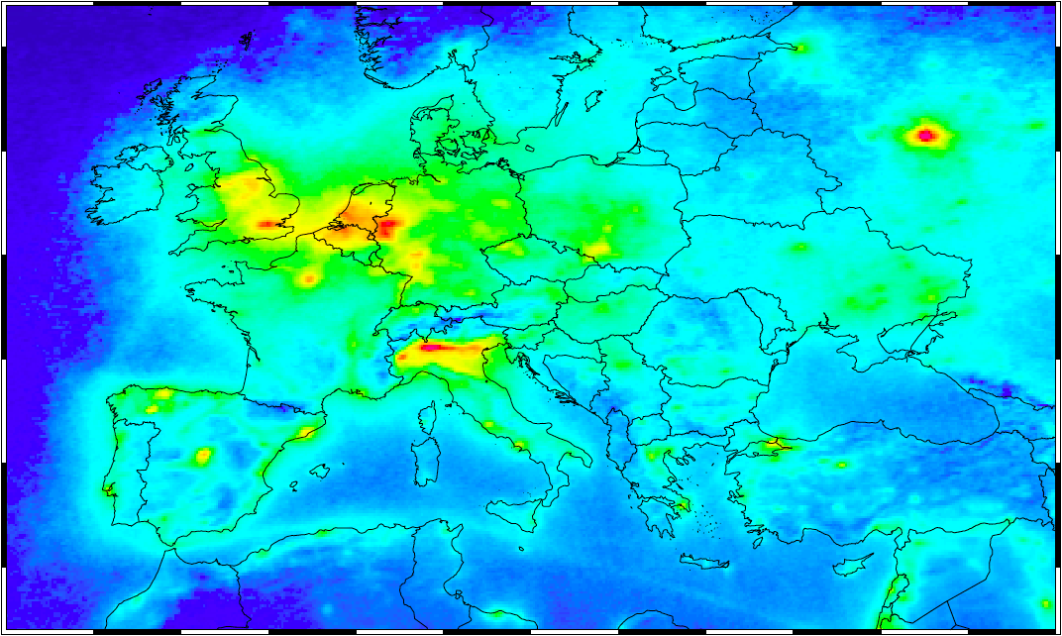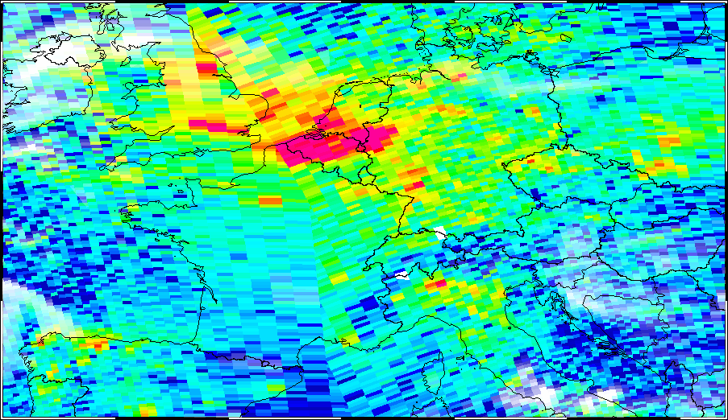

Figure 1. Measurements of the tropospheric NO₂ column over Europe from the Ozone Monitoring Instrument (OMI) on EOS-Aura (Boersma et al., 2011). Top panel: yearly-mean observation for 2005. Bottom panel: A sum of all observations available for assimilation on one day with little cloud cover (30 August 2005), showing the pixel size (13x24 km at nadir) and the overlap between orbits at high latitude. The retrieved cloud fraction is used to fade out the measurements (white indicates 100% cloud cover).
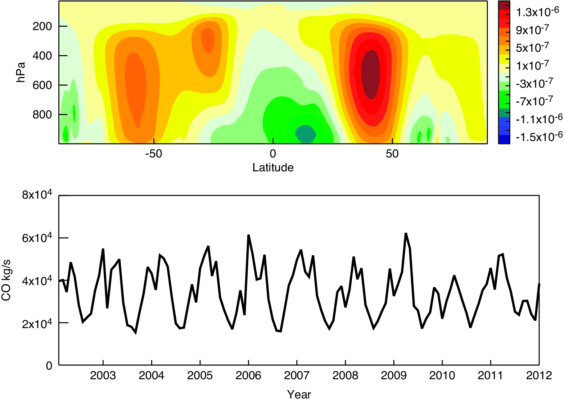

Figure 2: Cross section at 180 E of the average zonal CO flux (kg/(m²s)) in the 2003-2012 period calculated from the CO, U and density fields of the MACC re-analysis (top). Time series of monthly mean CO (kg/s) transported over the Northern Pacific through a pane at 180 E (30N-70N, up 300 hPa) (bottom).

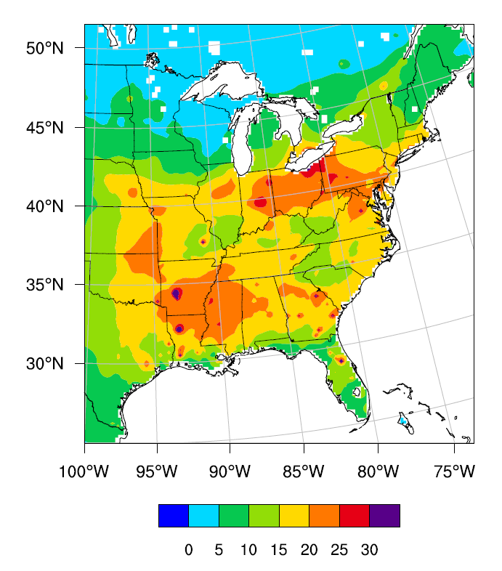
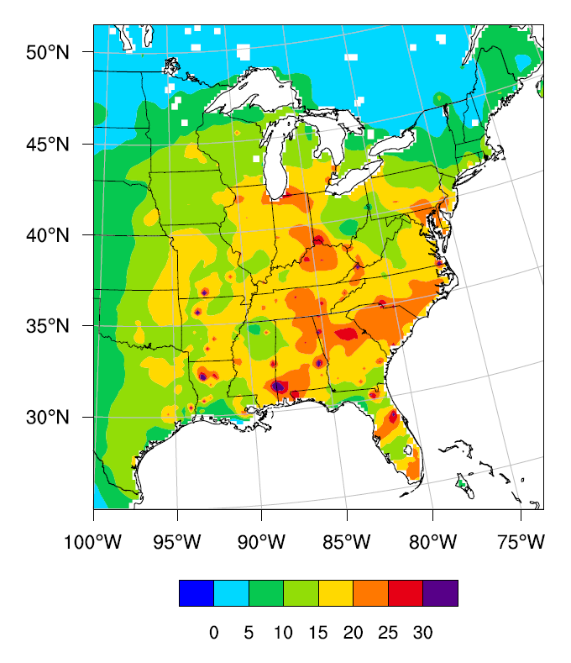

Figure 3. 24-hour average PM_{2.5} concentrations (μg/m³) for June 29 (left) and July 05, 2012 (right).

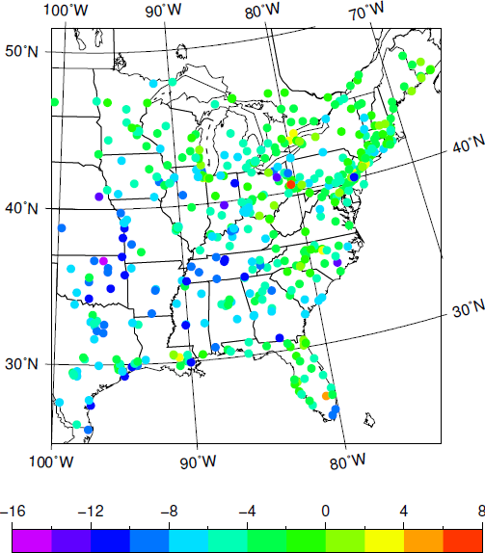
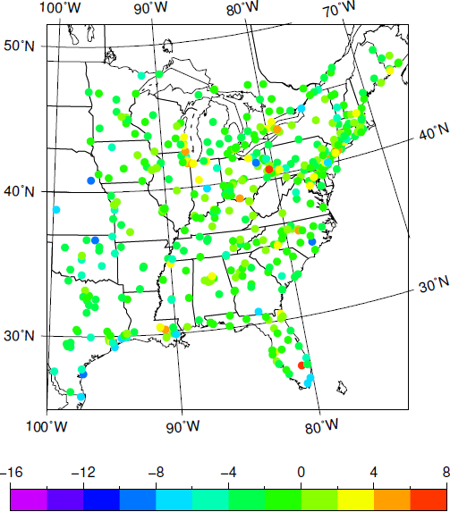

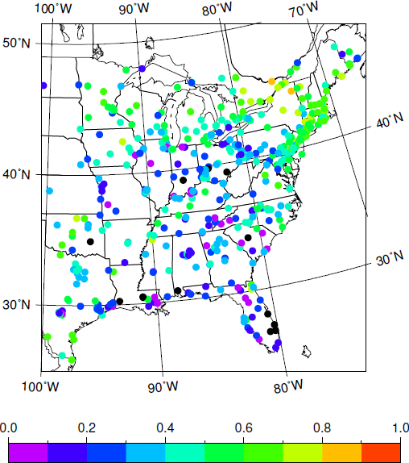
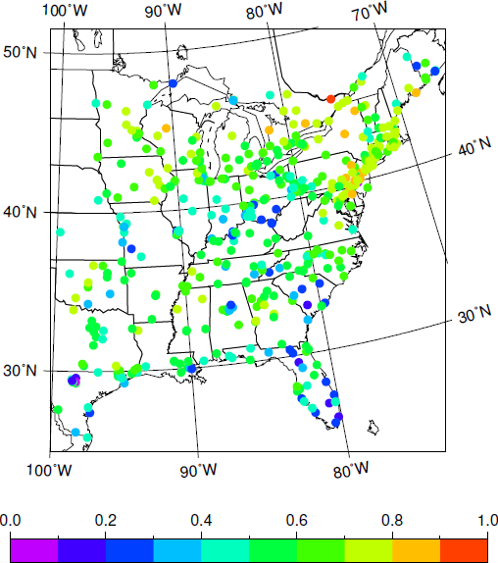

Figure 4. Bias (μg/m³) (top) and temporal correlation (bottom) of forecasts for NoDA (left) and EnKF (right) simulations against AIRnow observations for the period 28 June – 6 July 2012. Black dots denote negative correlations.

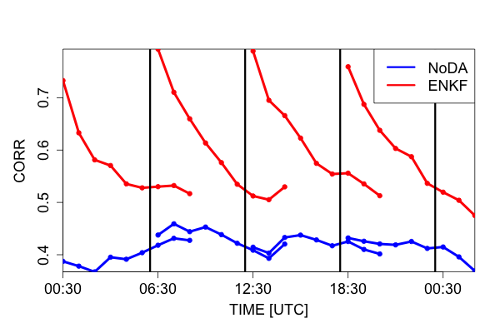
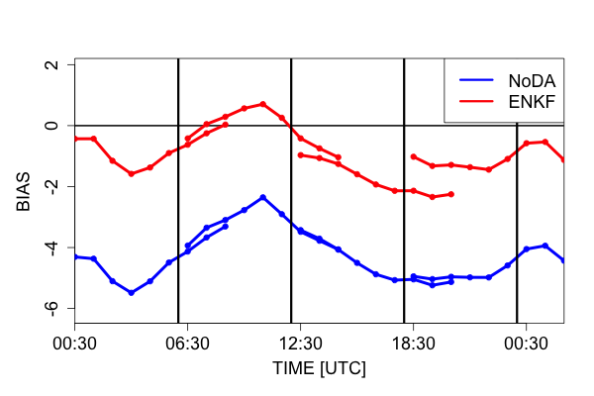

Figure 5. Diurnal cycle of bias (μg/m³) (left) and spatial correlation (right) of PM_{2.5} forecasts for the NoDA (blue) and EnKF (red) simulations against AIRnow observations for the period 28 June – 6 July 2012. The black vertical lines are plotted at assimilation times.

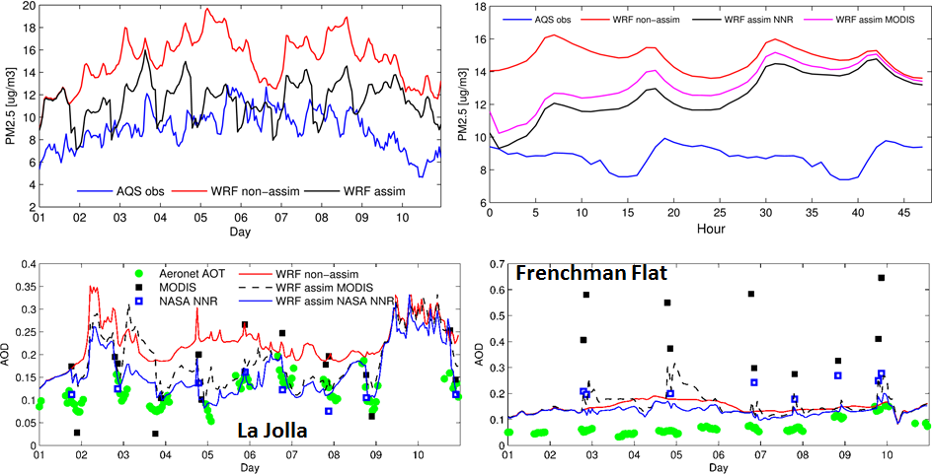

Figure 6. Results when assimilating satellite retrieved AOD over the SW US for the first 10 days of May 2010. Top-left panel shows time series of model and observed mean PM_{2.5} over AQS sites in California and Nevada. Top-right panel shows mean PM_{2.5} as a function of forecast hour for the same sites. Bottom panels shows AOD time series at two sites for AERONET data (500 nm), operational MODIS (550 nm), NASA NNR (550 nm), the non-assimilated forecast and the two assimilation forecasts (500 nm). Modified from Saide et al. (2013).

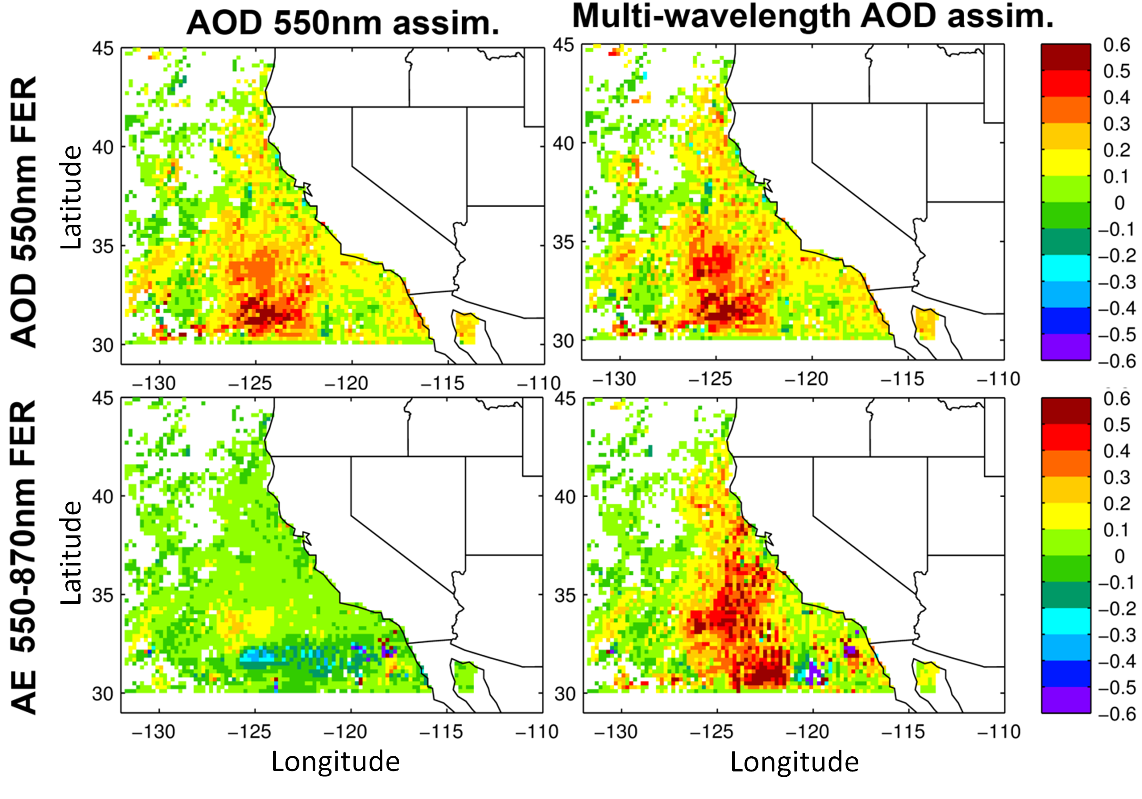

Figure 7. Fractional error reductions for 550 nm AOD and 550–870 nm Ångström exponent (rows) from non-assimilated to assimilation of Terra retrievals computed using Aqua retrievals (e.g., errors for a ~3 hour forecast). Figures in the left column assimilate only MODIS 550 nm AOD while the ones in the right column assimilate MODIS 550, 660, 870, and 1240 nm over ocean and only 550 nm over land. Modified from Saide et al. (2013).

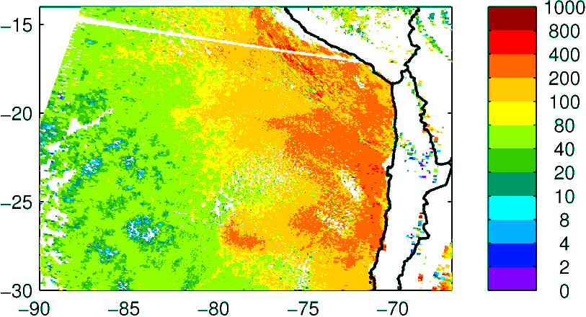
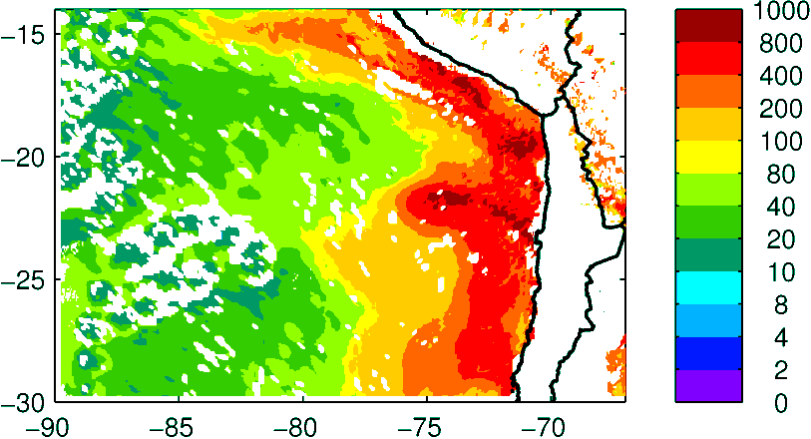
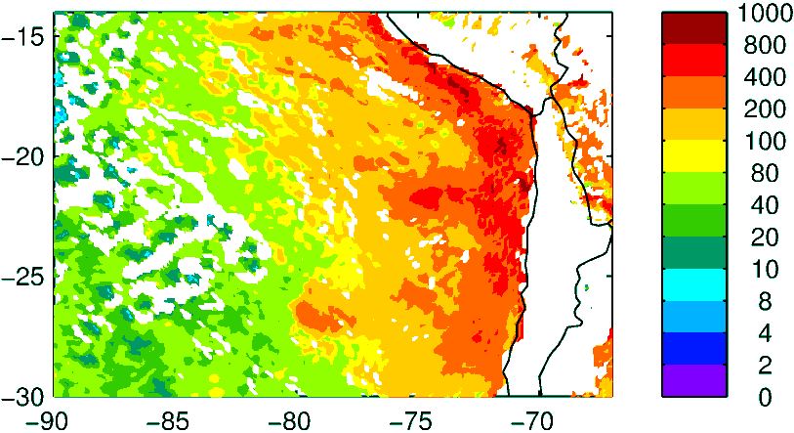
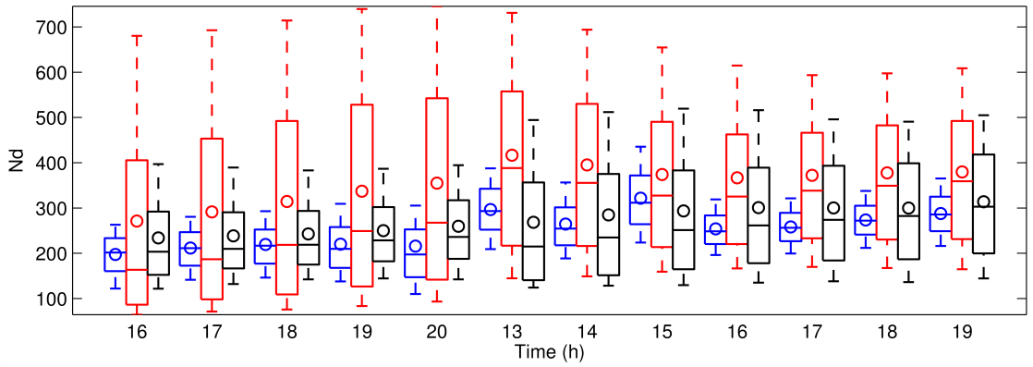
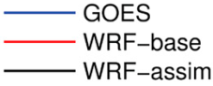
1st day
2nd day
MODIS Terra
Guess
Assimilated

Figure 8. Results when assimilating cloud retrievals to improve below-cloud aerosol state. Top panels show observed and model maps of cloud droplet number [N_{d}, #/cm³] for the southeastern Pacific. The bottom panel shows time series of GOES and N_{d} forecasts after assimilation of the MODIS retrieval on the top panels. The time series are presented as box and whisker plots computed over the rectangle on the top-left panel; center solid lines indicate the median, circles represent the mean, boxes indicate upper and lower quartiles, and whiskers show the upper and lower deciles. Time series are shown during day time for 2 days after assimilation.

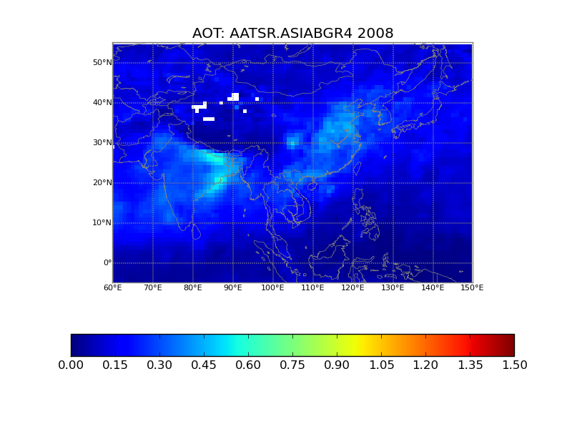

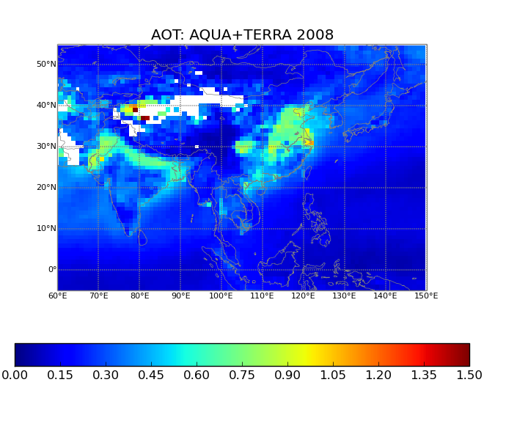

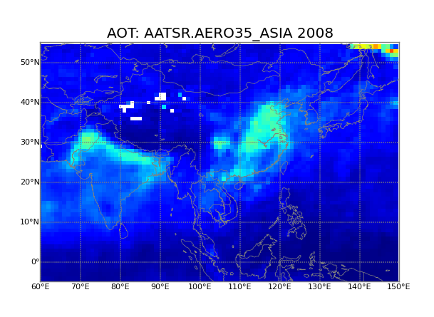

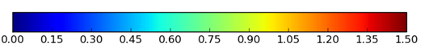

Figure 9. SILAM a priori (top), MODIS observations (middle) and SILAM a posteriori (bottom) AOD, mean over 2008, model output fully collocated with MODIS.

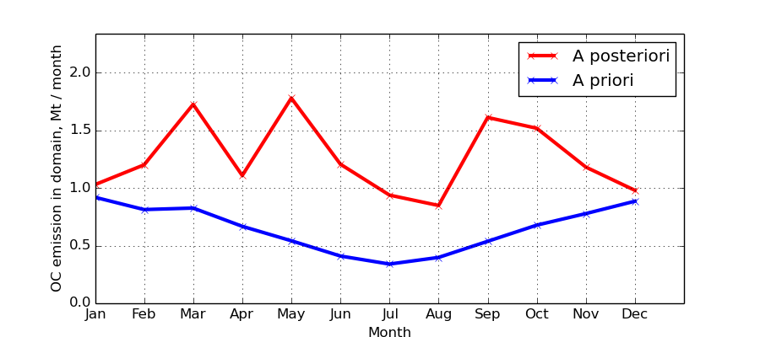

Figure 10. Monthly emissions of OC in Asia, total 2008, unit = Mt PM month⁻¹. Annual average OC mass: a priori: 7.8 x 10⁹ kg; a posteriori: 1.5 x 10¹⁰ kg.

